V8

Height Gauge with Fine Adjustment

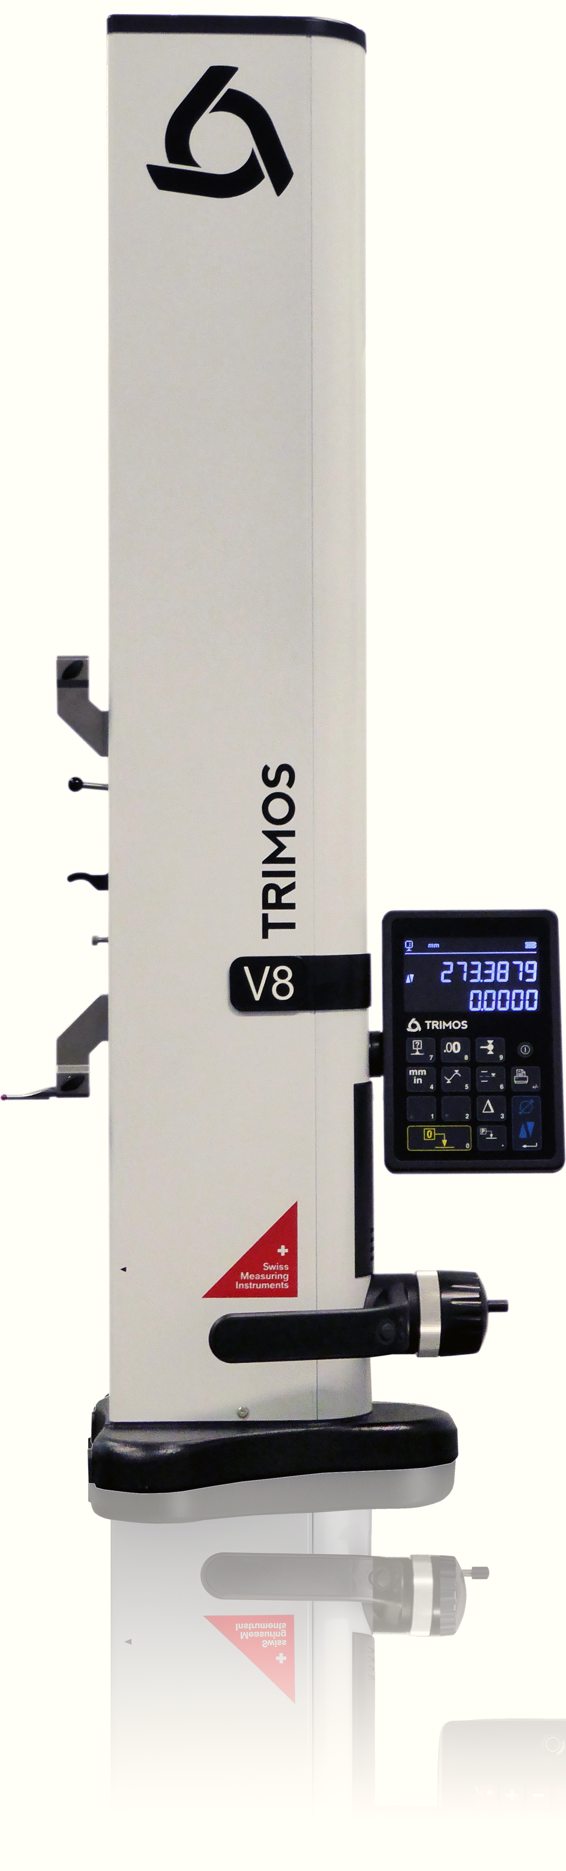

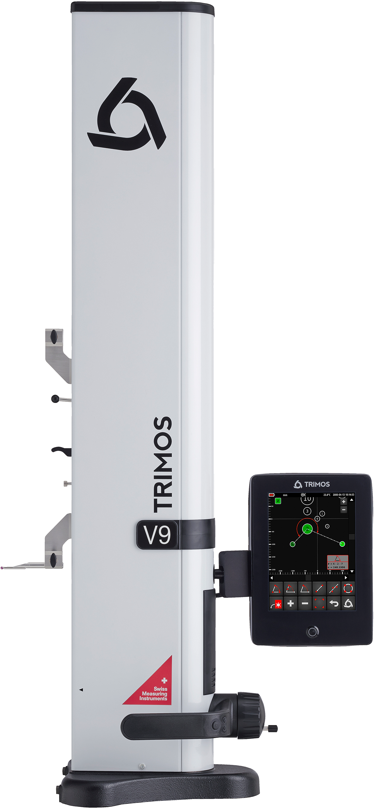

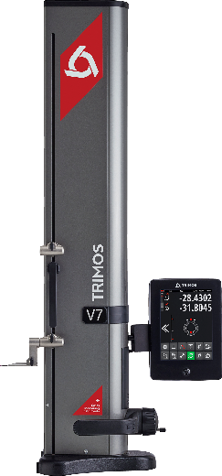
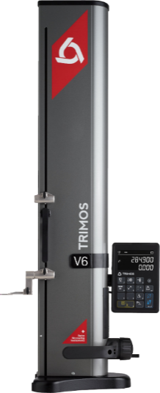
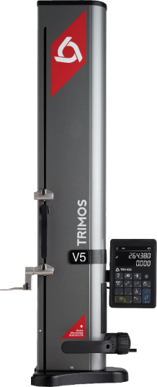
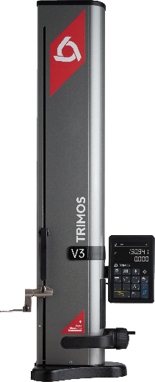
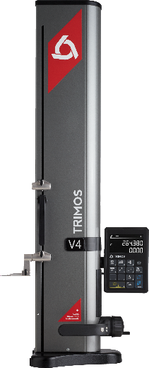

V9

V7

V6
V4
V5
V3

1.  PRESENTATION  E  D  F  - Measuring range from 400 to 1100 mm  - Specific handwheel for fine adjustment  - Manual displacement  - Exceptional precision level  - Large range of accessories  - All possible adjustments without tools  - Interfaces RS232 and USB  - Wireless data transfer (optional) | 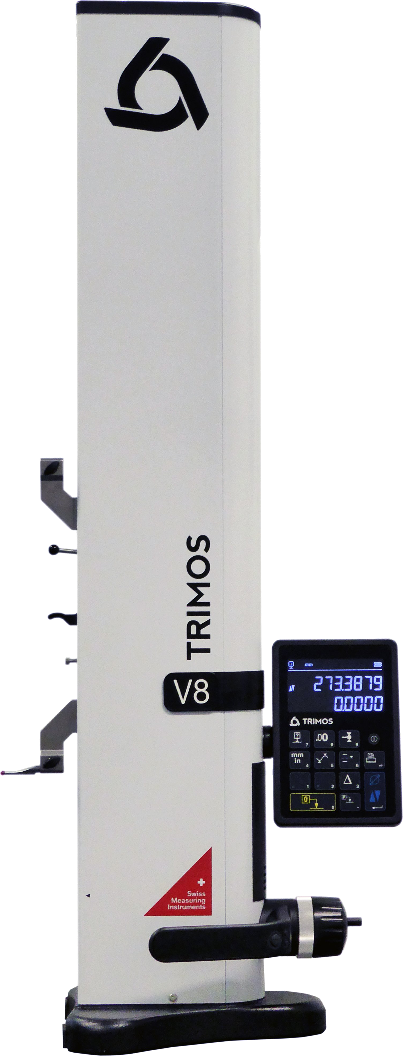  G  C  B  A
  After the very successful launch of the V-line height gauges, Trimos has developed a new instrument in its height gauge family, the V8.
  The mechanical design and delivery scope of the V8 are identical to the V9. It shares the features that made the model V9 so successful: extreme precision and repeatability, high resolution, and Swiss made finish. What is to underline about this new model is its specific handwheel for fine adjustment. Trimos developed this fine adjustment to answer to specific applications requiring a fine adjustment of carriage position.
  The V8 guarantees, like its predecessors, an extremely easy use with great robustness, flexibility and high precision.
  The large 2-line « Black Mask » display of the V8 offers an exceptional contrast in all lighting conditions. The display provides functions that are directly accessible and depicted with easy-to-understand symbols.
  A : « Black Mask » display with user-friendly functions
  B : Specific handwheel for fine adjustment
  C : Horizontal displacement handle with programmable functions buttons and air cushion
  D : Additional probe holder
  E : Probe weight balance system
  F : Interchangeable measuring insert
  G : Cast iron base for optimal stability

2.
FINE ADJUSTMENT
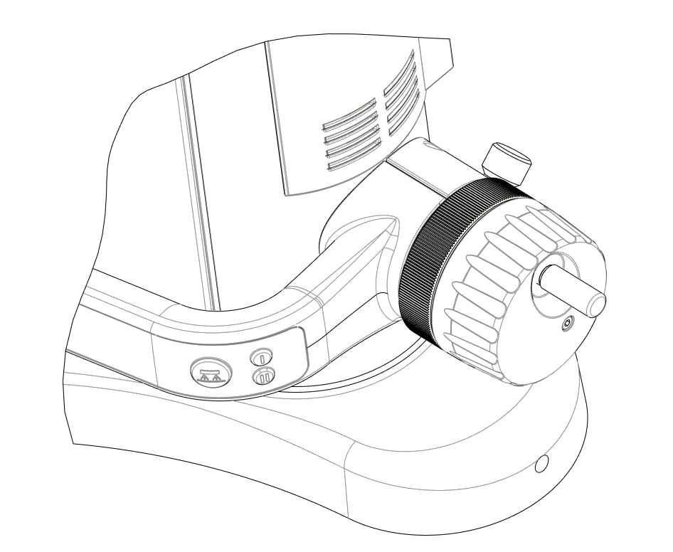

A Handwheel for carriage displacement
B Fine adjustment screw
C Locking ring for fine adjustment
D Button for activation of air cushion and programmable function buttons

B

C

A

D

3.
TECHNICAL DATA

V8 | 400 | 700 | 1100
Measuring range mm (in) | 406 (16) | 710 (28) | 1109 (43)
Measuring range with extension mm (in) | 724 (28) | 1028 (40) | 1427 (56)
Max. permissible errors, B_{MPE} µm | 1.2 + L(mm)/1000
Repeatability, R_{MPE} (2s) µm | 0.4 (Ø: 1)
Frontal perpendicularity, S_{MPE} µm | 5 | 8 | 11
Maximal Resolution mm (in) | 0.0001 (0.000005)
Measuring force N | 0.75 ÷ 1.5
Autonomy h | 12
Interfaces | USB / RS232 / Wireless
Air cushion | Yes
Weight kg | 21 | 24 | 33

The above values have been determined according to ISO 13225 with the standard measuring insert (TA-MI-119).
4.
APPLICATIONS AND FUNCTIONALITIES

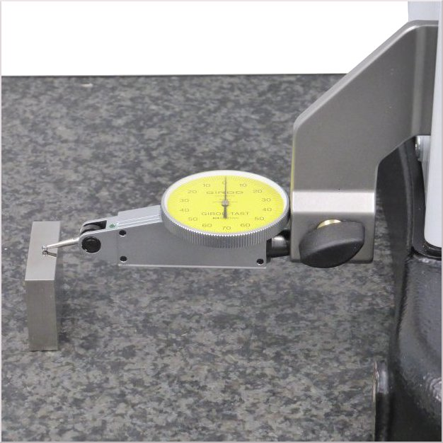 | 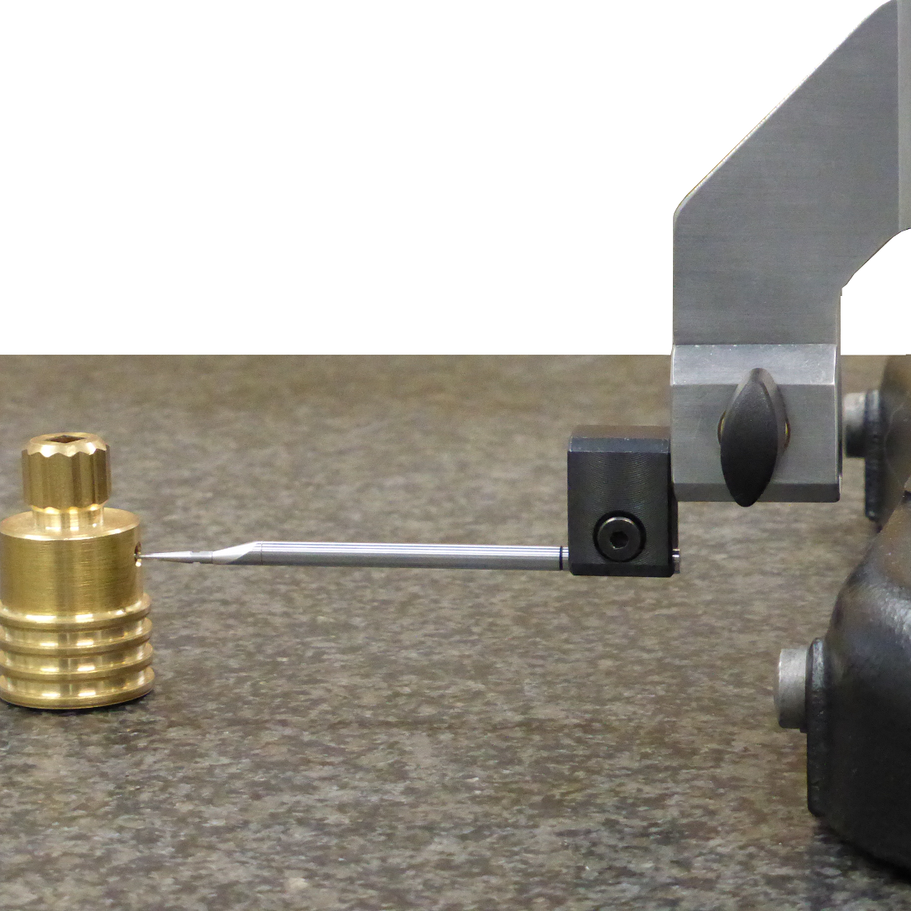 | 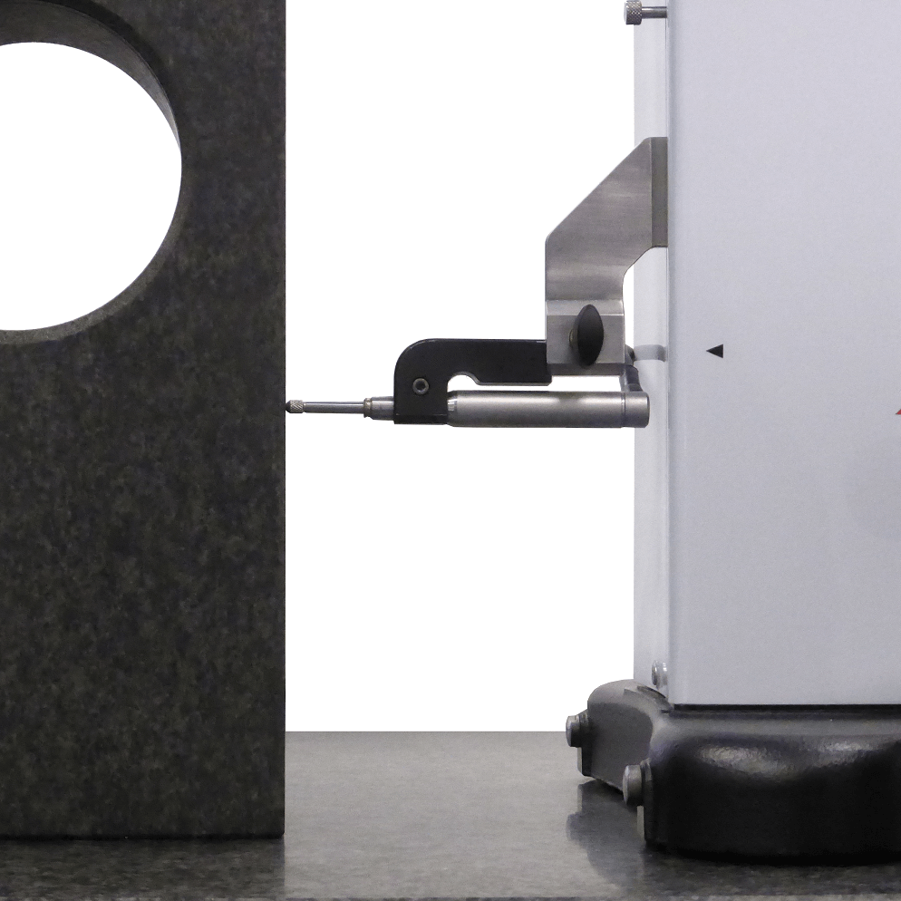
Fine adjustment for specific applications requiring an accurate carriage position | Small diameters measurements with insert Ø 4 mm | Perpendicularity measurements with electronic probe
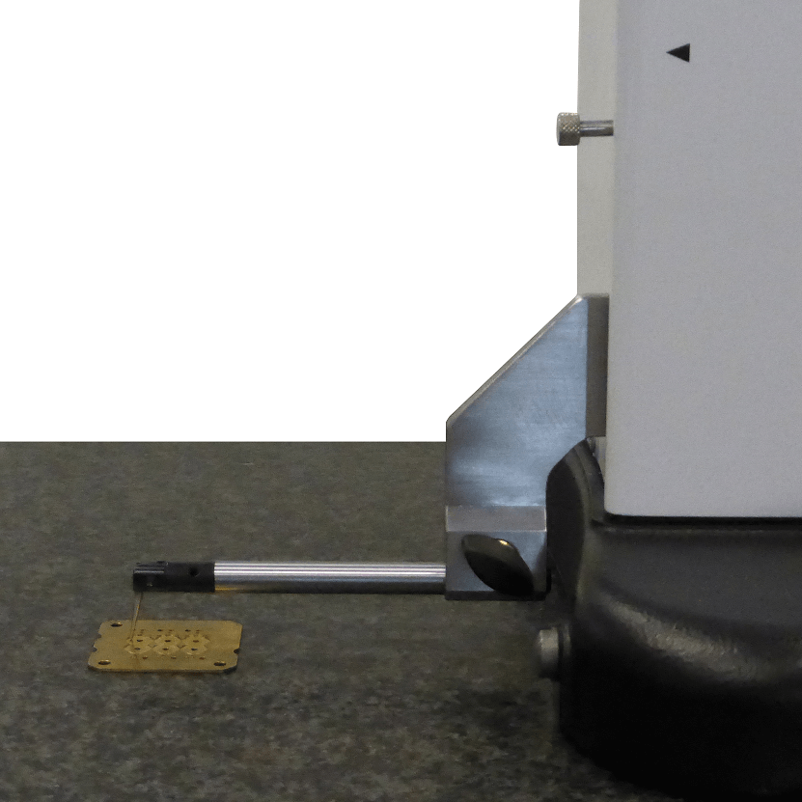 | 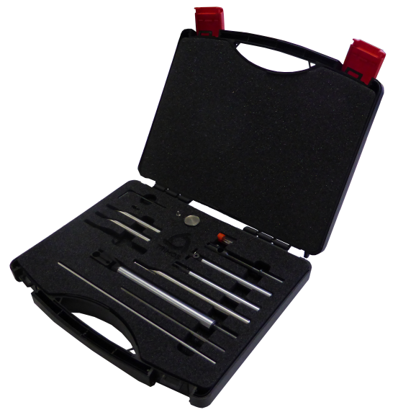 | 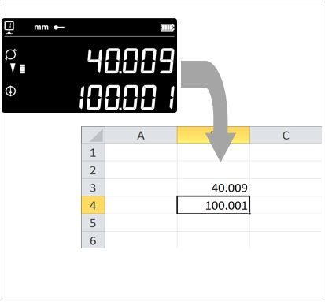
Height measurements on watch movement plate | Large range of accessories for all types of applications | Very easy data transfer via USB, RS232 or Wireless connection

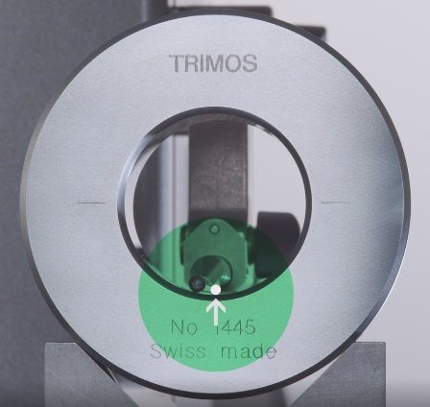 |   SMART REVERSE:  Diameter measurement faster, more accurate and simpler  SmartReverse technology is the result of an intense collaboration between Trimos users and our R & D team in order to optimize diameter measurements.  SmartReverse makes the measurement of diameters very efficient by clearly indicating the reversal points with audible and visual signals. The user is guided precisely during the measurement of diameters, which generates a significant gain in speed and reliability of the measurement.


Trimos S.A.
Av.de Longemalle 5
CH-1020 Renens
T. +41 21 633 01 01
info@trimos.ch
www.trimos.com 750 02 0070 03 – Version 1.1/2019-03 – Changes without prior notice

