2D Height Gauges

What is a 2D Height Gauge?

A height gauge is a dimensional measuring instrument with a single vertical axis used on a granite table. It is used universally for the measurement of mechanical parts. Its preferred location is the workshop, close to the machining center, or the measuring room. It provides accurate, fast and easy measurement of parts in production, directly by the operator.

The measurement of distances, diameters and center distances are the basic functions of a height gauge. The most sophisticated models (2D) offer advanced functionalities such as 2-dimensional measurement, statistics or programming, but also measurement of perpendicularity, angle, flatness and temperature compensation.

The height gauge is positioned between the hand tools and the 3D measuring machines (CMMs). It offers the following advantages:

- Measuring accuracy similar to the best CMMs
- Universal measuring instrument, substitutes for most hand tools
- Extremely fast and simple measurement
- Use close to the machining center, no bottlenecks in metrology
- Time savings compared to a CMM for equivalent measurements
- Allows measurements that were previously only possible on CMMs, e.g. 2D
- Allows you to reserve CMM time for the most complex tasks
- Considering the above points, the return on investment is very fast.

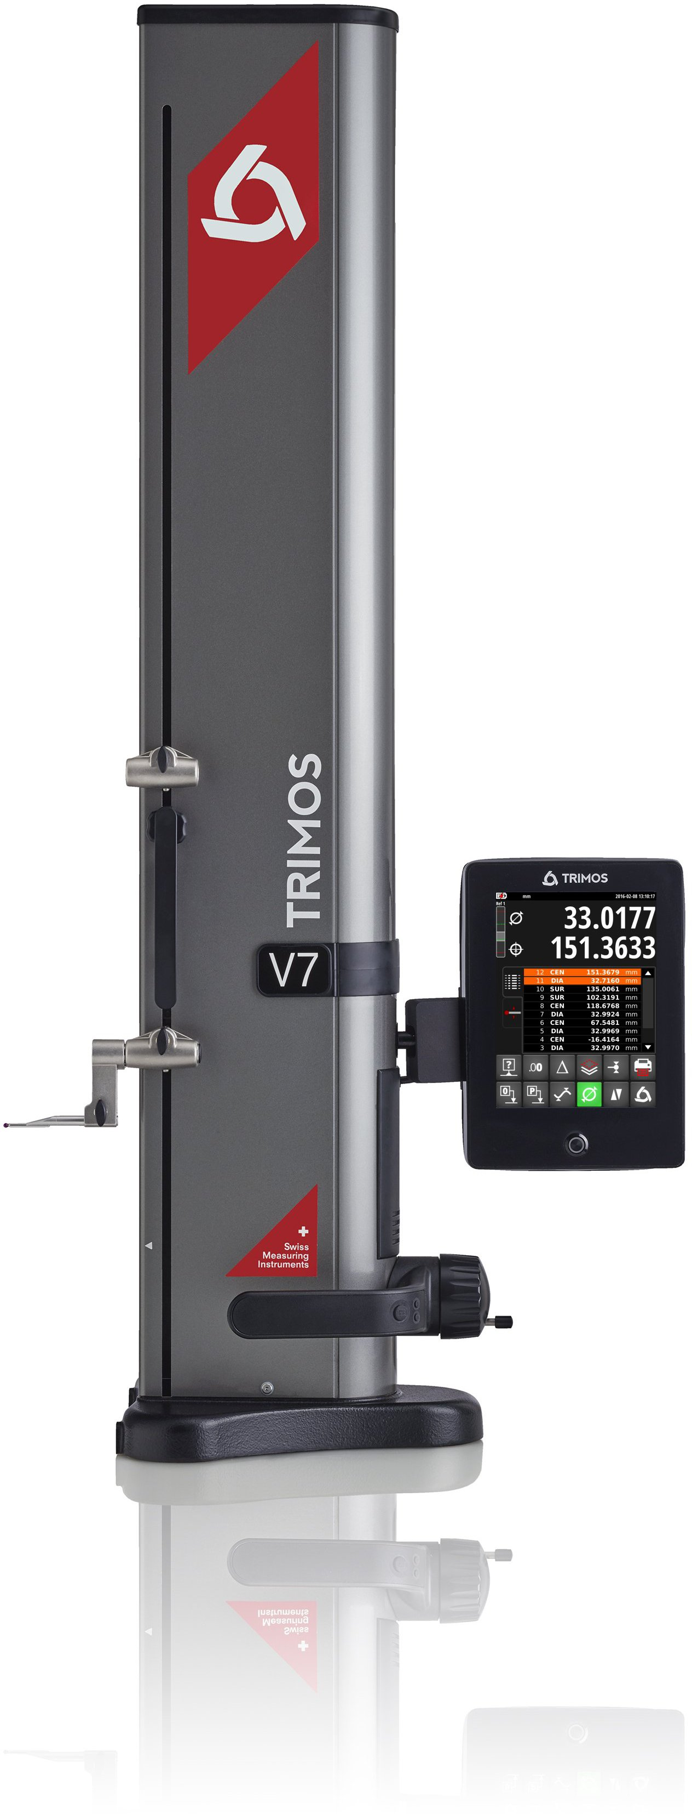

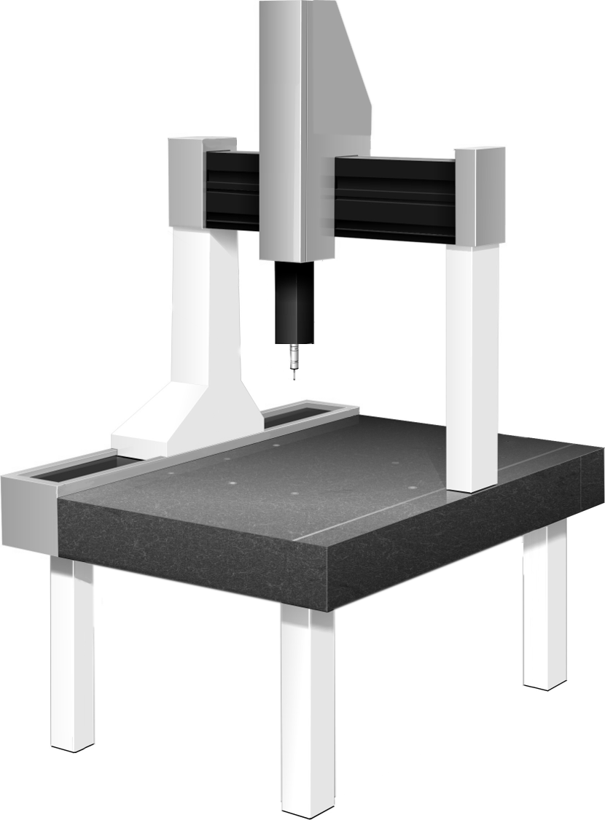

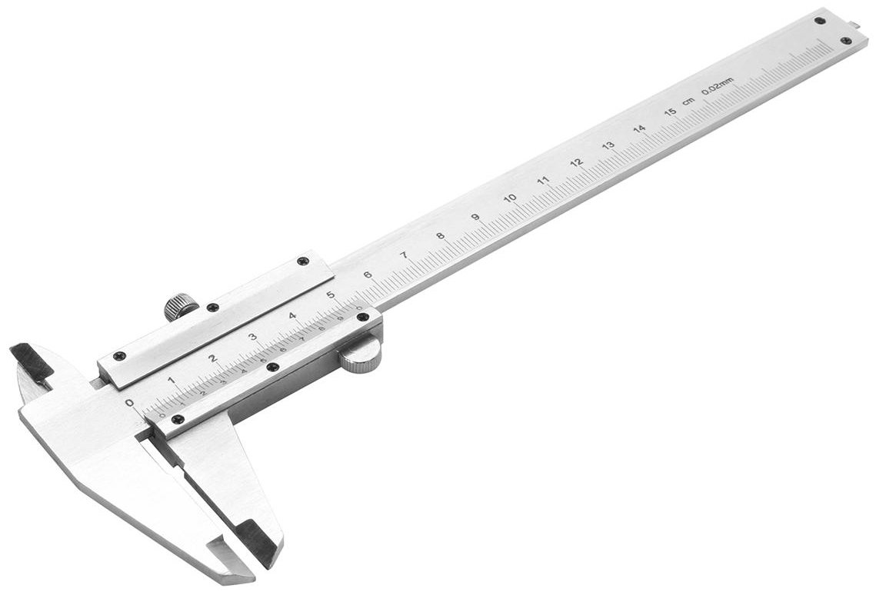
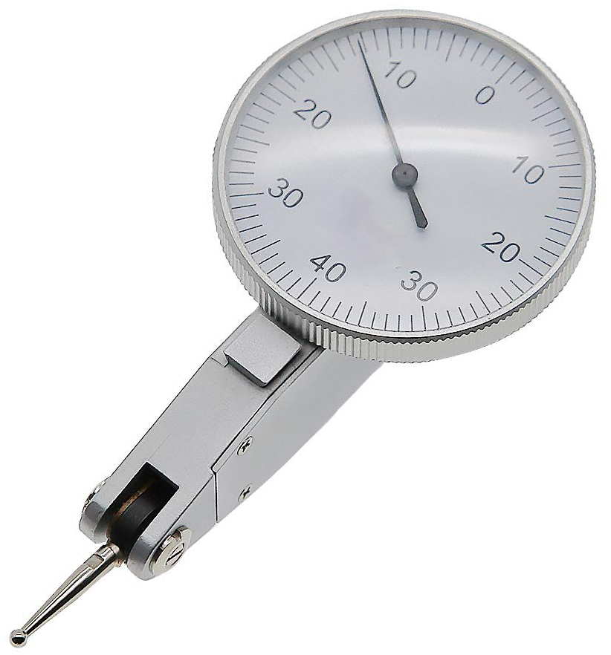
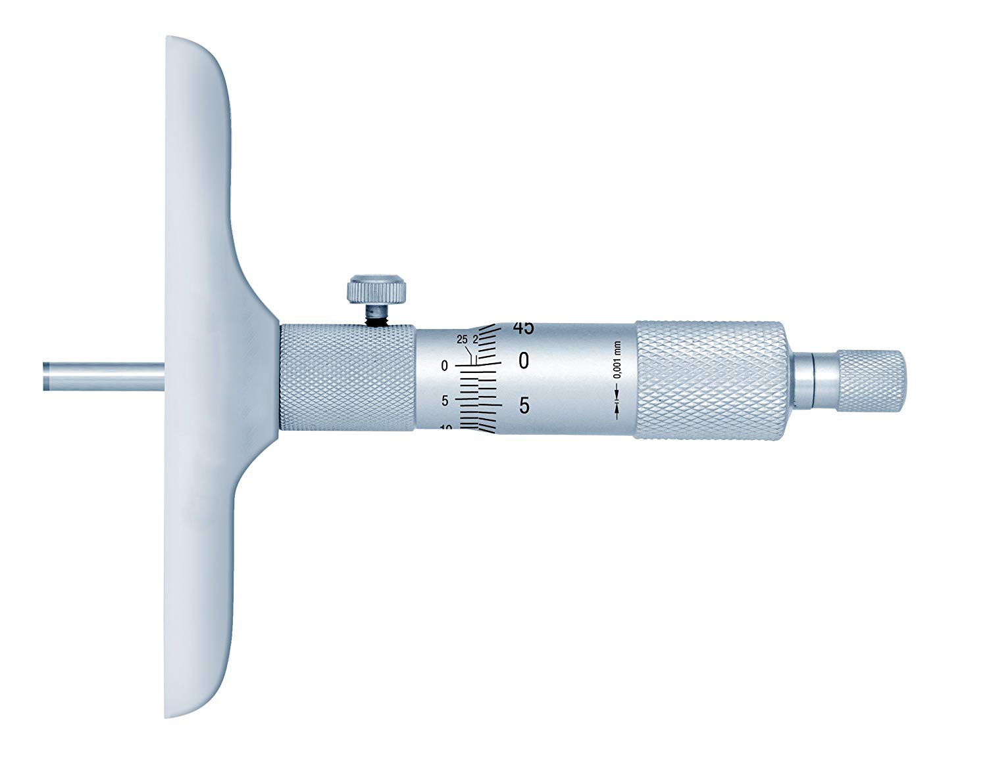
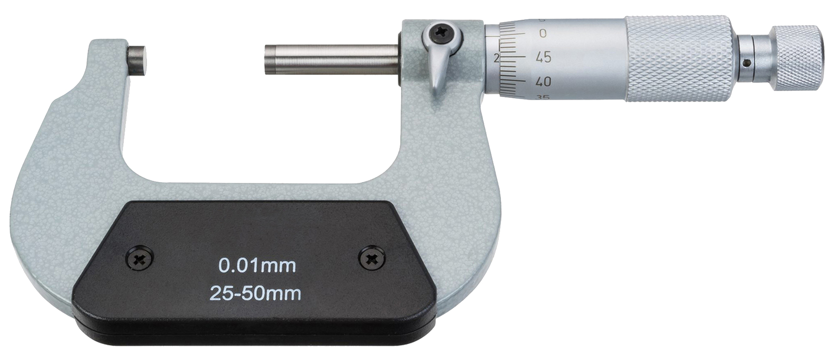
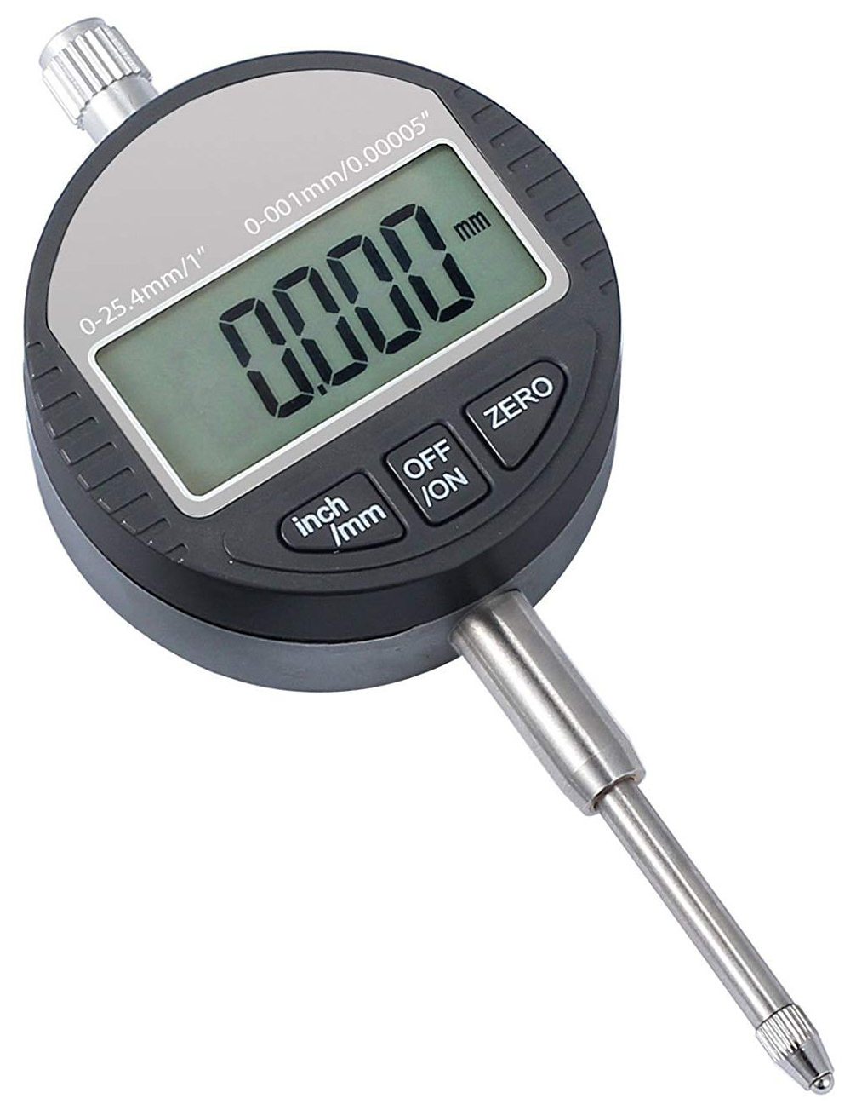
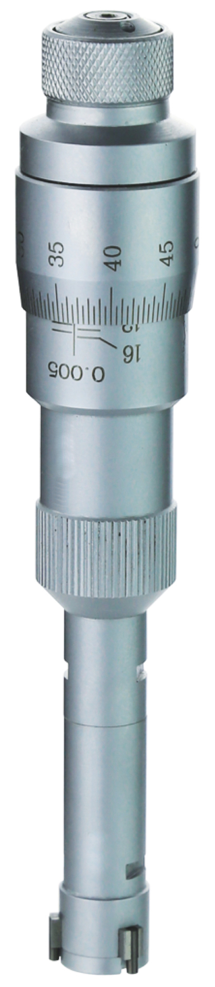

Eliminates your metrology bottlenecks
Complements all hand tools

What is the Purpose of a 2D Height Gauge?

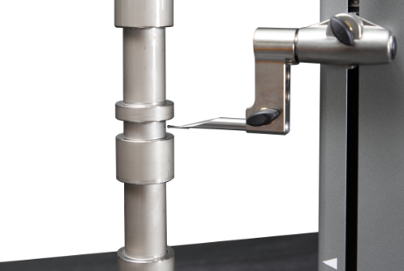  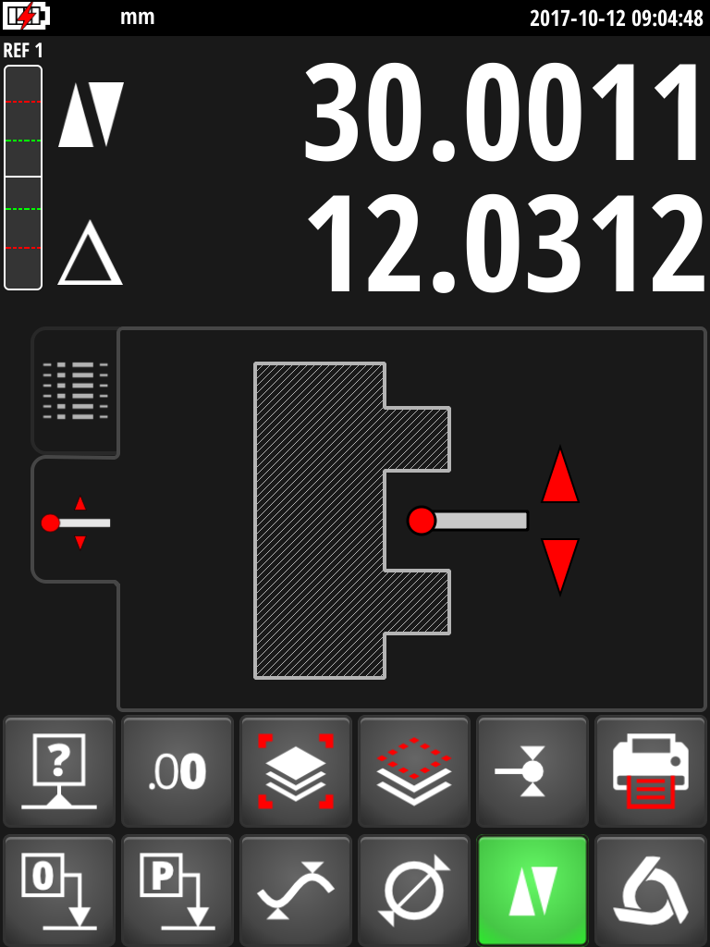 | 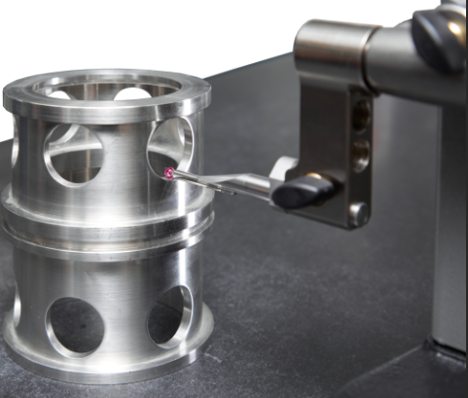  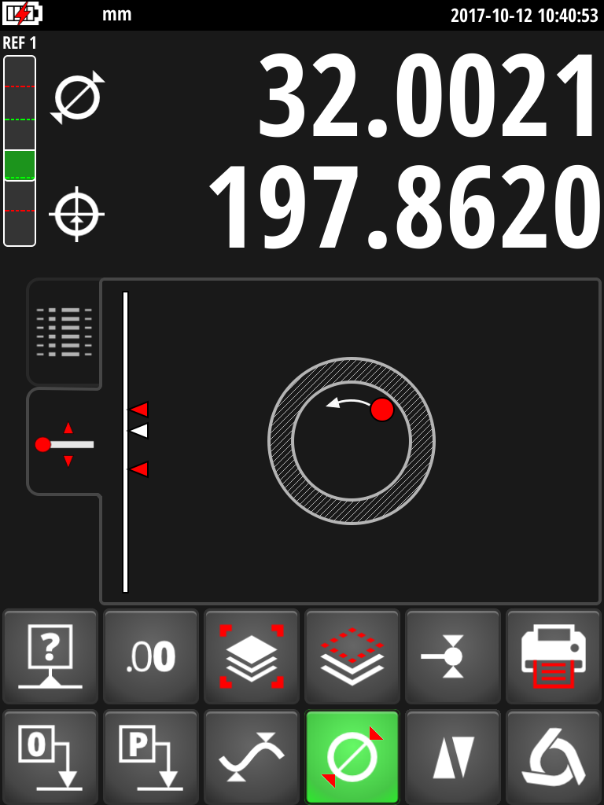
Height measurements  The basic functions of height gauges include measuring heights, thicknesses and chain dimensions. V7 and V9 offer unique measuring ergonomics and readability. The absolute dimension (=from zero) and the distance from the last probe are displayed at the same time for each measurement. This allows a very efficient measurement of chain dimensions. All results are displayed in the buffer as a list. The toleranced dimensions are displayed in colour according to the result. | Diameter measurements  Diameters have never been easier to measure.  In manual mode, simply engage the measuring force and move the part sideways to pass the reversal point. No need to hold the crank handle during this operation. In motorized mode, diameter measurement is performed automatically in a single operation. The reversal points is clearly indicated by audible and visual signals. The user is thus guided precisely during diameter measurement, which results in a significant increase in speed and reliability of the result.
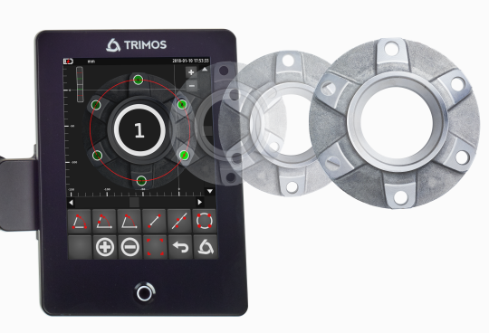 | 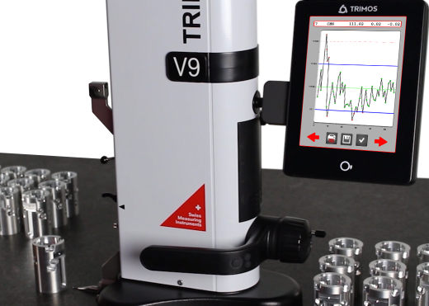
Measurement in 2 coordinates (2D)  The display of V7 and V9 offers possibilities of graphic visualization never before achieved on a height gauge. The large screen size makes it possible to display the part in 2D in a very comfortable way. Simply measure the part as normal, rotate it and measure it again in the 2nd axis. The results appear immediately on the screen in 2 dimensions. It is then very easy and intuitive to measure distances, angles, regression circles etc. by clicking directly on the various bores displayed. | Measurement of series of workpieces  Programming is very useful for repetitive series of parts. Simply measure the part normally to make a program. User comments can be added for greater clarity of the tasks to be performed. In motorized mode the user only has to follow the program steps and move the part to be measured. The instrument manages the rest automatically.  The statistical analysis of the results is carried out directly by the SPC software integrated in the display.

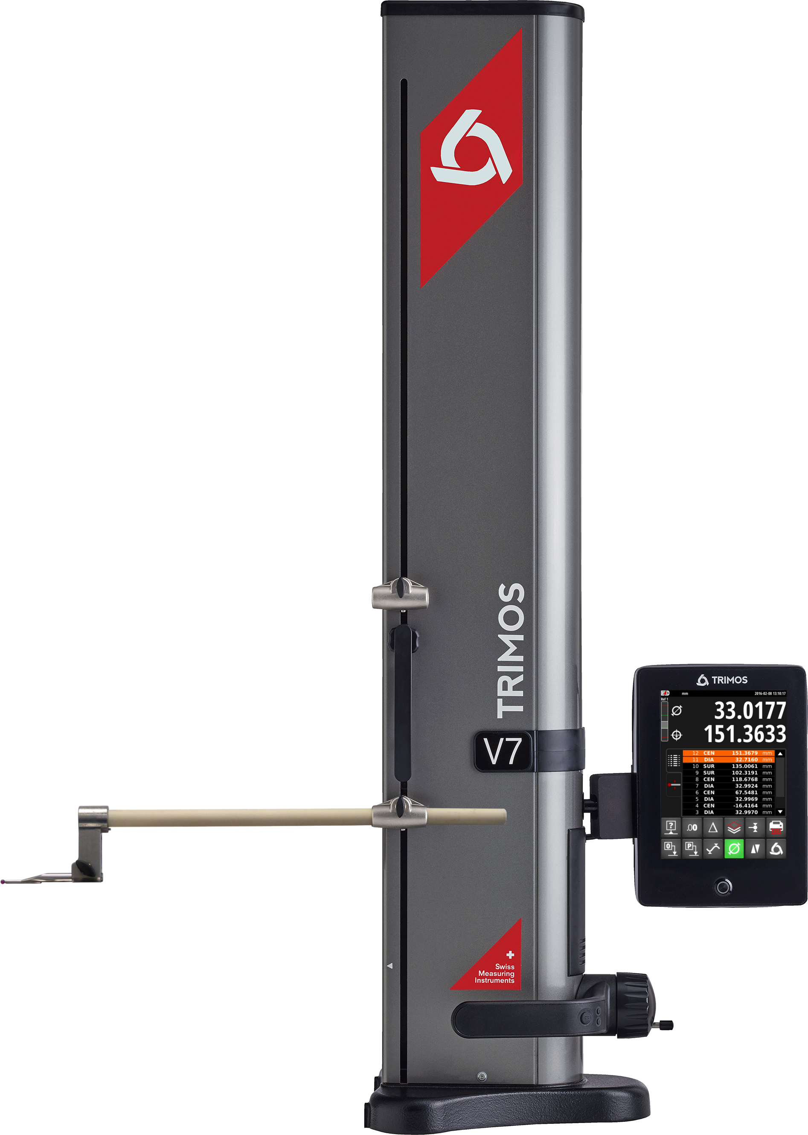
Presentation

Tablet-type display consisting of a touch screen that has proven itself in many industrial applications. Its size (8 ") offers exceptional reading comfort. The uncompromising ergonomics of the interface have been designed to ensure ease of use in workshop conditions.
Only the functions useful for the measurement in progress are displayed, which reduces the number of buttons and simplifies use.
The display can be rotated in any direction.

In order to ensure the highest precision and reliability we use only the best measuring systems on the market.

2nd probe holder for measuring range extension.

Interchangeable insert and insert holder.
Inserts up to 400 mm in length are available as standard (V7) with breathtaking repeatability.
The very robust mechanics of the V7 allows the use of probes up to 400 g.

Handwheel for moving the measuring carriage:
The motorised mode can be switched on at any time by pulling the crank handle outwards.
In manual mode, it is not necessary to hold it in position during measurement. This ensures a constant measuring force and makes diameter measurements much easier.

Horizontal movement handle with air cushion engagement button and 2 programmable function buttons for the most frequently used functions.
Cast iron base with hard nickel plating providing excellent corrosion and wear resistance.

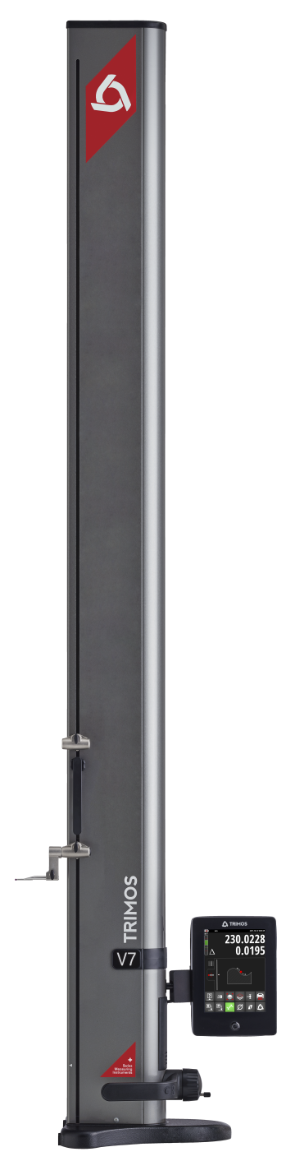
Trimos 2D Instruments

V7: Accessible to everyone in the workshop

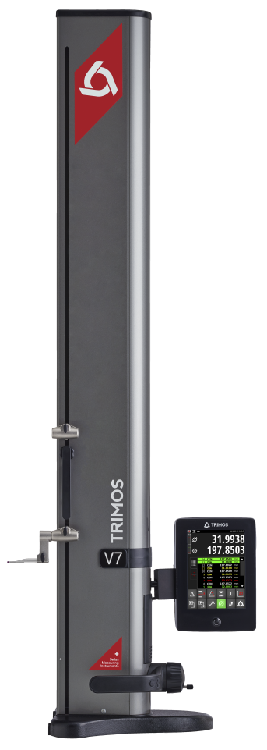

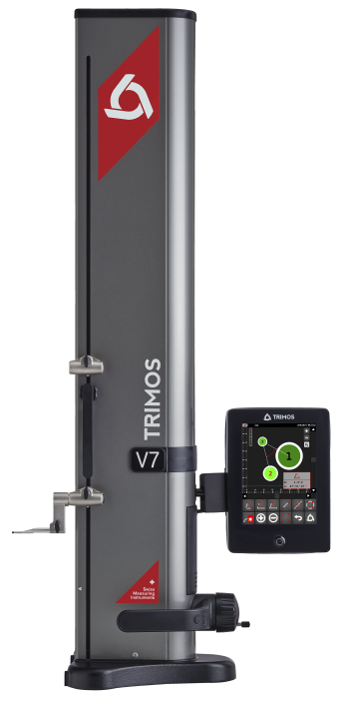

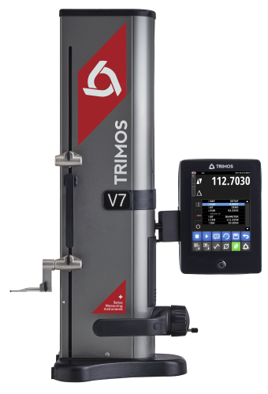

The V7 are available with measuring ranges from 400 to 1800 mm. They have been designed for use in the workshop. Their special feature is an extremely robust mechanics allowing the use of probes of various lengths and masses.
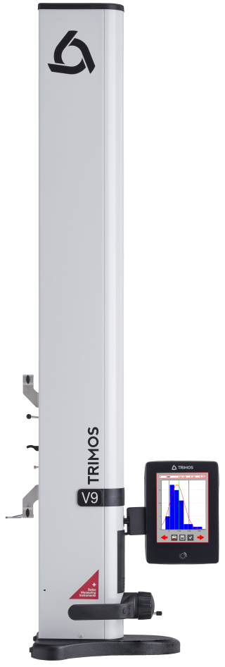
V9: Focus on precision

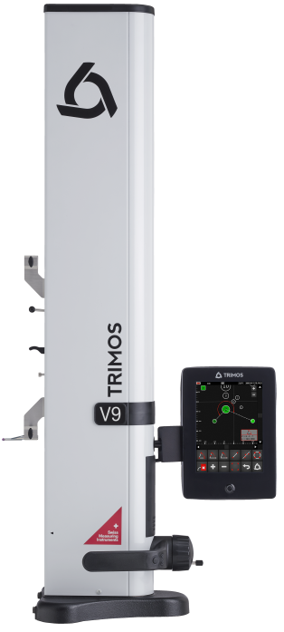

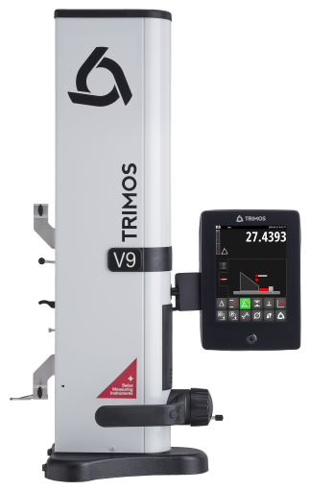

The V9 are available in 3 different sizes: 400, 700 and 1100 mm. Their mechanical design has made no compromise on precision. This is what allows them to be positioned as the most accurate height gauge on the market.

Display
Clear interface

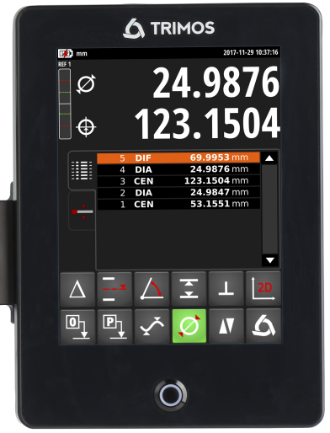
The graphical interface is organised according to a very strict logic. Ergonomics, button positions, colours and menu sequences are based on the experience of 7 generations of height gauges and proven ergonomic principles. The result speaks for itself:

- Very sober display
- No "pollution" of the screen with unnecessary information and small print
- Maximum contrast for easy reading even in difficult lighting conditions
- The size of the screen (8") allows the display of very large characters with very wide viewing angles in all directions (IPS panel).
- The flexibility offered by the touch screen allows only the necessary functions to be displayed.
- Intuitive and easy operation
- Quick and direct access to all important functions
- Integrated graphical help

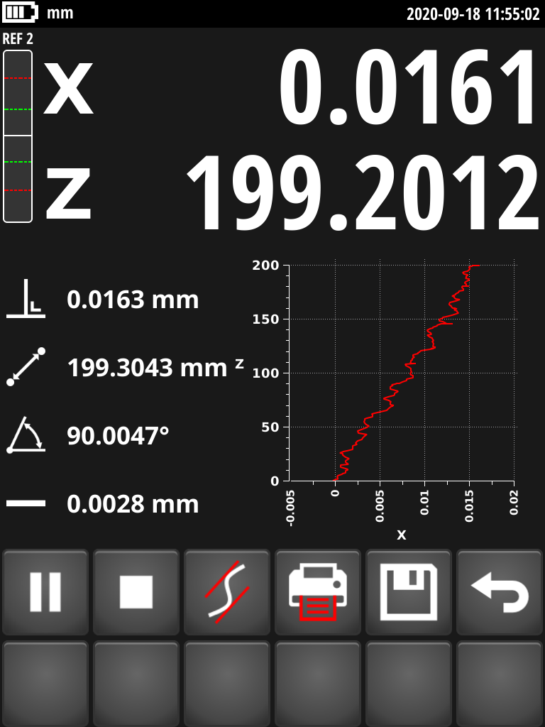 | Perpendicularity  The perpendicularity measurements made with the electronic probe are displayed graphically together with all relevant parameters. The curve is drawn in real time during the measurement and clearly indicates the workpiece defect. |  | 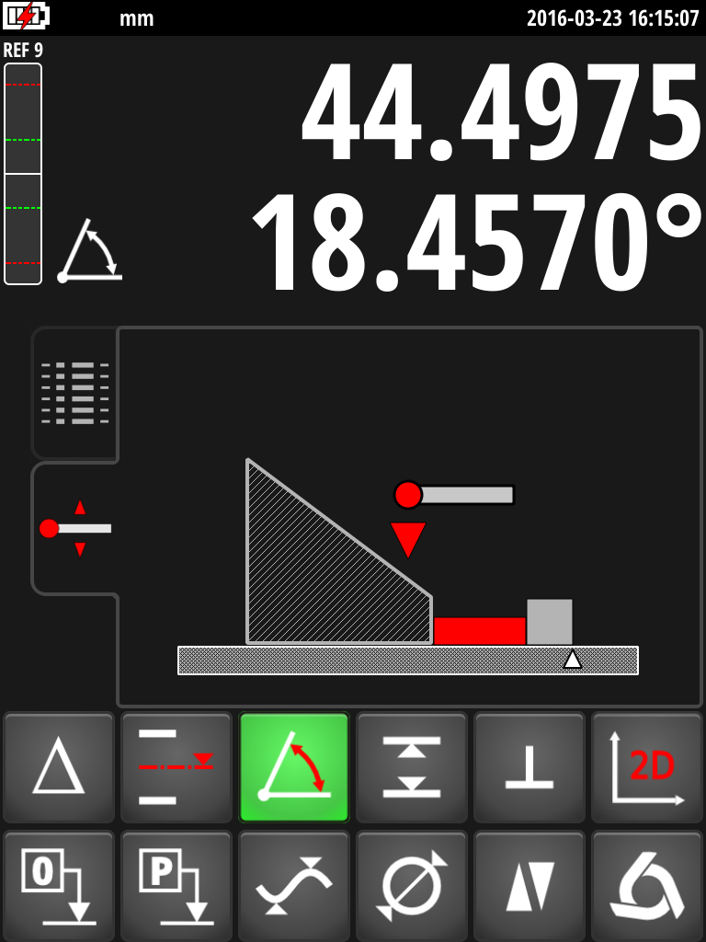 | Angles  The angle and cone measurements are interactively carried out with the help of graphical support. At each step, the user is guided on the action to be carried out. There is therefore no risk of error.
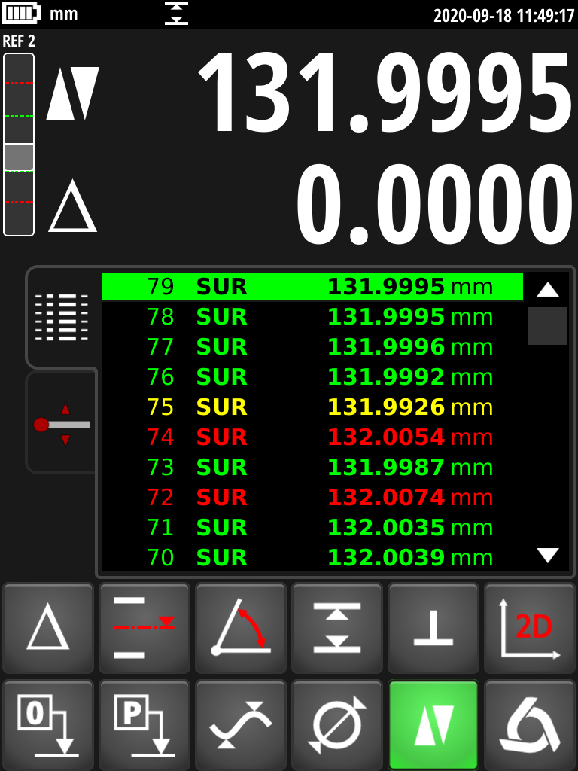 | Tolerances  The dimensions can be toleranced when measuring series parts. For each measurement, the value is displayed in colour depending on whether or not the specified tolerance is met. |  | 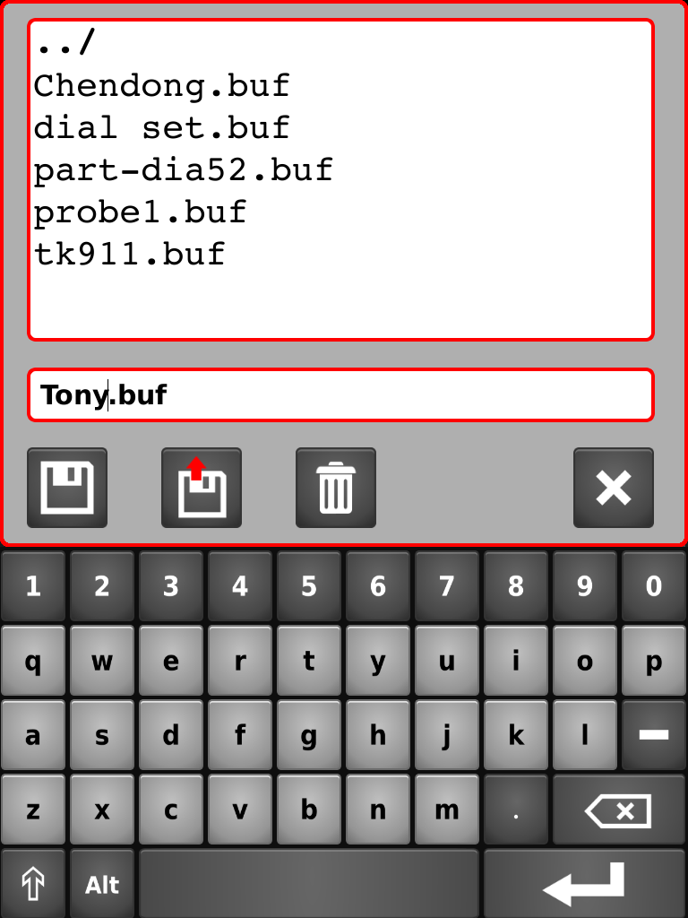 | Data backup  All measurement results can be saved on a USB stick or in the display itself. They can be recalled from the display at any time or exported to a PC for analysis.

Embedded intelligence
Data Management

The V7 and V9 are well equipped to meet the challenges of Industry 4.0. Thanks to their communication interfaces, these instruments can be integrated into any industrial environment.

3 Interfaces

 |  | 
The display has 5 USB ports. These allow individual or group measurements to be sent to a PC, connected to a USB printer or saved on a USB stick. The connection is made with a standard USB A-B cable. | RS232 interfaces are still widely used in workshops. This means that an existing height gauge can be replaced as is without changing its connection parameters. | Trimos offers a reliable and simple solution for wireless data transmission (available as an accessory). Connection to a PC is possible via the free TrimosDataTransfer software. The solution is also compatible with the Sylvac Sylcom and Vmux software.

Numerous possibilities to exploit the data

Sending data to a PC:  Sending data to a PC via USB, RS232 or wireless is child's play. The free TrimosDataTransfer software allows you to send data to any application. | 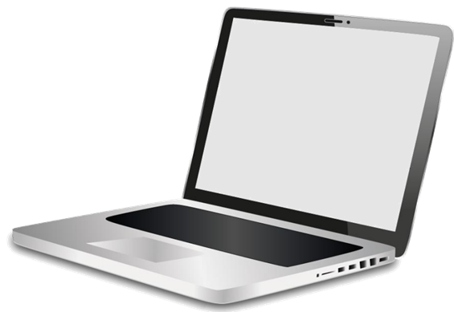 | 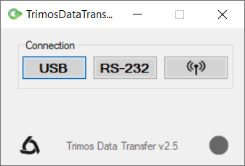
Sending to a USB printer:  The majority of USB printers on the market can be connected to the instrument. Customised reports can be configured directly on the display. This makes it possible to publish results professionally, quickly, easily and without the need for a PC. | 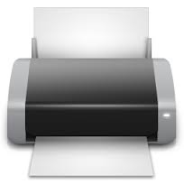 | 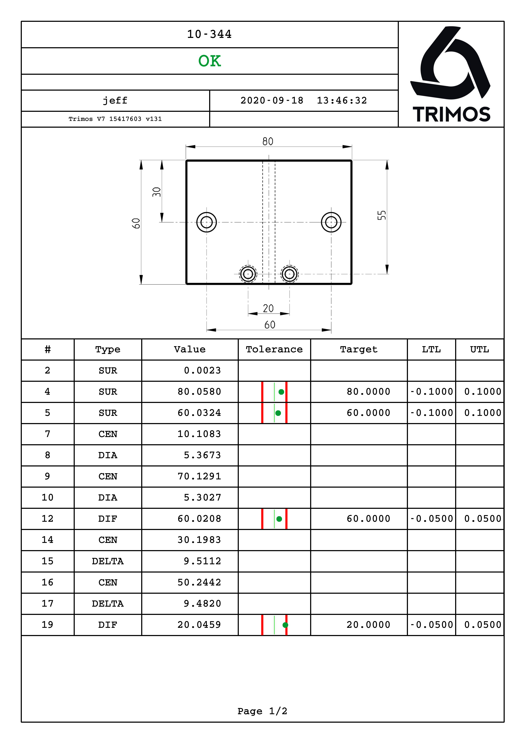
Backup to USB key:  All the data produced by the instrument (measurements, programmes, statistics, perpendicularity, 2D etc.) can be saved on a USB key. This is also the case for measurement reports which are saved in PDF format. The saved files can easily be used with standard PC programs. | 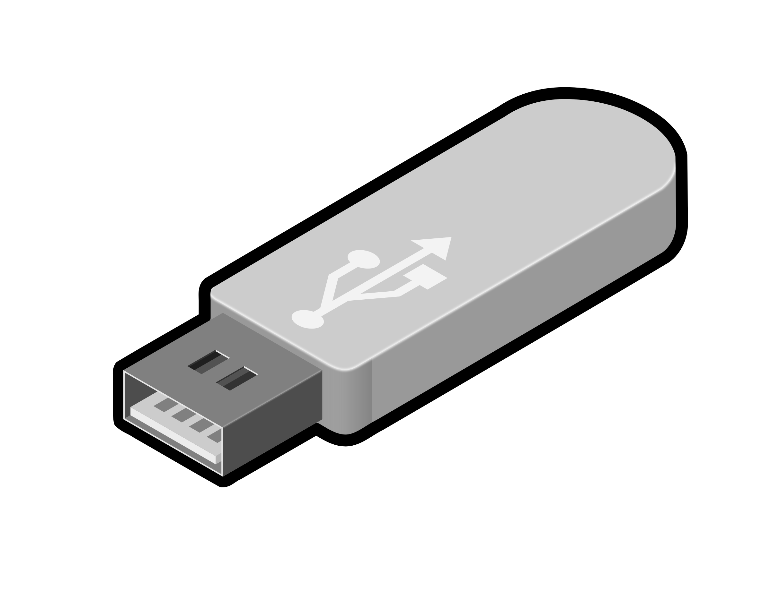
Printing on a thermal printer:  A thermal printer is part of the standard accessories. It is mounted directly on the back of the display as an integral part of the instrument. It allows you to export each measured value one by one. | 

Key Points

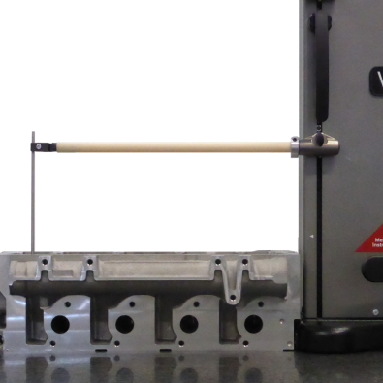 | Long probes  The highly robust construction of the Trimos V7 height gauges allows the use of a wide variety of probes up to 400 mm in length with breathtaking repeatability. Adjustment of the balance to compensate for the weight of the probe is carried out simply by means of a thumbwheel and requires no tools.
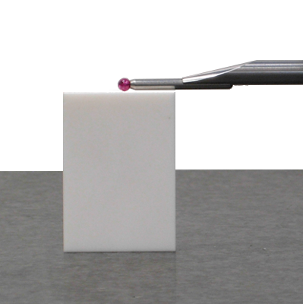 | Accuracy  The V9 have been developed for the most demanding users. Laboratories and workshops for which measurement reliability is crucial will fully appreciate their exceptional level of accuracy.
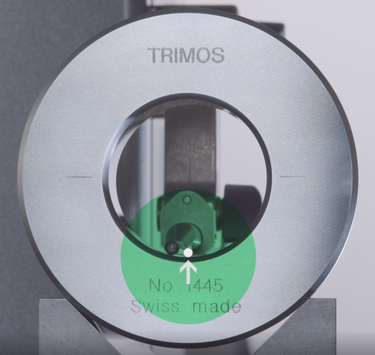 | SmartReverse  SmartReverse technology makes diameter measurement very efficient by clearly indicating the passage of reversal points with audible and visual signals. This provides the user with precise guidance when measuring diameters, resulting in a significant increase in measurement speed and reliability.
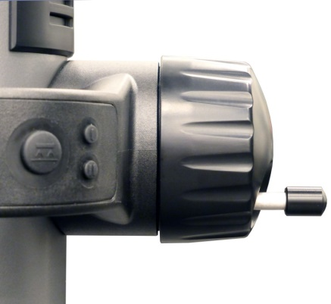  ManuAL  MotoriséD | Manual and motorised movement  The V7 and V9 are equipped with a revolutionary handwheel that allows the user to move the measuring carriage either manually or motorised. Each of these modes is uncompromising, meaning that the user who prefers a manual instrument will not notice any difference compared to a conventional manual instrument, and the same goes for a motorised movement. This innovation avoids making a difficult choice when acquiring an instrument and makes it possible to satisfy multiple potential users of the same instrument.
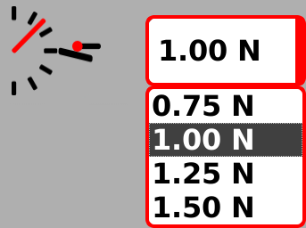 | Electronically adjustable measuring force  The measuring force can become an important criterion depending on the material being measured and in particular its modulus of elasticity. If the material deforms during probing, the measurement result will be affected. For this reason, the measuring force of V7 and V9 can be adjusted with a simple click.

Key Points

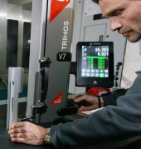 | Ergonomics  Hand tools (calipers or micrometers of all kinds) are designed to be operated with the right hand while holding the piece in the left hand. This natural configuration is found on the Trimos height gauge. The crank handle on the right side of the instrument allows the user to maintain control of the measurement at all times with a comfortable position of the hand on the crank handle. The left hand is dedicated to the movement of the workpiece to be measured. The orientation of the screen ensures perfect readability in all configurations.
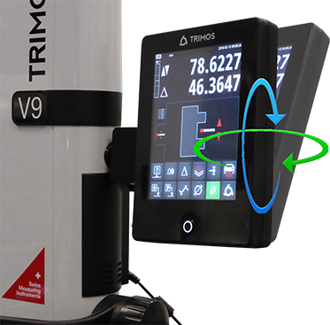 | Adjusting the display position  The display can be rotated in all directions. It has been designed for optimum legibility in all lighting conditions. Clear graphics and information displayed in white on a black background ensure maximum reading comfort. The font size has been chosen for simple, safe and efficient reading of the measurement results.
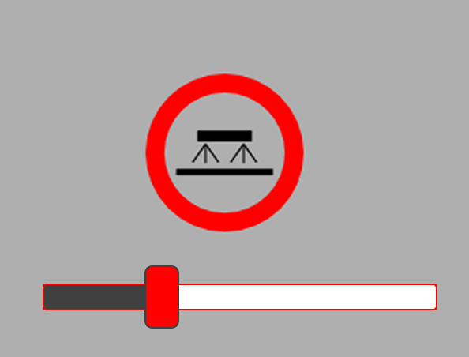 | Air cushion  The air cushion under the base allows the instrument to be moved effortlessly. It is electronically adjustable to suit all types and qualities of measuring tables.
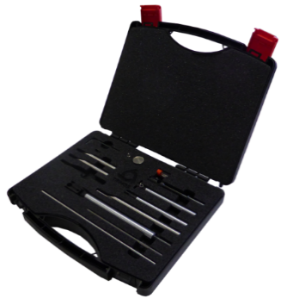 | Accessories  The range of accessories available covers almost all applications. The unique key weight compensation system also allows the use of specific keys up to 400 g.
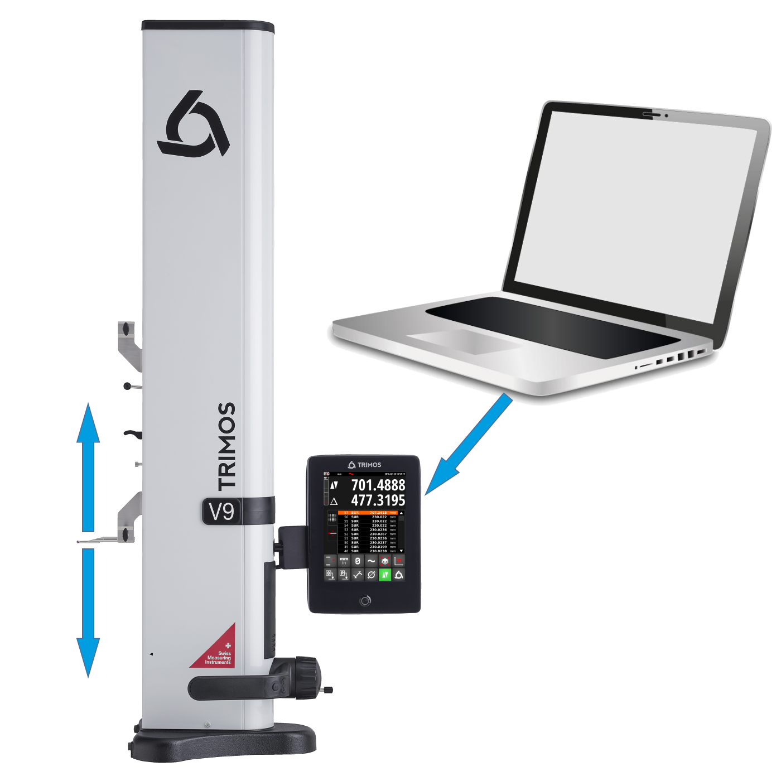 | Remote control  All functions and movements of the instrument can be controlled remotely (wired or wireless). This allows the automation of measuring procedures in the context of high quality requirements.

Technical Data

V7 | 400 | 700 | 1100 | 1800
Measuring range mm (in) | 407 (16) | 711 (28) | 1110 (44) | 1810 (71)
Application range mm (in) | 719 (28) | 1023 (40) | 1422 (56) | 2122 (83)
Max. permissible errors, B_{MPE} µm | 2 + L(mm)/400 |  |  | 2.5 + L(mm)/300
Repeatability, R_{MPE} µm | 1 (Ø: 2)
Perpendicularity deviation (frontal), S_{MPE} µm | 5 | 8 | 11 | 25
Max. resolution mm (in) | 0.0001 (.00001)
Measuring force N | 0.75 ÷ 1.5
Autonomy h | 12
Data output | USB / RS232 / wireless (option)
Air cushion | Yes
Weight kg | 22 | 25 | 34 | 41

The above values have been determined according to ISO 13225 with the standard insert (TA-MI-101).

V9 | 400 | 700 | 1100
Measuring range mm (in) | 406 (16) | 710 (28) | 1109 (43)
Application range mm (in) | 724 (28) | 1028 (40) | 1427 (56)
Max. permissible errors, B_{MPE} µm | 1.2 + L(mm)/1000
Repeatability, R_{MPE} µm | 0.4 (Ø: 1)
Perpendicularity deviation (frontal), S_{MPE} µm | 5 | 8 | 11
Max. resolution mm (in) | 0.0001 (0.00001)
Measuring force N | 0.75 ÷ 1.5
Autonomy h | 12
Data output | USB / RS232 / wireless (option)
Air cushion | Yes
Weight kg | 21 | 24 | 33

The above values have been determined according to ISO 13225 with the standard insert (TA-MI-119).

Functions

- Heights, thicknesses  - Chain dimensions  - Diameters  - Centre distances  - Minimum, maximum  - Flatness  - Perpendicularity  - Zero, Preset  - 9 references  - mm/in  - Calculation between values | - Angles and cones  - Tolerances  - Inversion of measuring direction  - Measurements in 2 coordinates (2D)  - Measurement sequences  - Statistical analysis  - USB, RS232 & wireless data transfer  - Backup to USB key  - Screenshots  - Remote control  - Adjustable measuring force

Quality and Tradition

Almost 50 years ago, Trimos was the first manufacturer to offer height gauges. Today we are proud to still be leaders in the field with innovative solutions at the cutting edge of technology.
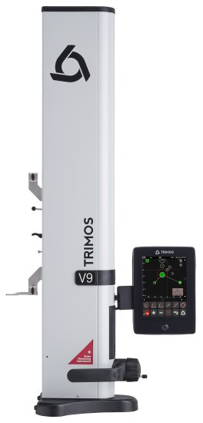

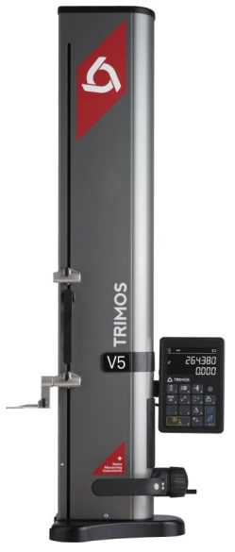
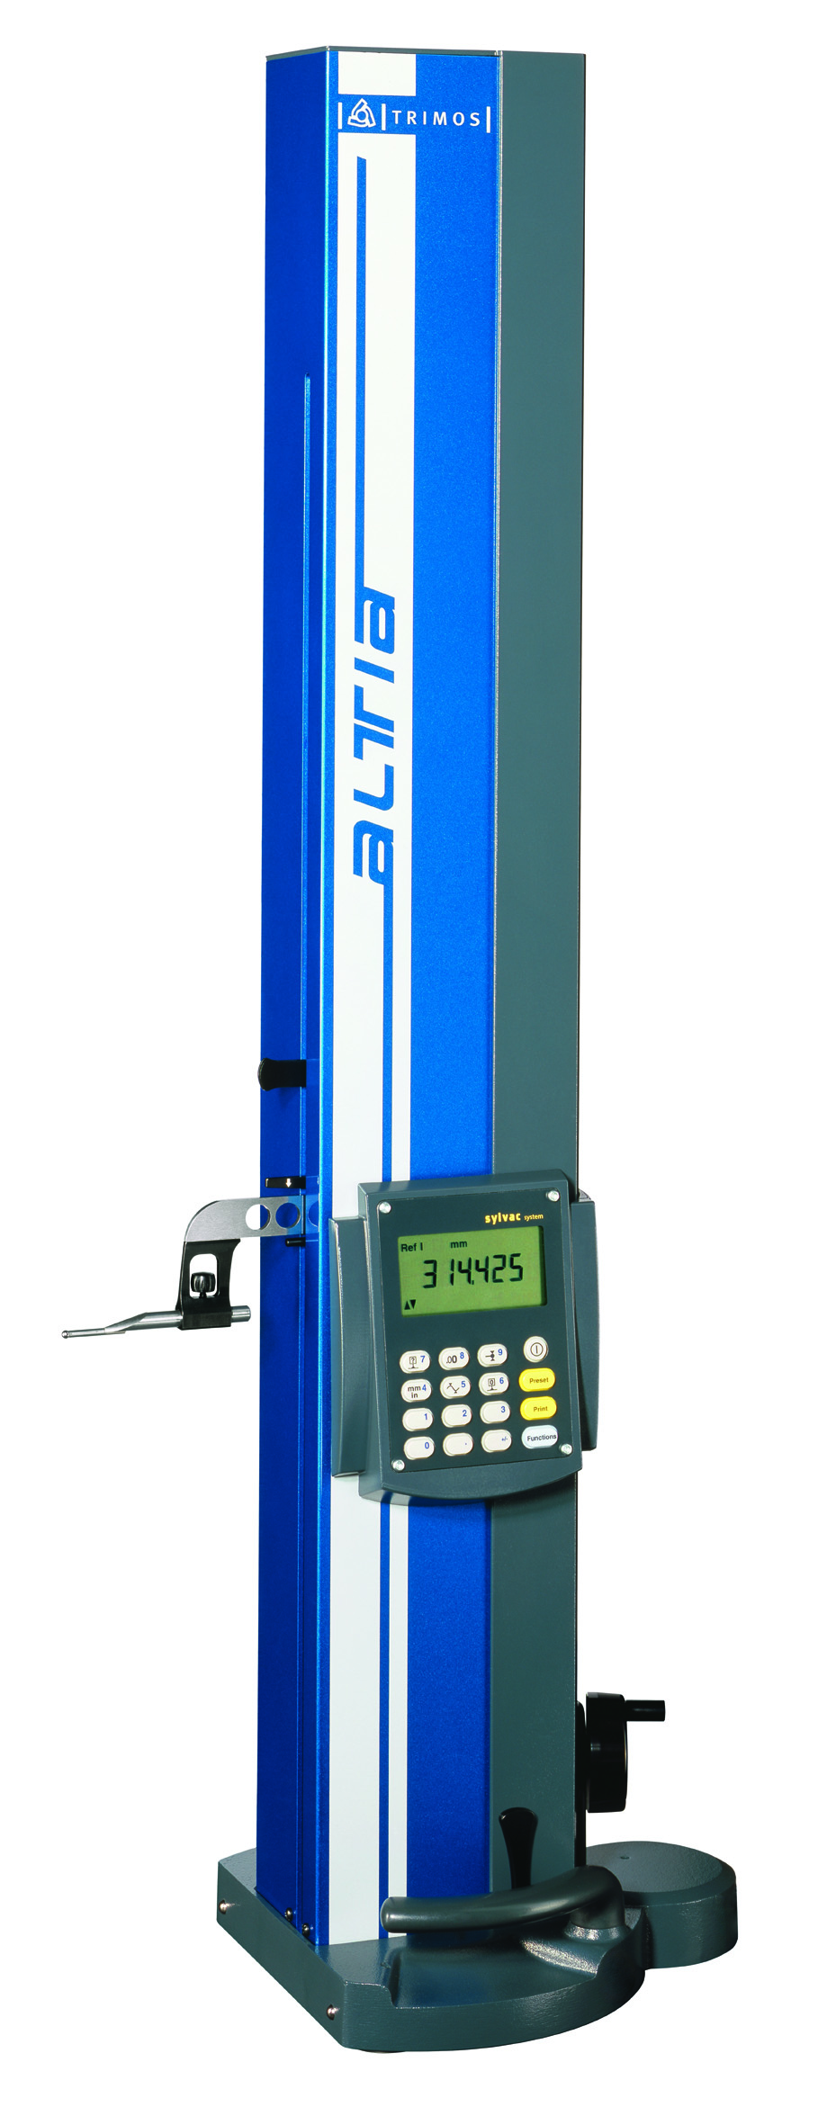

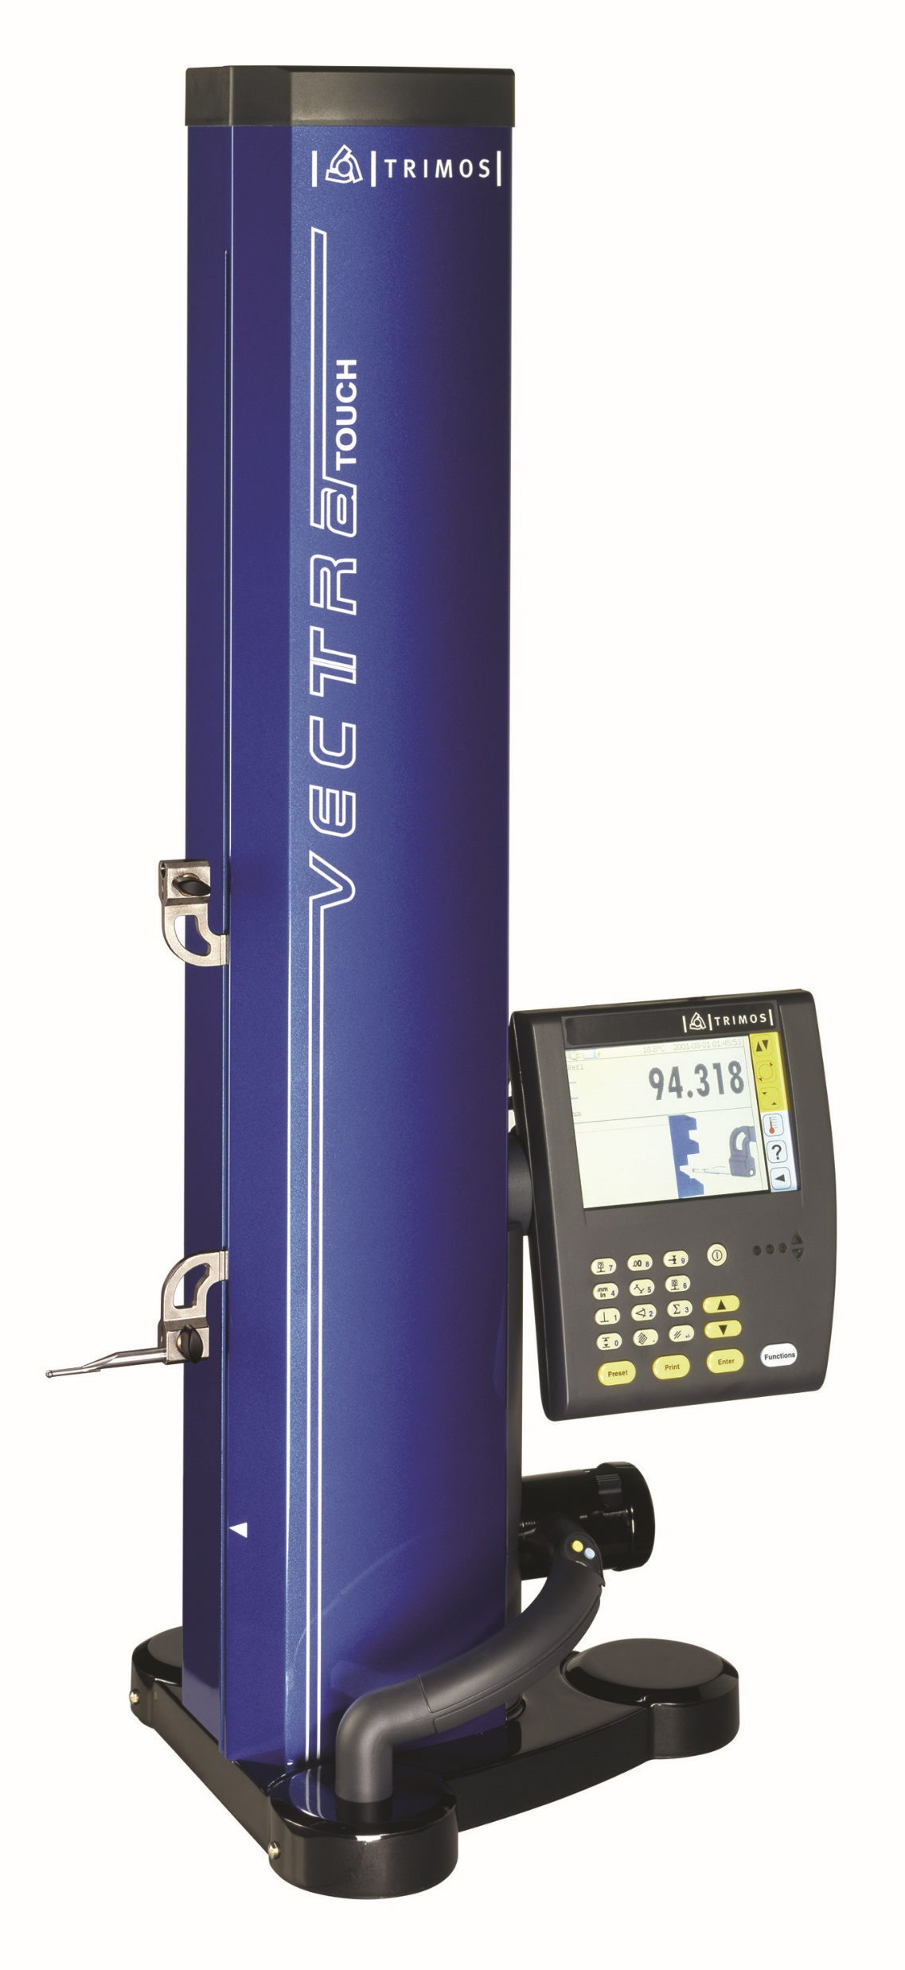
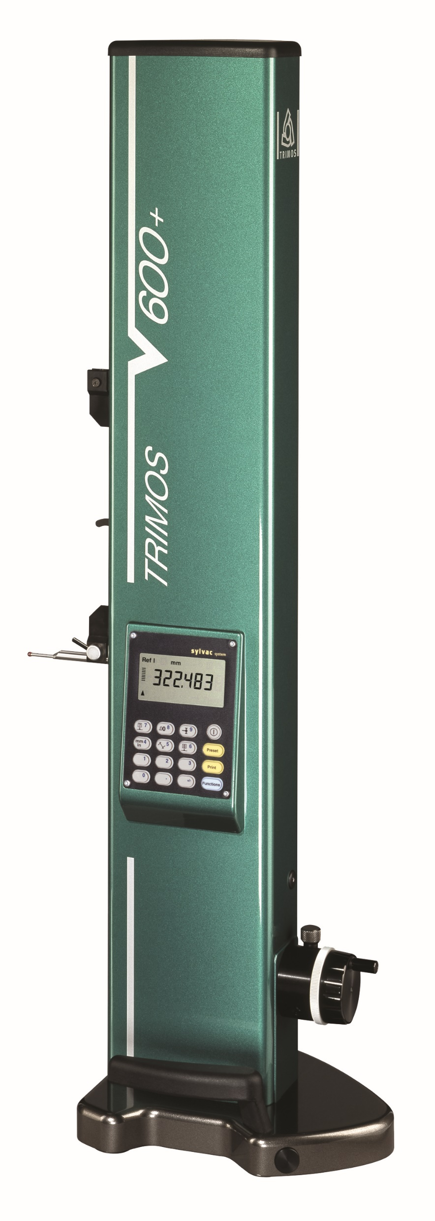
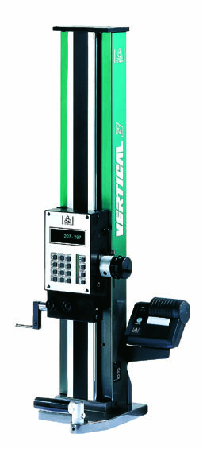
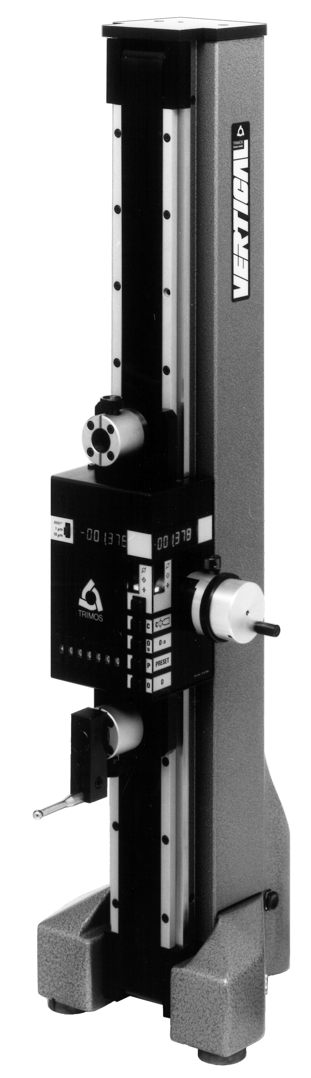
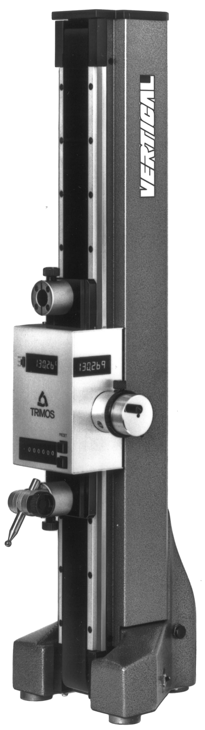

2016
2014
2005
2002
1998
1988
1981
1972

V7 and V9 are part of the 8th generation of height gauges developed by Trimos. By acquiring one of our products, you benefit from all this experience.

Trimos height gauges are designed for the most extreme workshop conditions. They are developed and manufactured in Switzerland in our own workshops on state-of-the-art machining centres. Trimos instruments are built to last for many years. This is why we can offer an unconditional 3-year guarantee.

Our philosophy is to offer products and solutions that help our customers improve their productivity. We achieve this goal by adhering to 3 fundamental principles: ease of use through simple interfaces, reliability through the use of proven components and precision by integrating the best measuring systems.

Thanks to our network of exclusive agents, we are able to offer the following services worldwide:
- Technical support close to you and in your own language
- Training by highly qualified personnel
- Maintenance and repair service far beyond the legal requirements
- Calibration service

Resolutely forward-looking, the latest generation of Trimos height gauge is ready to meet the challenges of the next industrial revolution.


 | www. height-gauge.com
 | V7
 | V9
 | Video
 | www.trimos.com

Trimos S.A.
Av.de Longemalle 5
CH-1020 Renens
T. +41 21 633 01 01
info@trimos.ch
www.trimos.com 750 02 0081 03 – Version 1.0/2020-11 – Changes without prior notice

