Horizon Setting HS5

Setting of Measuring Equipment Manual and Motorized

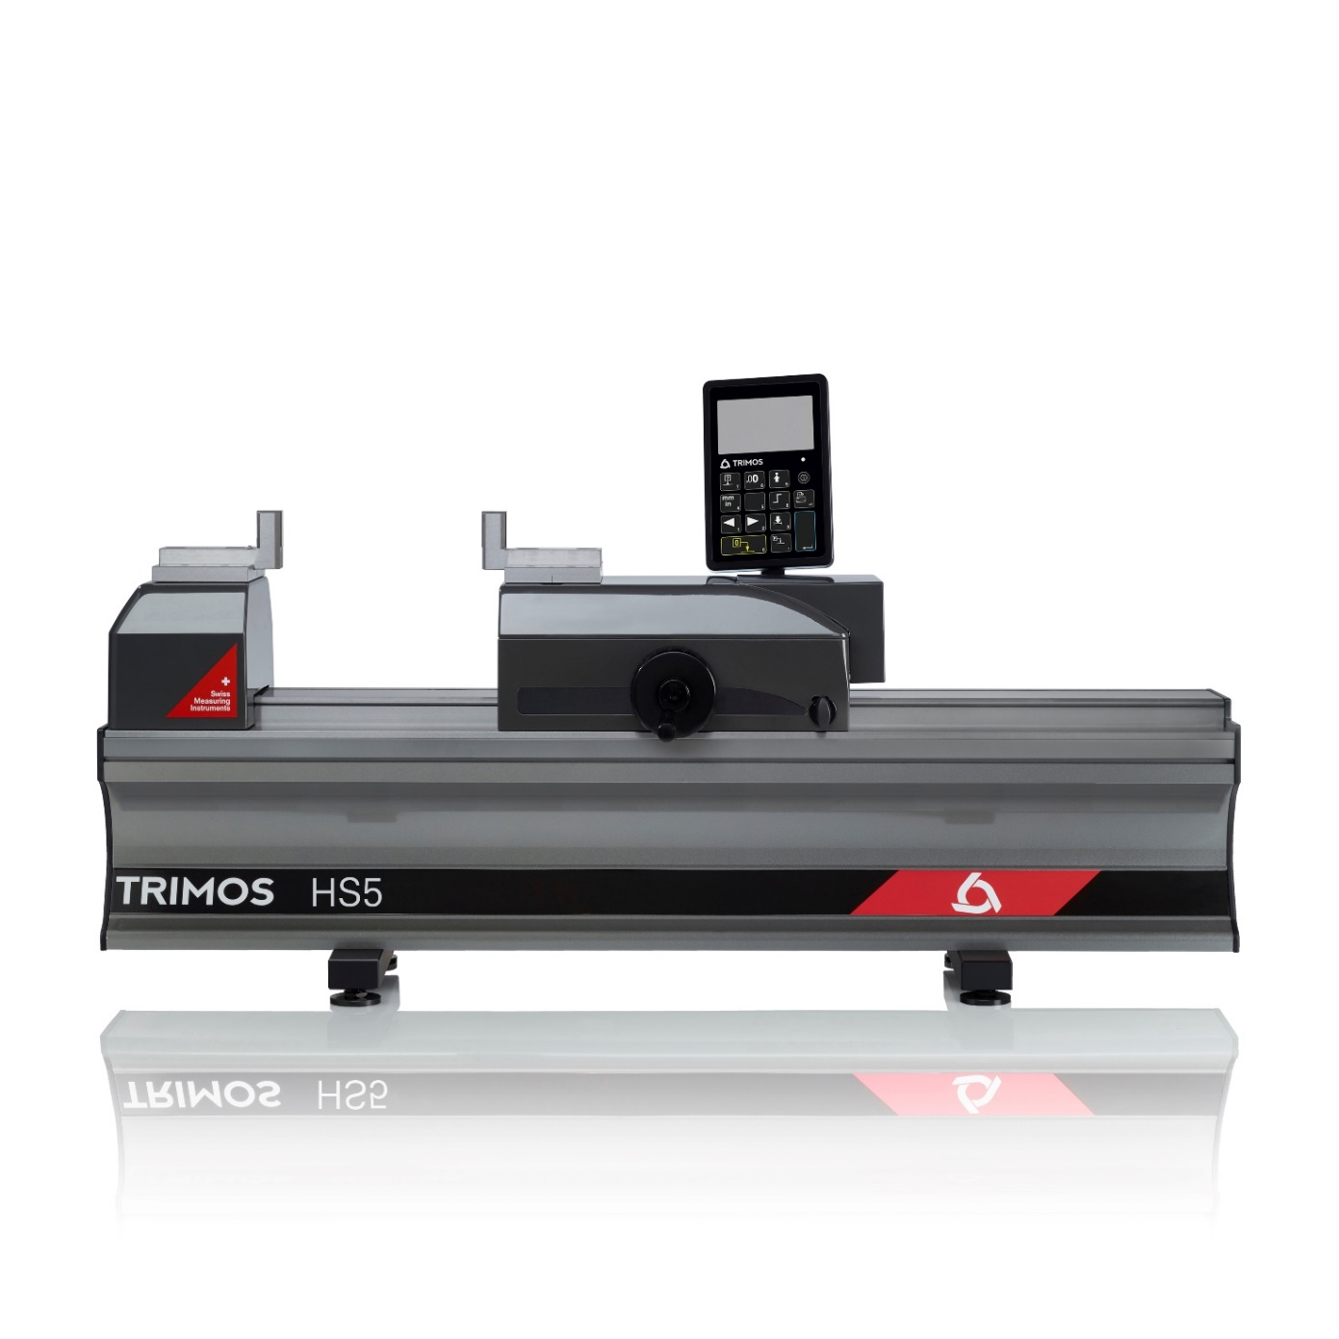
1.
PRESENTATION

This new HS5 is the first of the setting line that can work in manual mode for fast movement or in motorized mode for very precise positioning. The mechanical fine adjustment has been replaced by a motor allowing a very precise servo control.
The HS5 is the ideal instrument for the control and calibration of measuring means with fixed dimensions. Its high precision and finishing level position it as a top of the range model for workshop or laboratory use. It is the perfect answer to current needs in the manufacturing field.

This new model is based on the already well known Trimos Horizon Premium, but a new electronics and innovative display are incorporated. A modern and ergonomic design, as well as a great ease of use guarantee optimal and high productivity measuring results.

Trimos proposes a complete range of instruments from 500 mm to 3000 mm. All measuring ranges are direct, which means that the whole measuring range is available without adjustment or intermediary re-calibration. A large selection of easily interchangeable accessories completes the possible applications and guarantees a correct positioning of the instruments to be calibrated.

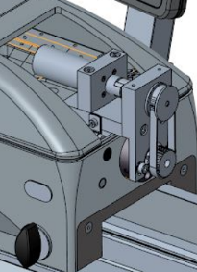
- Delivered with two parallel 25 mm TEL5 gauge blocks insert
- Robust design, ideal for use in workshop
- Very simple use
- Fast and precise checking
- Manual or motorized displacement
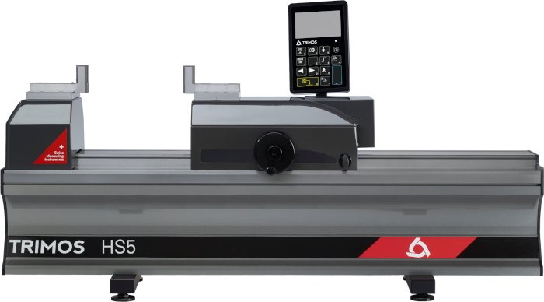
Interchangeable accessories
Digital display with data output

Switch Manual - Motorised

Handwheel for
Displacement and zero setting

2.
SPECIALLY DESIGNED FOR SETTING

- 2 points bore gauges
- 2 points internal and external comparative measuring equipment
- Dial indicators
- Calipers
3.
FEATURES

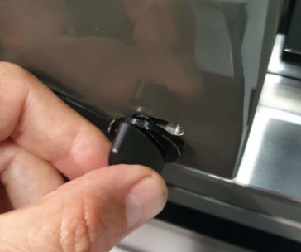  Switch ON/OFF the motor | 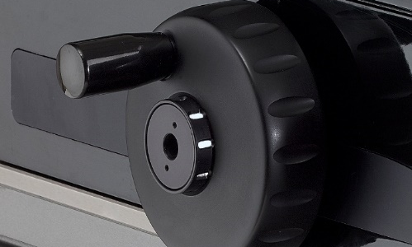  Setting force management with indicator

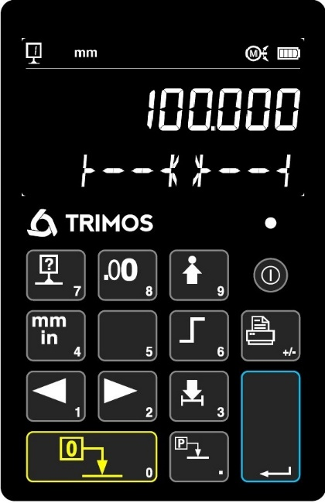
3
4
5
6
7
2
1

Motorised Functions

1. Move to right
2. Move to left
3. Manual or Motorised
4. Motorised range
5. Move to (target)
6. Move by Step
7. Move to Center position

4.
TECHNICAL SPECIFICATIONS

Horizon Setting HS5 | HS5-500 | HS5-1000 | HS5-1500 | HS5-2000 | HS5-3000
Measuring range ¹⁾ mm | 550 | 1050 | 1550 | 2050 | 3050
Max. permissible error ²⁾ µm | 0.7+L/1000
Measuring range motorised mm | 8mm (0, -1mm)
Repeatability (2s) ²⁾ µm | 0.5
Max. resolution mm | 0.0001
Measuring Force (0 setting) N | 15
Interfaces | USB / RS232
Protection IP of measuring system (CEI 60529) | IP67
Weight kg | 94 | 123 | 152 | 181 | 239
Manual Displacement speed max. mm/s | 1.5
Operational temperature °C | +10 ÷ +40
Operational humidity limit % | 20-80
- May vary according to accessory used.
- The values have been measured at a temperature of 20 ± 0.2 °C and relative humidity of 50 ±5%.

5.
APPLICATIONS
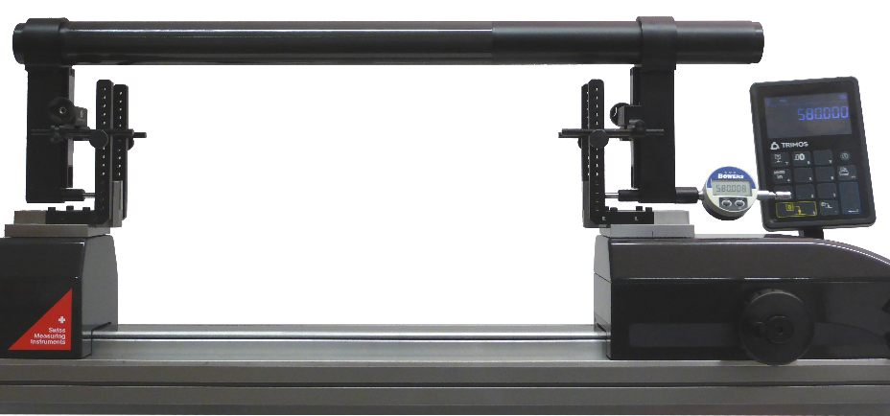 |  | 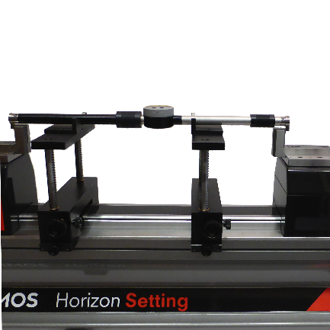
Setting of a large gauge |  | Setting of two points internal and external comparative measuring equipment (TEL5, TELMA7, TELMN7.2)
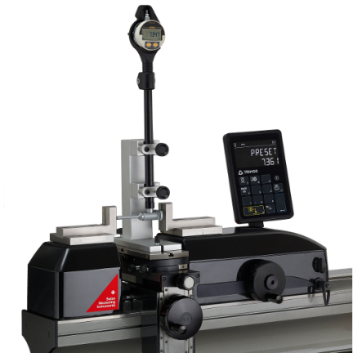 | 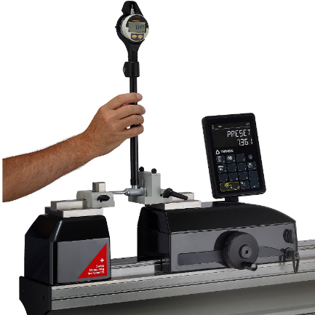 | 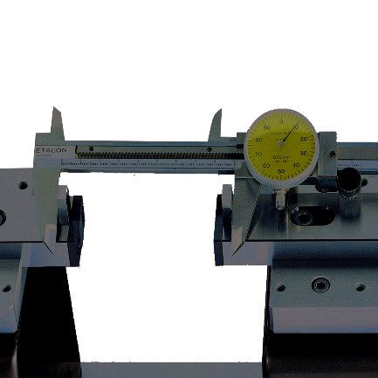
Setting of 2-point bore gauges with holder (TA-SU-313, TA-SU-318, TEL5) | Setting of 2-point bore gauges by hand (TA-SU-301, TEL5) | Checking of calipers (TEL 5.10)
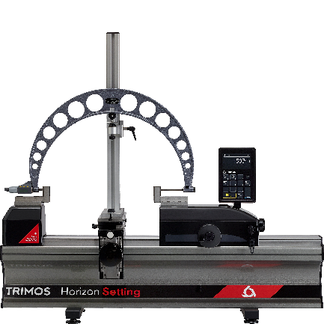 | 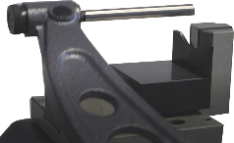  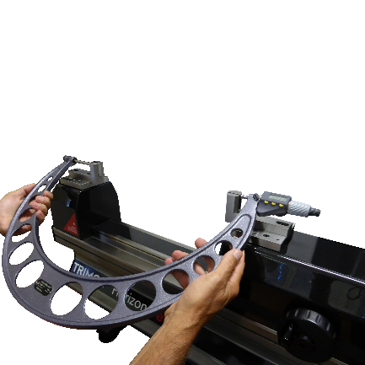 | 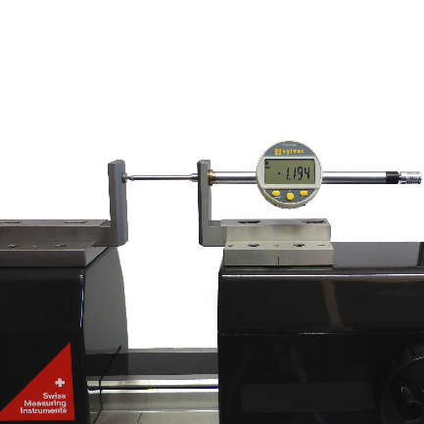
Checking of external micrometer held on a support (TA-SU-313, LABC20.1/SP02, TEL5) | Manually checking of external micrometer (TEL5, TEL11) | Checking of dial indicator  (TEL5CN)
Trimos S.A.
Av.de Longemalle 5
CH-1020 Renens
T. +41 21 633 01 01
info@trimos.ch
www.trimos.com 750 02 0088 03 – Version 1.0/2022-04 – Changes without prior notice

