HC-Line

New Generation of Calibration Instruments

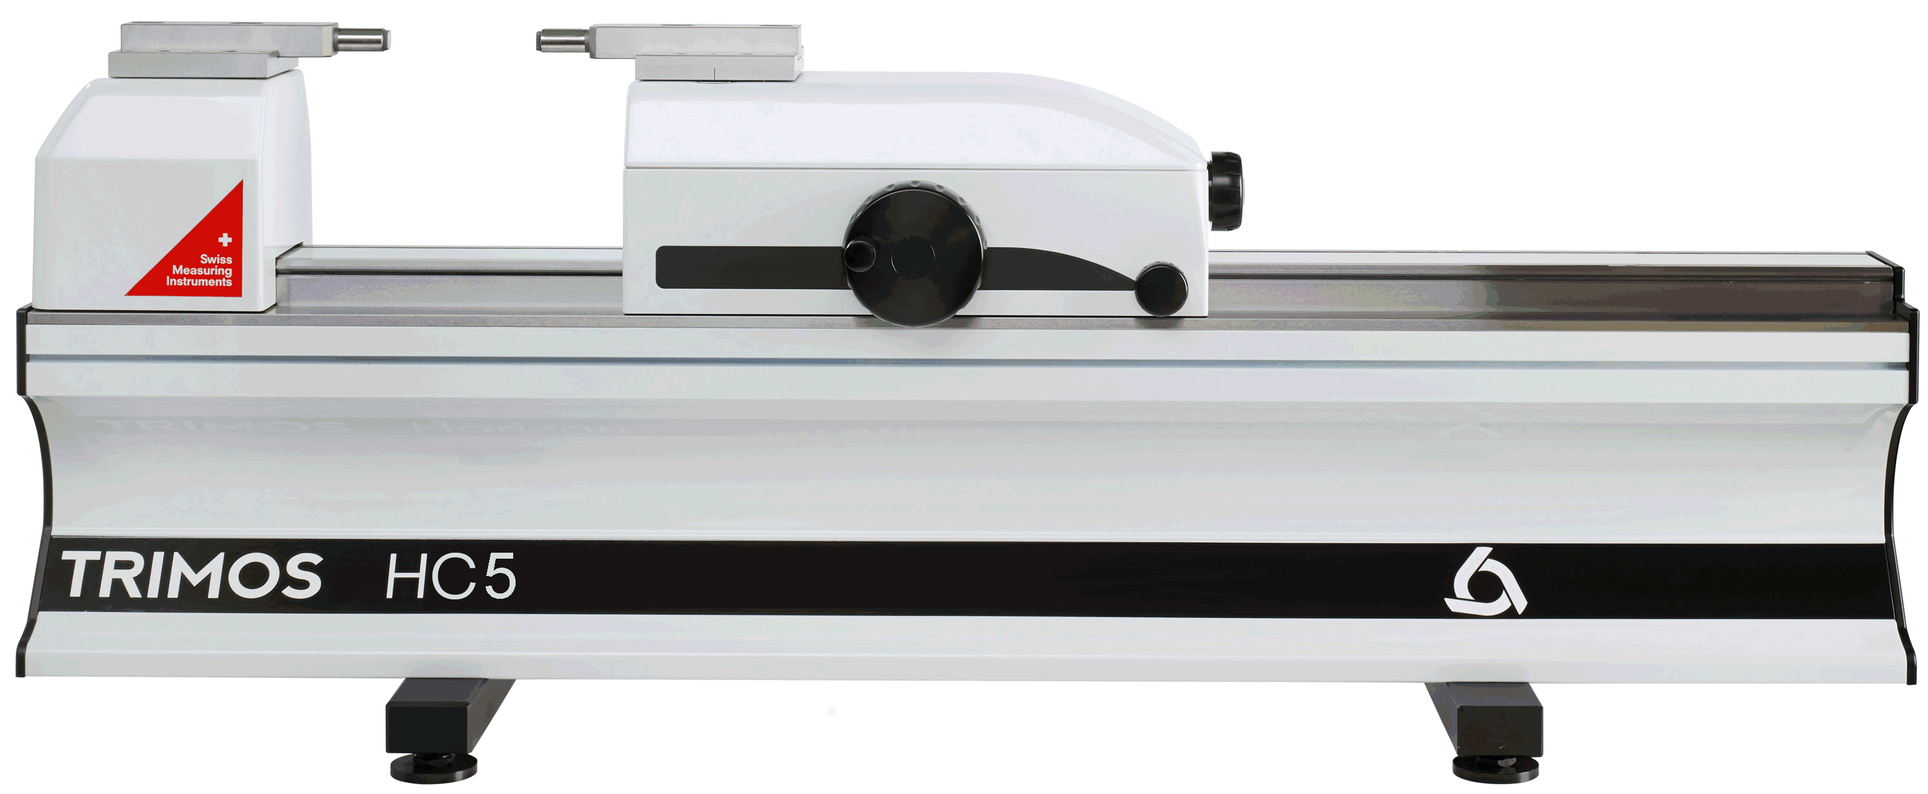

1.
PRESENTATION

The HC-line is designed for the calibration of fixed and variable dimension measuring equipment. The ergonomic design and reliability of these instruments, as well as their accuracy and ease of use, meet the most stringent requirements and increase the productivity of any laboratory.

The instruments are computer controlled. The exclusive WinDHI software makes it easy to perform all measurement functions. A temperature compensation system as well as a gauge inspection software can be installed to complement the performance of the instrument.

Instruments with a measuring range of 300 to 3000 mm are available, all manufactured in one piece. All measuring ranges are direct, i.e. the full measuring range is available without intermediate adjustment or recalibration.

- Quick displacement of the measuring carriage
- Adjustable force from ~1N to ~12N continuously
- Electronic monitoring of the measuring force
- Optical and acoustic indication of the measuring position
- 0.1 µm resolution
- Windows 10 & 11 compatible
- Wide range of display options
- Complies with the requirements of the ISO 9000 standard

HC3 | HC4 | HC5 | Range (mm)
 |  | ∎ | 300
∎ | ∎ | ∎ | 500
∎ | ∎ | ∎ | 1000
∎ | ∎ |  | 1500
∎ | ∎ |  | 2000
∎ | ∎ |  | 3000

2.
APPLICATIONS
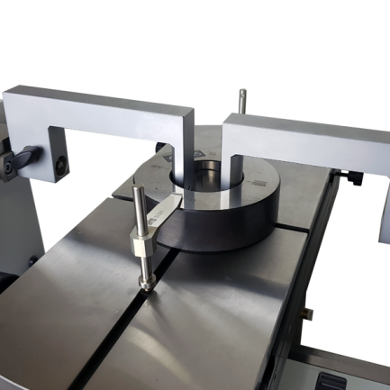 | 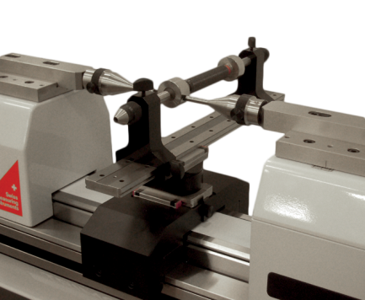 | 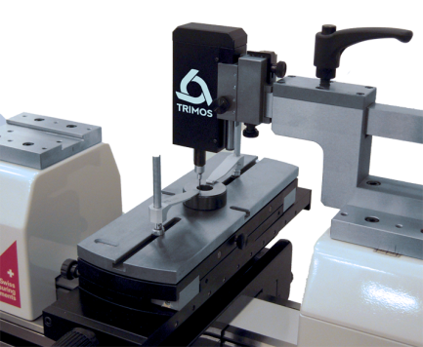
Calibration of plain ring gauges  (TA-SU-313, TA-MI-371, TA-SU-354, HPA-1) | Calibration of plain plug gauges  (HPA-1, TULM6/L05, LABC-15) | Calibration of small plain ring gauges  (TA-SU-313, TA-MS-370, TEL76, TA-SU-354)
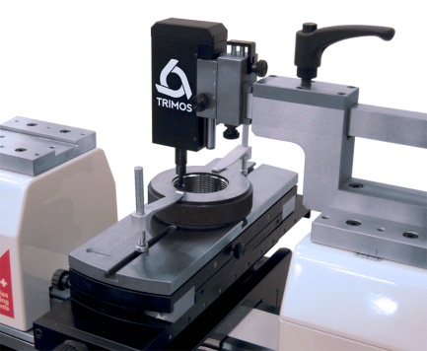 | 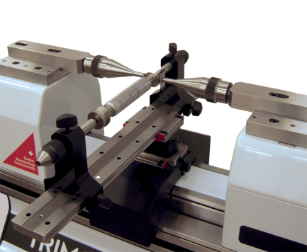 | 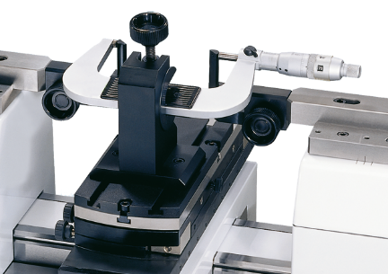
Calibration of threaded ring gauges  (TA-SU-313, TA-MS-370, TA-SU-354, TUML13.2, TA-MS-307) | Calibration of threaded plug gauges  (HPA-1, TEL6, 3P/0.17-3.2 /S6.5, LABC-15) | Calibration of external micrometers  (TA-SU-313, HPA-1, TULM14)
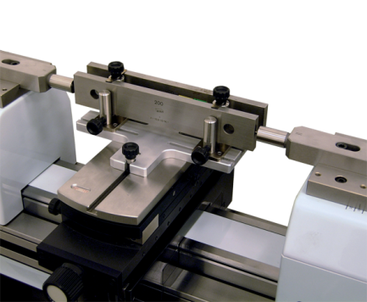 | 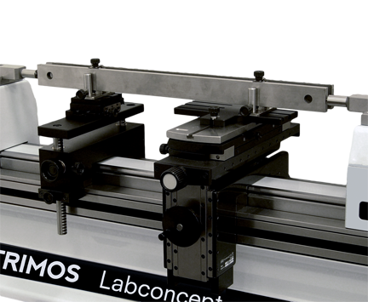 | 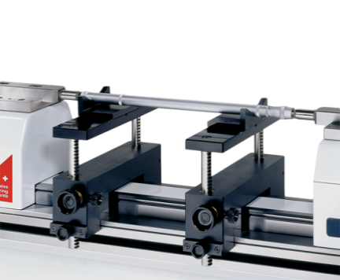
Comparative control of gauge blocks 100 ÷ 250 mm  (TA-SU-313, TA-SU-305) | Comparative control of gauge blocks > 250 mm  (TA-SU-313, TELMA7/P, TA-SU-305, TA-SU-306) | Calibration of 2-point internal micrometers  (HPA-1, TELMA7, TELMN7.2)

3.
TECHNICAL DATA

HC3 | 500 | 1000 | 1500 | 2000 | 3000
Measurement range mm (in) | 550 (20) | 1050 (40) | 1550 (60) | 2050 (80) | 3050 (120)
Maximum permissible errors, B _{MPE}¹⁾ µm | 0.6+L/1200
Repeatability, R_{MPE} (2s) µm | 0.1
Maximal resolution mm | 0.00001
Adjustable measuring force N | 0.3 /^{2,3)} 0.5 / ^{2,3)}1 ÷ 12 ³⁾
Maximum travel speed mm/s | 4000
Operating temperature °C | +10 ÷ +40
Relative humidity % | 20 ÷ 80
Weight kg | 94 | 123 | 152 | 181 | 239

HC4 | 500 | 1000 | 1500 | 2000 | 3000
Measurement range mm (in) | 550 (20) | 1050 (40) | 1550 (60) | 2050 (80) | 3050 (120)
Maximum permissible errors, B _{MPE}¹⁾ µm | 0.3+L/2000
Repeatability, R_{MPE} (2s) µm | 0.1
Maximal resolution mm | 0.00001
Adjustable measuring force N | 0.3 /^{2,3)} 0.5 / ^{2,3)}1 ÷ 12 ³⁾
Maximum travel speed mm/s | 4000
Operating temperature °C | +10 ÷ +40
Relative humidity % | 20 ÷ 80
Weight kg | 94 | 123 | 152 | 181 | 239

HC5 | 300 | 500 |  | 1000
Measurement range mm (in) | 350 (13) | 550 (20) |  | 1050 (40)
Maximum permissible errors, B _{MPE}¹⁾ µm | 0.1+L/2000 |  | 0.15+L/2000
Repeatability, R_{MPE} (2s) µm | 0.05
Maximal resolution mm | 0.00001
Adjustable measuring force N | 0.3 /^{2,3)} 0.5 / ^{2,3)}1 ÷ 12 ³⁾
Maximum travel speed mm/s | 4000
Operating temperature °C | +10 ÷ +40
Relative humidity % | 20 ÷ 80
Weight kg | 78 | 94 |  | 123

1) Values determined at a temperature of 20 ± 0.2 °C and a relative humidity of 50 ± 5 %.
2) With electronic probe
3) Force display in the WinDHI software window only



Trimos S.A.
Av.de Longemalle 5
CH-1020 Renens
T. +41 21 633 01 01
info@trimos.ch
www.trimos.com 750 02 0086 03 - Version 1.1/2203-01 - Changes without prior notice

