ALESTA N

Motorized Setting Bench for Measuring Instruments

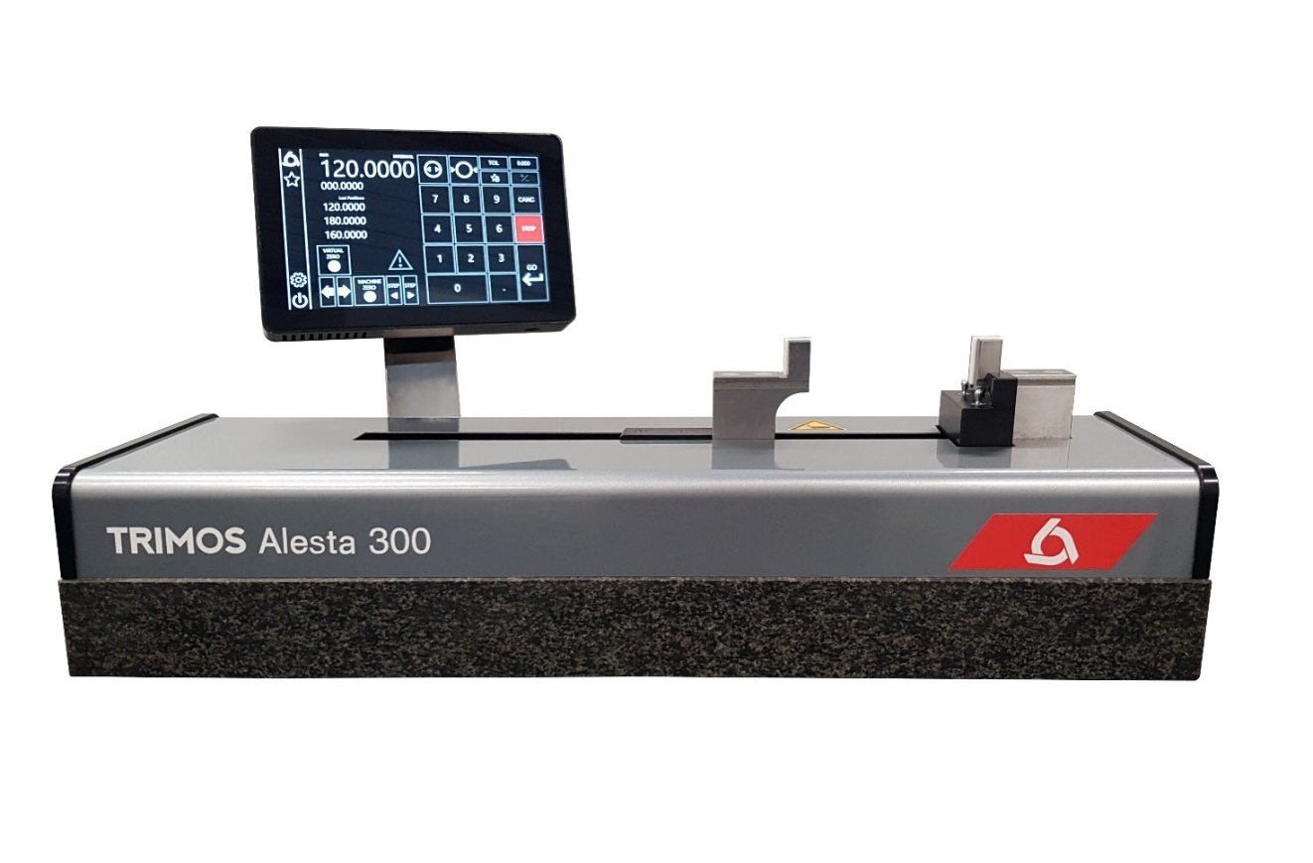

1.
PRESENTATION

Motorized Alesta N is the ideal instrument for the checking and calibration of measuring means with variable dimensions. Its high precision and finishing level position it as a top of the range model for workshop or laboratory use. It is the perfect answer to current needs in the manufacturing field.

This new model is based on the already well known Trimos Horizon Setting line, but a new electronics and innovative color display are incorporated. A modern and ergonomic design, as well as a great ease of use guarantee optimal and high productivity measuring results.

Trimos proposes a complete range of instruments. All measuring ranges are direct, which means that the whole measuring range is available without adjustment or intermediary re-calibration. A large selection of easily interchangeable accessories completes the possible applications and guarantees a correct positioning of the instruments to be calibrated.

Perfect for setting and zeroing gauges in the shopfloor, they can also be used as a calibration machine in compliance to ISO standards.
The adapters ensure objective and precise setting of gages in just a few seconds

- Motorized operativity
- For inside, outside, 2 and 3 points instruments
- No need to buy and recalibrate gage blocks and rings
- Inhouse calibration of instruments
- Time for setting operation reduced by 90%
- List of preset values for recall – optional bar code scanner
- Connectivity and interface via USB and Ethernet
- Adapters of ALESTA version compatible
Digital display with data output

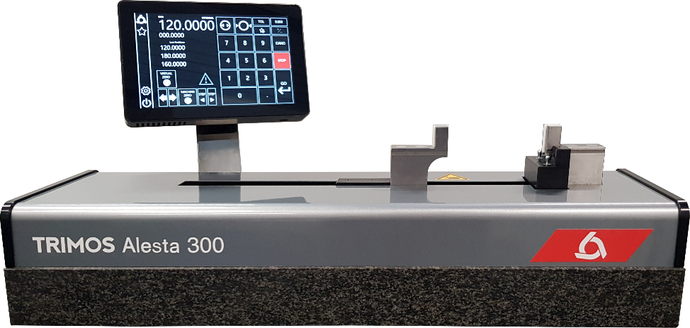
Fine adjustment carriage

Dimensionally stable instrument base, positioned on three level points

2.
SPECIALLY DESIGNED FOR SETTING

- 2 points bore gauges
- 2 points internal and external comparative measuring equipment
- Dial indicators
- Calipers
3.
FEATURES

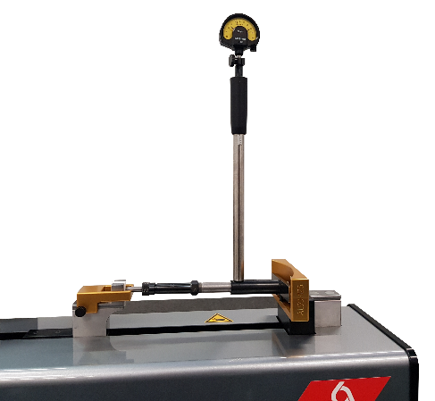 | 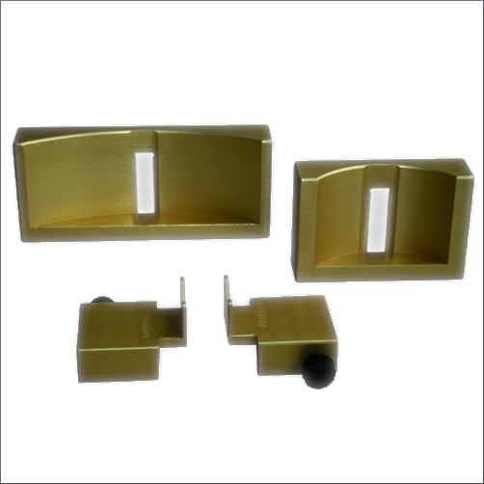 | 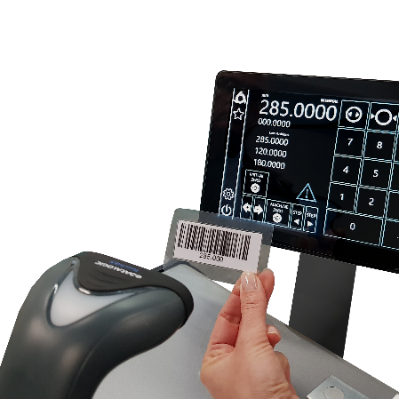
Setting of two-point bore gauges | Wide range of adapters to fit most two-point bore gauges and garantee of easy/quick setting | Datalogic Bar-code device to speed up the input of setting values
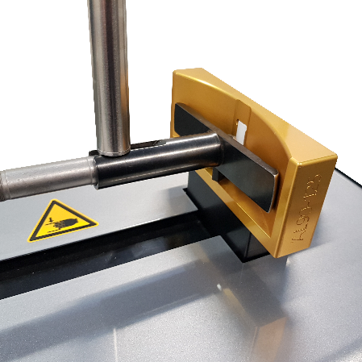 | 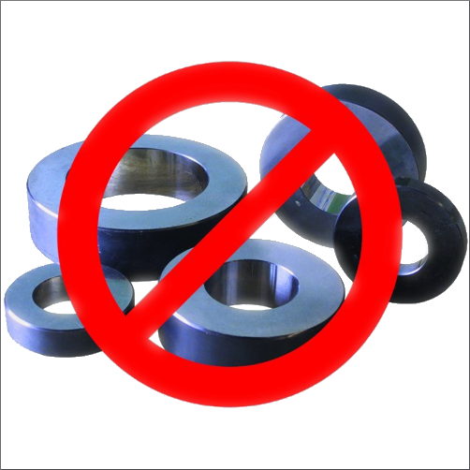 | 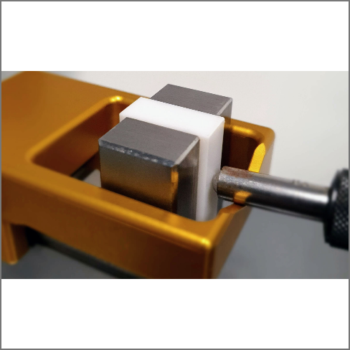
Interchangeable accessories | No need to have a lot of different setting rings. | Ceramic gauges block
4.
TECHNICAL SPECIFICATIONS

Alesta N | 300 | 600 | 1000
Application range (external measurements) mm (in) | 300 (12) | 600 (23) | 1000 (40)
Application range (internal measurements) mm (in) | 40 ÷ 340  (1.6 - 13) | 40 ÷ 640  (1.6 - 23) | 40 ÷ 1040  (1.6 - 41.5)
Max. permissible errors ¹⁾ µm | 1.5 + L(mm)/500
Repeatability (2s) ¹⁾ µm | 0.8
Resolution mm (in) | 0.0001 (.000001)
Interfaces | ETHERNET and USB
Operational temperature °C | 20±1
Temperature of storage °C | -10 ÷ +40
Weight kg | 80 | 140 | 360
1) Values valid at temperature of 20±0.2 °C and relative humidity of 50±5%.

Trimos S.A.
Av.de Longemalle 5
CH-1020 Renens
T. +41 21 633 01 01
info@trimos.ch
www.trimos.com 750 02 0089 03 – Version 1.0/2023-03 – Changes without prior notice

