ScanSurf80
3D Scanner Laser

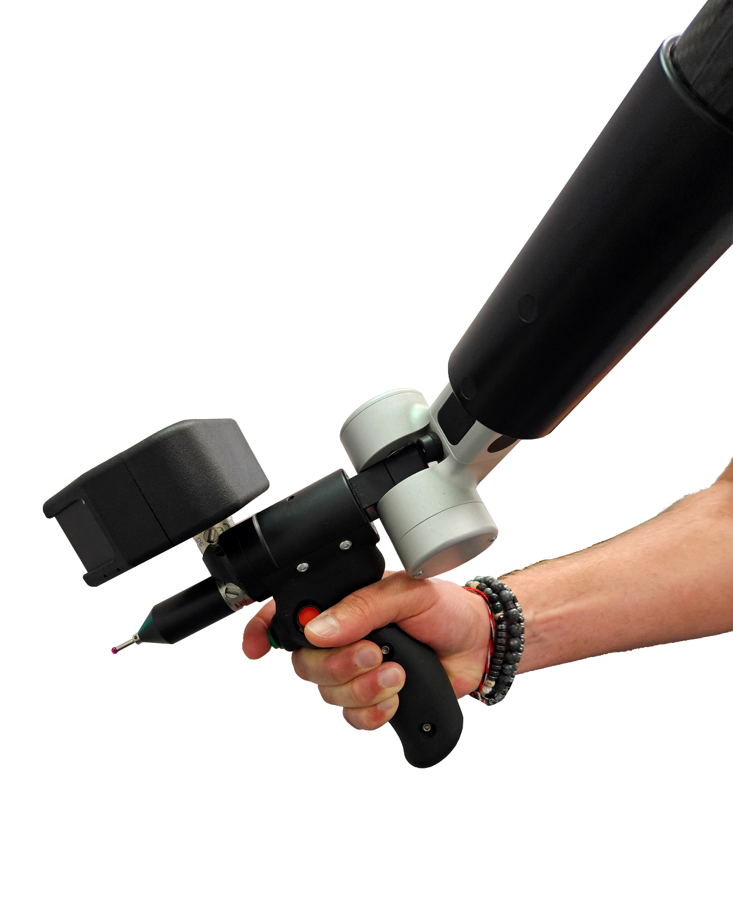
The perfect price/performance compromise

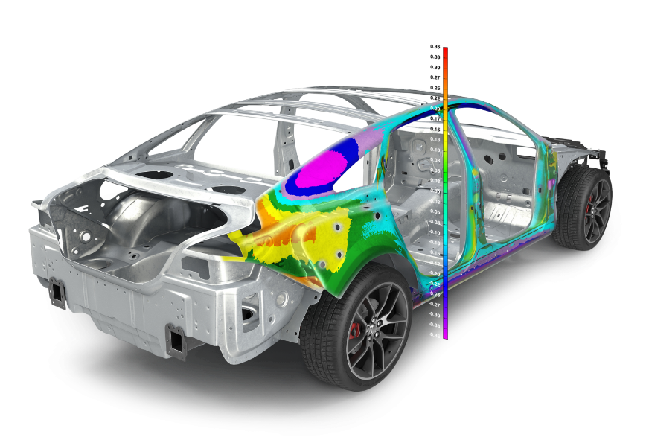
PolyWorks│InspectorTM image courtesy of InnovMetric software
1.
PRESENTATION
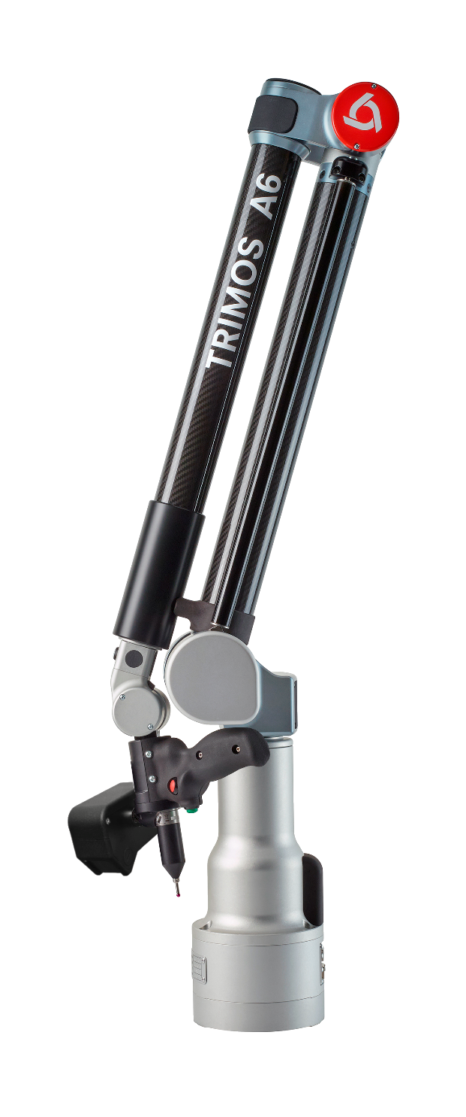
The Trimos ScanSurf80 laser scanner, the ultimate solution for scanning measurements and reverse engineering.

This high-performance laser scanner provides very high measurement resolution and stability at high speeds of up to 6 kHz, thanks to high-quality height 2048 points per profile and are characterized by high resistance to stray light.

Ergonomy
The ScanSurf scanner is optimized to be mounted on a Trimos Articulated Arm reducing at most the bulk and the weight on the holding axis. The laser scanner above the 6th axis makes the use of the tactile probe more comfortable.

Accurate
The ScanSurf80 offers an exceptional balance of price and accuracy, positioning his performance in the top choice in the entry-level market.

Always ready
With the ScanSurf Scanner there's no need to apply any change from probe to scanner and vice versa. In fact, the probe is mounted on an additional autojoint connector to be always ready for tactile measurements when needed.

Versatile selection
The scanner features BLUE light technology, with a line length covering up to 110 mm, making it suitable for any surface and a wide range of application.

- Compatibility with the 7 axis A6 model
- Shock and vibrations resistant
- Light and compact
- Renishaw Autojoint connector
- Pointer laser
- Ideal price / performance compromise
- Third party software compatible and easy integration

2.
TECHNICAL SPECIFICATIONS

ScanSurf 80
Measuring range X mm | 50…110
Working range Z mm | 83…213
Max. points acquisition rate pt/s | 350’000
Max. Points per line (PPL) | 2048
Resolution in X µm | 26…55 (>2000 points)
Resolution in Z µm | 3.2…14
Linear accuracy µm | 32.5
Laser color | Blue (405 nm)
Connection interface | Renishaw Autojoint
A-Line Measuring Arm compatibility | A6
Communication | Ethernet TCP/IP
Laser class | 2M
Ingress Protection | IP 67
Operational Temperature °C | +0 ÷ +45
Stocking Temperature °C | -20 ÷ +70
Operational Humidity % | +5…+95 without condensation
Dimensions mm | 133 x 93 x 38
Weight Kg | 0.45
Software compatibility | PolyWorks|Inspector™ & PolyWorks|Modelor™
Power supply VDC | 18…30
CEM requirements | DIN EN 61000-6-2, 61000-6-4

ScanSurf80 scanning accuracy ScanSurf80 scanner laser measuring range
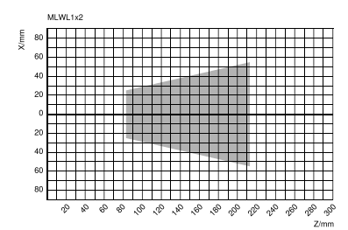
A6 arm measuring range | Accuracy
1800 mm | 0.045 mm
2500 mm | 0.050 mm
3200 mm | 0.058 mm
4000 mm | 0.067 mm
5000 mm | 0.083 mm
7000 mm | 0.112 mm
9000 mm | 0.180 mm

Z = working distance
X = working range


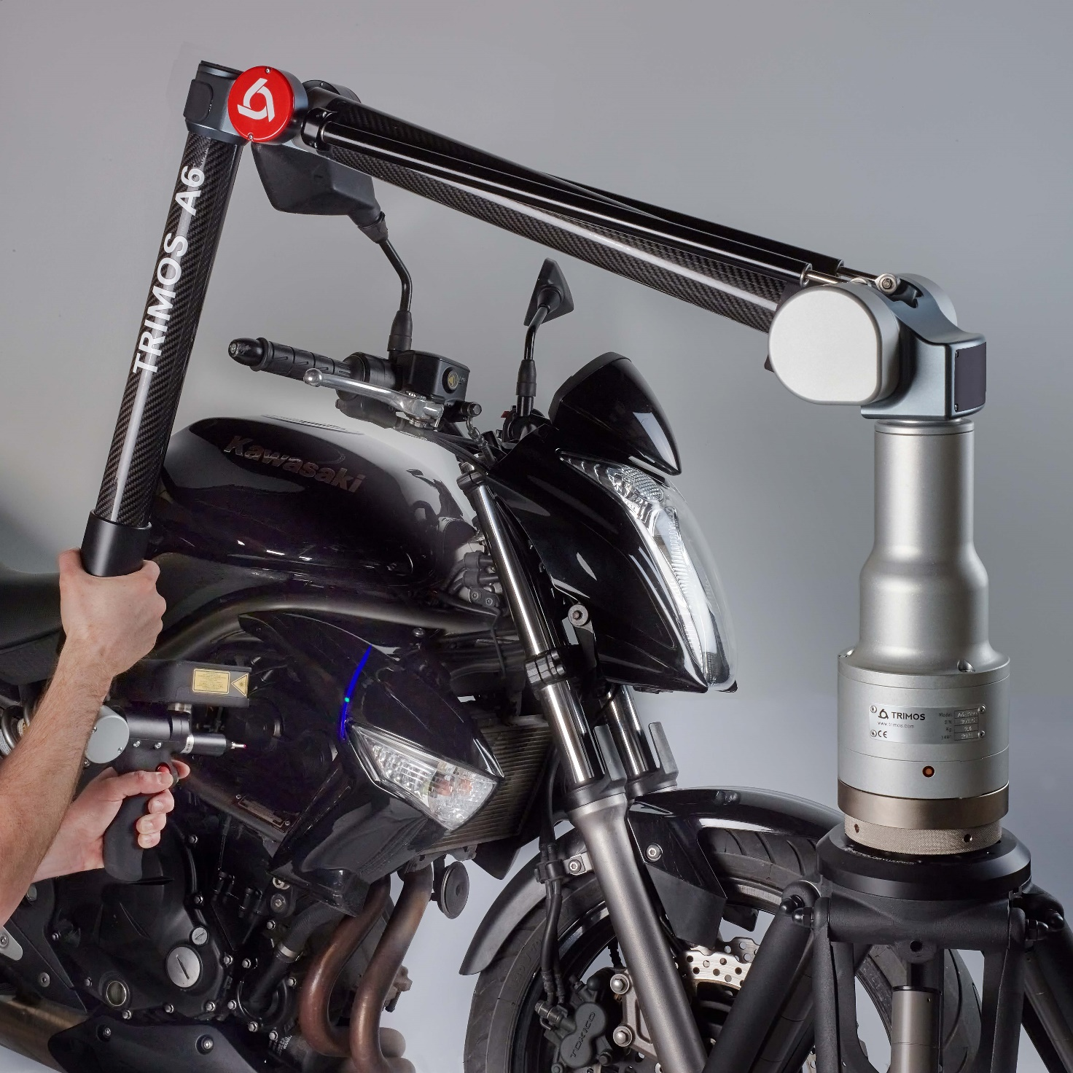



Trimos S.A.
Av.de Longemalle 5
CH-1020 Renens
T. +41 21 633 01 01
info@trimos.ch
www.trimos.com 750 02 0087 03 – Version 2.1/2024-10 – Changes without prior notice

