Horizon Setting HS6

Setting of Measuring Equipment with Variable Dimensions

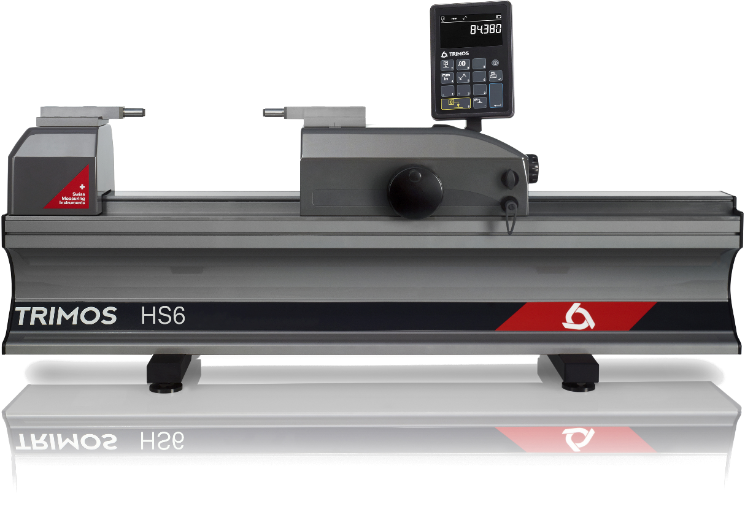

1.
PRESENTATION

Horizon Setting Plus is the ideal instrument for the control and calibration of measuring means with fixed and variable dimensions. Its high precision and finishing level position it as a top of the range model for workshop or laboratory use. It is the perfect answer to current needs in the manufacturing field.

This new model is based on the already well known Trimos Horizon Premium, but a new electronics and innovative display are incorporated. A modern and ergonomic design, as well as a great ease of use guarantee optimal and high productivity measuring results.

Trimos proposes a complete range of instruments from 500 mm to 3000 mm. All measuring ranges are direct, which means that the whole measuring range is available without adjustment or intermediary re-calibration. A large selection of easily interchangeable accessories completes the possible applications and guarantees a correct positioning of the instruments to be calibrated.

- Delivered with two standard anvil HPA-1
- Robust design, ideal for use in workshop
- Very simple use
- Fast and precise checking
- Works on battery or power supply
- 3N measuring force

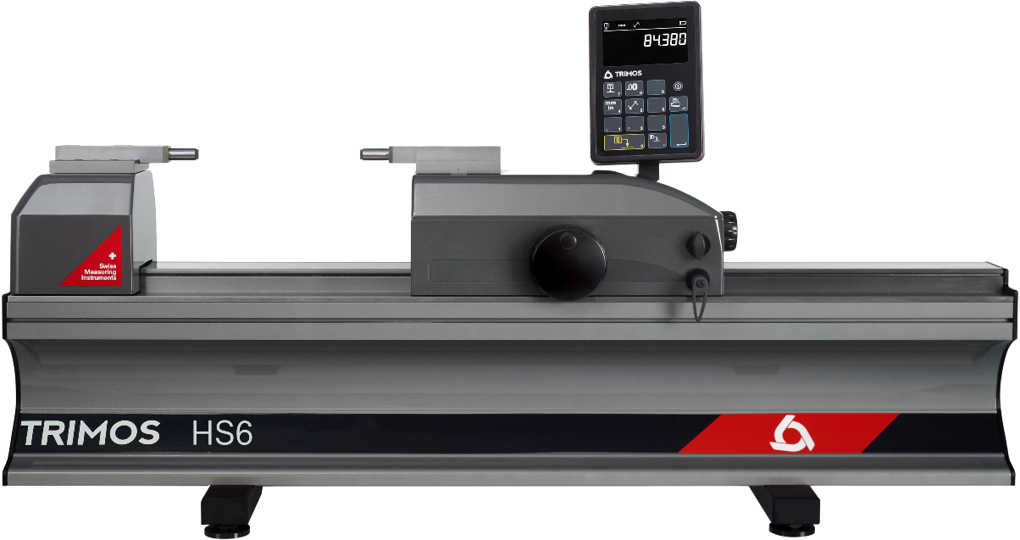
Locking device for fine measuring carriage
Interchangeable accessories
Digital display with data output
Dimensionally stable instrument base, positioned on three level points

Fine adjustment carriage

Locking device for main carriage

Handwheel for displacement of measuring carriage

Measuring Force Indicator

Internal measurement (3N)

External measurement (3N)

2.
SPECIALLY DESIGNED FOR SETTING AND CHECKING

- 2 points bore gauges
- 2 points internal and external comparative measuring equipment
- Dial indicators
- Calipers
- Setting of 2 points internal micrometers
- Checking of ring gauges
- Checking of plug gauges
- Checking of thread plug gauges
- Checking of snap gauges
- Checking of external micrometers

3.
FEATURES

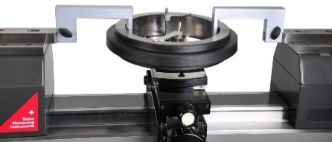
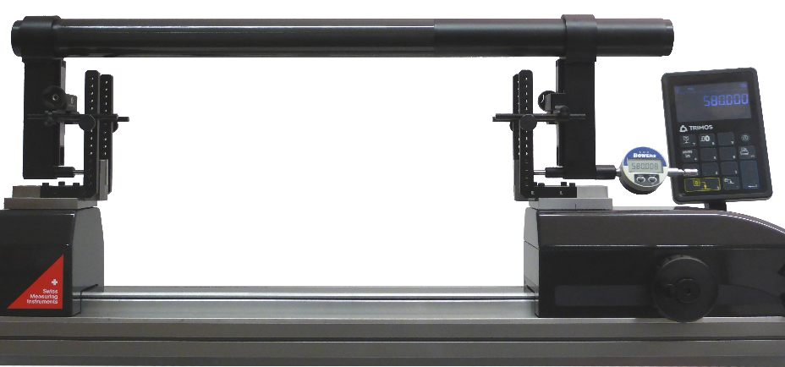
Setting of a large gauge | Checking of ring gauges from 12mm

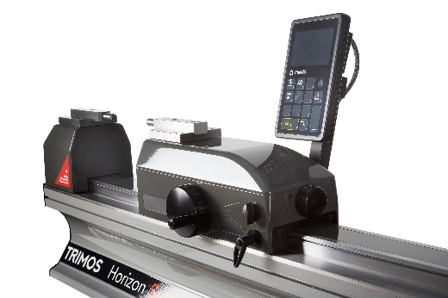 | 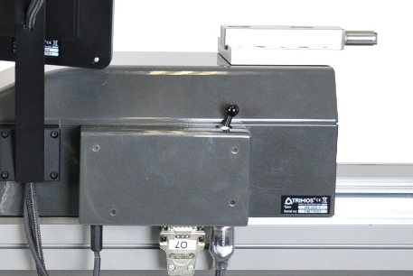
Two locking devices to hold the carriage

4.
TECHNICAL SPECIFICATIONS
Horizon Settings Plus HS6 | HS6-500 | HS6-1000 | HS6-1500 | HS6-2000 | HS6-3000
Part number | 700 216 10 51 | 700 216 20 51 | 700 216 30 51 | 700 216 40 51 | 700 216 60 51
Measuring range ¹⁾ mm (in) | 550 (21) | 1050 (41) | 1550 (61) | 2050 (80) | 3050 (120)
Max. permissible error ²⁾ µm | 0.7+L(mm)/1000
Repeatability (2s) ²⁾ µm (in) | 0.2 (.000008)
Max. resolution mm (in) | 0.0001 (.00001)
Displacement speed max. mm/s | 1500
Measuring force N | 3N
Operational temperature °C | +10 - +40
Operational humidity limit % | 20 - 80
Weight kg | 94 | 123 | 152 | 181 | 239

5.
APPLICATIONS
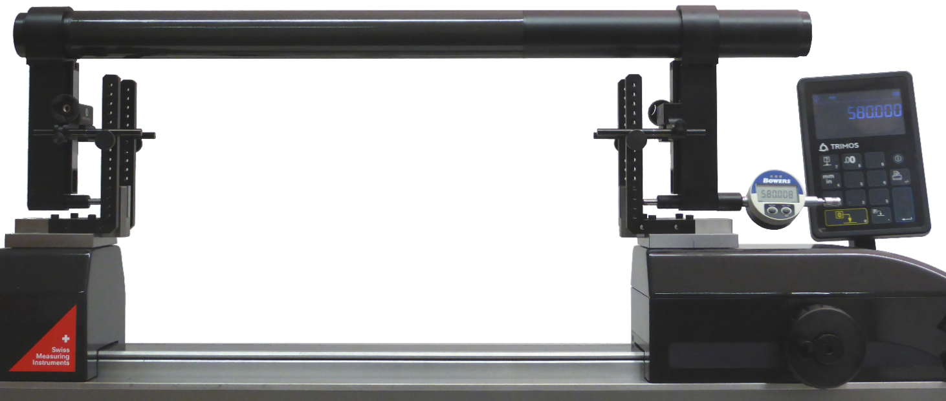

Setting of a large gauge

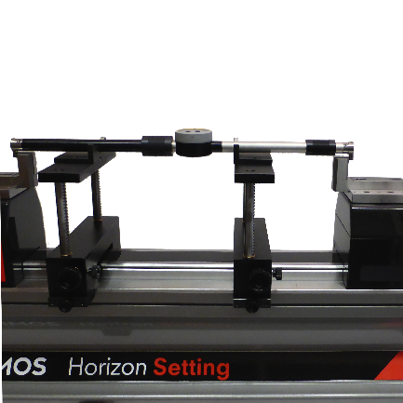  Setting of two points internal and external comparative measuring equipment  (TEL5, TELMA7, TELMN7.2) | 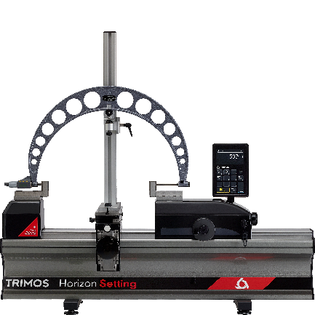  Checking of external micrometer held on a support  (TA-SU-313, LABC20.1/SP02,TEL5)
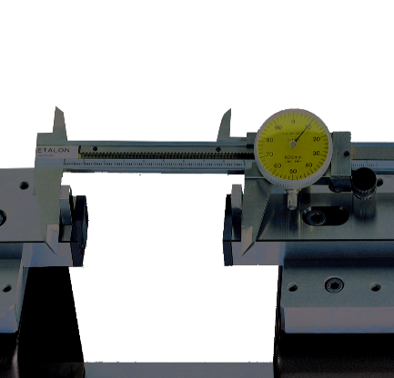  Checking of calipers  (TEL 5.10) | 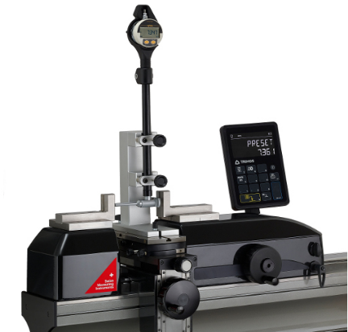  Setting of 2-point bore gauges with holder  (TA-SU-313, TA-SU-318, TEL5)
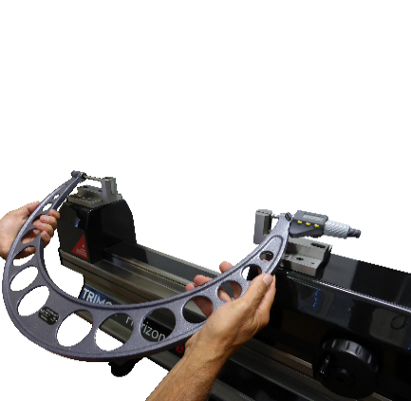  Manually checking of external micrometer  (TEL5, TEL 11) | 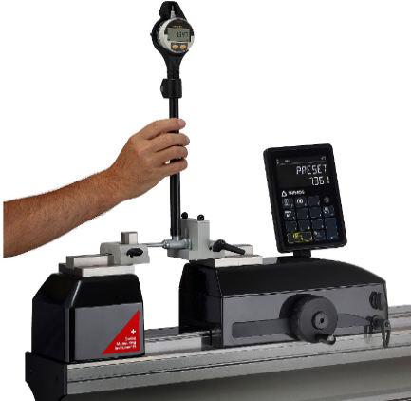  Setting manually of 2-point bore gauges  (TA-SU-301, TEL5)

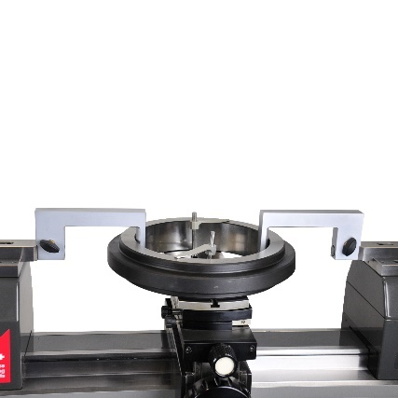  Checking of ring gauges  (TA-SU-313, TA-MI-370, TA-SU-304) | 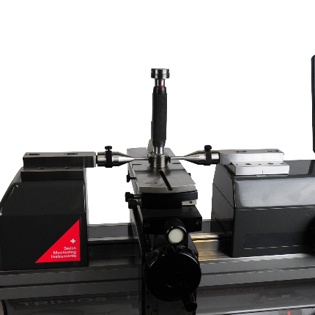  Checking of thread plug gauges (from m100 upwards)  (TA-SU-313, TEL6, 3P/0.17-3.2/S6.5)
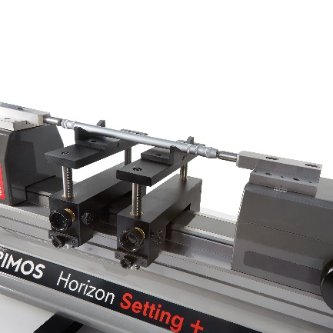  Setting of 2-point internal measuring equipment  (TELMA7) | 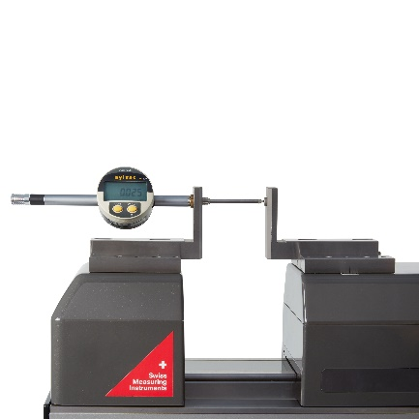  Checking of dial indicators and comparators  (TEL 5CN)
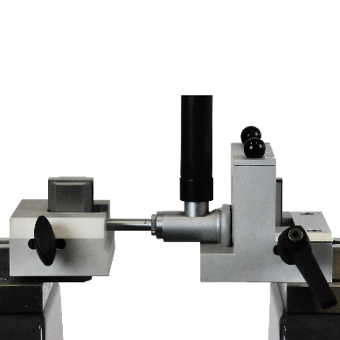  Setting of 2-point bore gauges  (TA-SU-301, TEL5) | 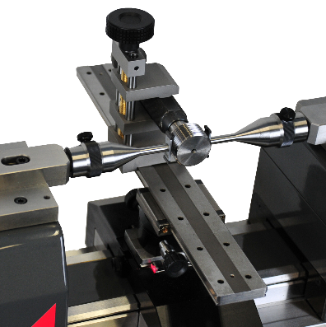  Checking of thread plug gauges  (max. M100/ø 4’’,  length 280 mm/11’’)  (TEL6, 3P/ 0.17-3.2/ S6.5, LABC15)

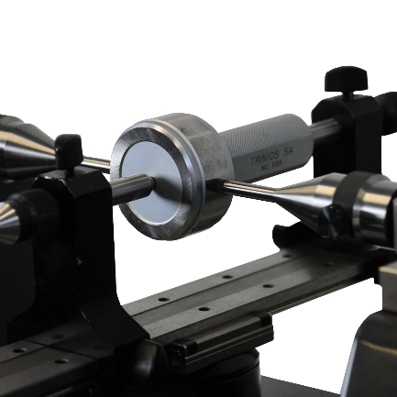  Checking of plug gauges and pin gauges (max. ø 100mm/4’’, length 280mm/11’’)  (TULM6/L0.5, LABC15) | 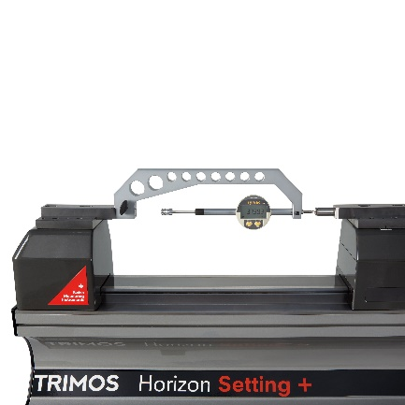  Checking of dial indicators and comparators  (TA-IH-301)
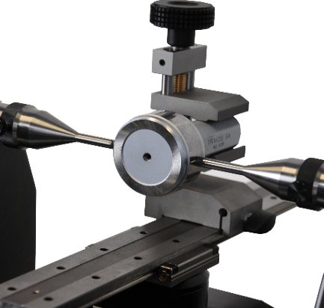  Checking of plug gauges and pin gauges  (max. ø 100mm/4’’, length 280mm/11’’)  (TULM6/L0.5, LABC15) | 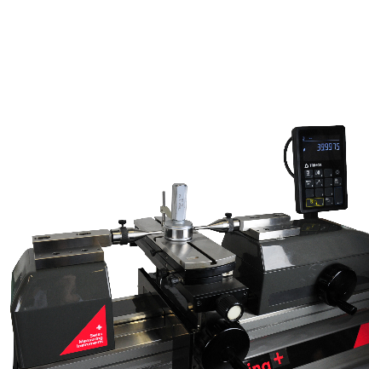  Checking of plug gauges  (larger than dia. 100mm)  (TEL6, TA-SU-313, TULM6/L0.5, TA-SU-304)
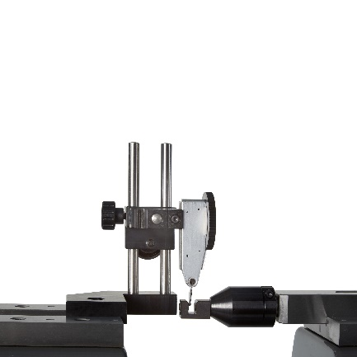  Checking of test indicators  (TULM 15.1) | 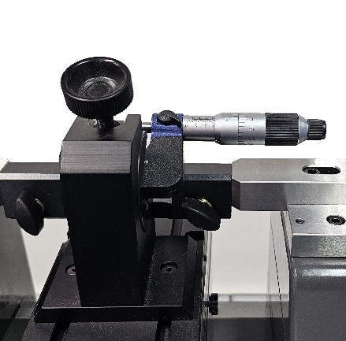  Manually checking of micrometer  (TEL5, TULM14)

Trimos S.A.
Av.de Longemalle 5
CH-1020 Renens
T. +41 21 633 01 01
info@trimos.ch
www.trimos.com 750 02 0074 03 – Version 2.1/2025-02 – Changes without prior notice

