V4+

New standard in height gauge performance

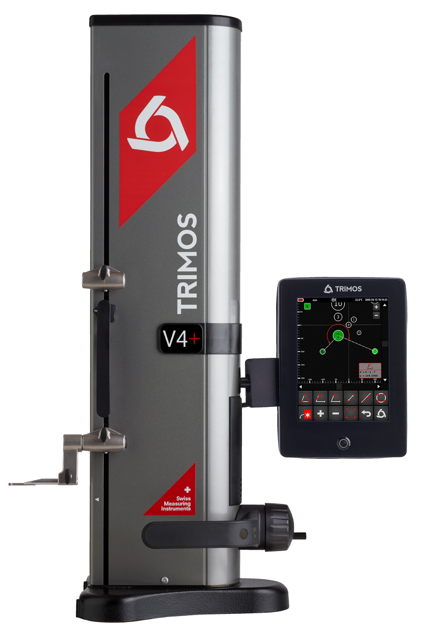

1.
PRESENTATION

The new V4+ redefines precision and functionality by seamlessly combining the mechanical excellence of the V4 with the advanced interface and innovative capabilities of advanced height gauges. This design delivers exceptional performance, making it an efficient and cost-effective alternative to traditional 2D height gauges, while ensuring unmatched performance and user experience.
Engineered with Swiss precision, the V4+ offers robust mechanical stability and integrates a smooth air cushion system for effortless movement on the measuring table. Its advanced capabilities include essential measurement functions such as distances, diameters, and center distances, ensuring versatility and ease of use for both simple and complex tasks.

Robust Mechanical Design
Supports long and heavy probes up to 400 mm with exceptional repeatability.
Dynamic graphical feedback
Real-time display of measurement progress and results, ensuring clarity and precision at every step.
Smart touch navigation
Intuitive menu structures and responsive touch controls make operation straightforward and efficient, reducing training time.
Integrated 2-coordinate measurement
Intuitive 2D visualization of parts, showing measurement results instantly.
Integrated measurement programs
Customizable programs simplify complex measurements, saving time and minimizing errors.
Comprehensive data connectivity
USB, RS232, and Wireless options for easy data export, integration, and analysis across systems.

These features are designed to deliver unparalleled measurement accuracy and streamline operations, making the V4+ a top choice for professionals seeking innovation and efficiency in a cost-effective package.
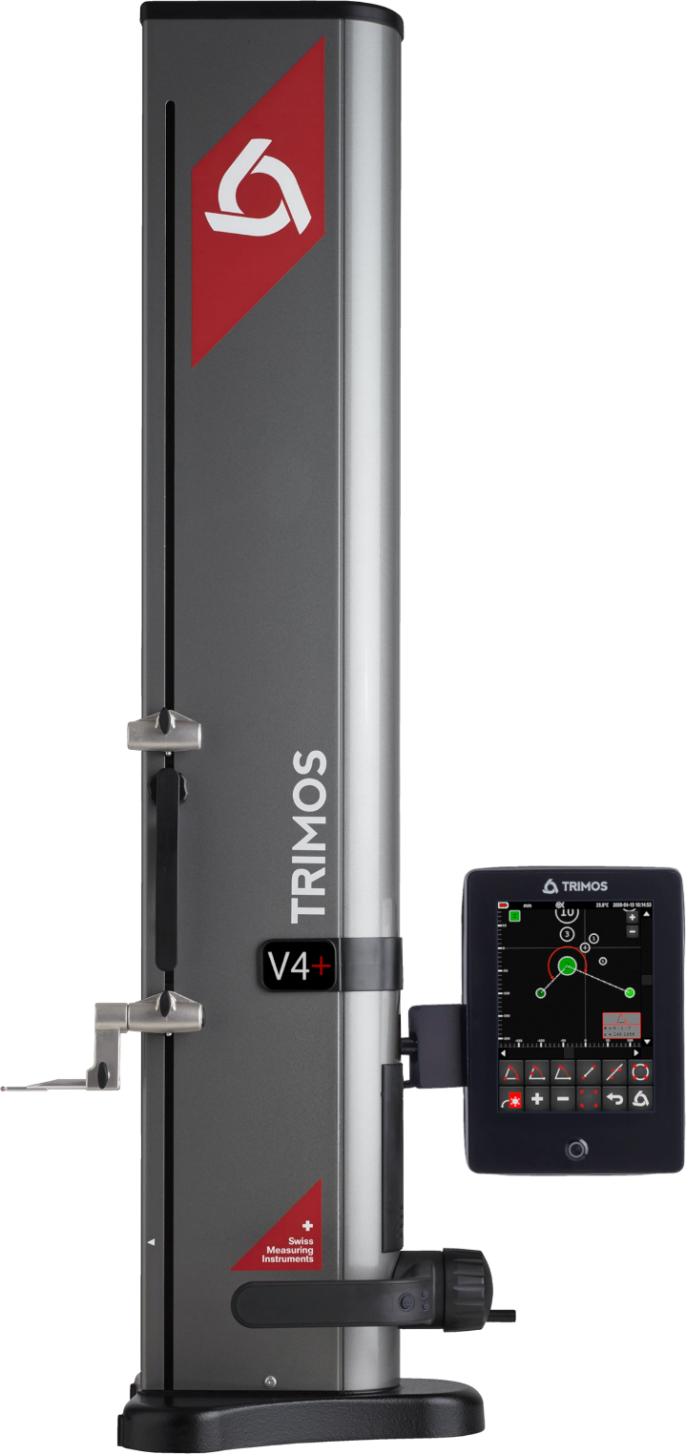

2.
KEY FEATURES

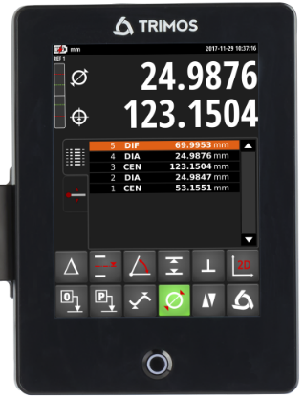 | 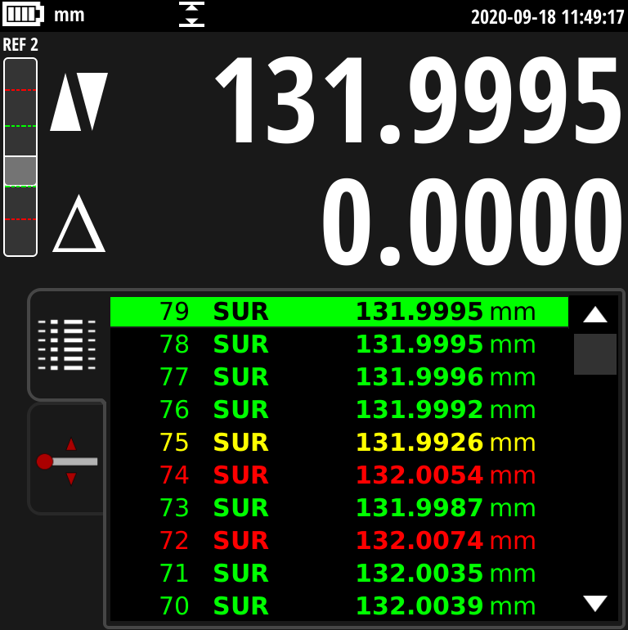 | 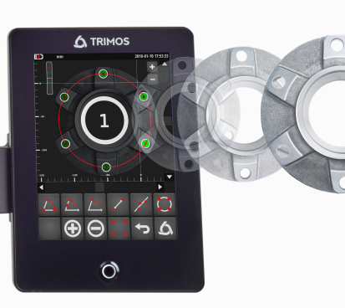
Advanced Display Interface  Large 8-inch touchscreen with clear graphics, high contrast, and intuitive navigation, ensuring excellent readability and ease of use in workshop environments. | Advanced tolerance view  Color-coded indications for tolerance compliance, enabling quick and accurate decision-making. | 2D Measurement Capabilities  2-coordinate measurements with instant graphical visualization for distances, angles, and regression circles directly on the display.
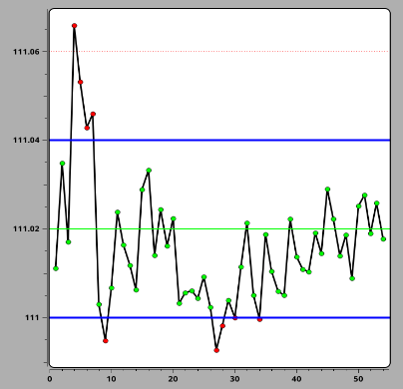 |   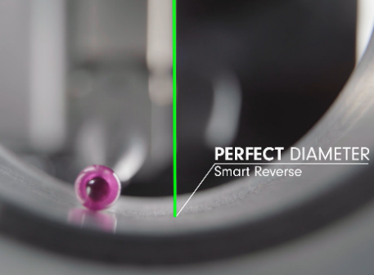 | 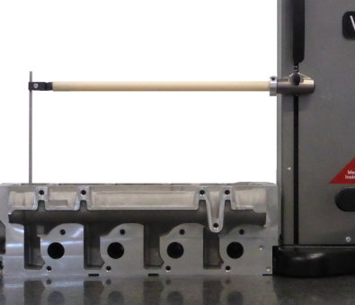
Real-Time Statistical Analysis  Embedded SPC software provides immediate statistical feedback for quality control. | SMART REVERSE  Diameter measurement with audible and visual signals for efficient reversal point detection. | Robust Mechanical Design  Supports long and heavy probes up to 400 mm with exceptional repeatability.
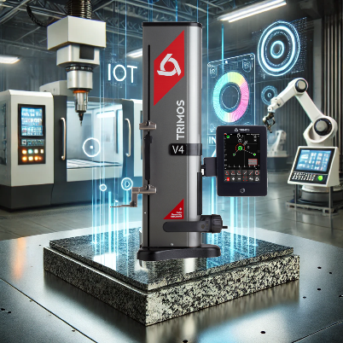 | 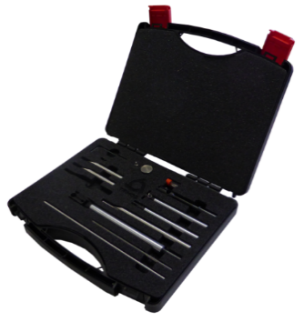 | 
Industry 4.0 Compatibility  Designed for seamless integration into modern industrial environments. | Large range of accessories  The range of accessories available covers almost all applications. | Two-Year Standard Warranty  Extendable up to an additional two years = 4 years!

3.
TECHNICAL DATA

V4+ | 400 | 700
Measuring range mm (in) | 407 (16) | 711 (28)
Measuring range with extension mm (in) | 719 (28) | 1023 (40)
Max. permissible errors, B_{MPE} µm | 2.5 + L(mm)/250
Repeatability, R_{MPE} (2s) µm | 2 (Ø: 3)
Frontal squareness deviation, S_{MPE} µm | 9 | 13
Maximal Resolution mm (in) | 0.001 (0.00005)
Measuring force N | 0.75 ÷ 1.5
Battery autonomy h | 20
Interfaces | USB / RS232 / Wireless
Air cushion | Yes
Weight kg | 21 | 24
The above values were determined in accordance with ISO 13225 using the TA-MI-101 insert.
R_{MPE} is defined as 2 times the standard deviation (2s) over a series of 20 height measurements.
4.
MODELS & REFERENCES

V4+
Measuring range 400 mm | V4+400
Measuring range 700 mm | V4+700

5.
DELIVERY

V4+
Instrument according to specifications | Measuring insert with ruby ball Ø4 mm
Charging unit | Setting gauge 25 mm
Calibration certificate | User’s manual


TRIMOS S.A.
Av.de Longemalle 5
CH-1020 Renens
T. +41 21 633 01 01
info@trimos.ch
www.trimos.com 750 02 0092 03 – Version 1.1/2025-04 – Changes without prior notice

