V2

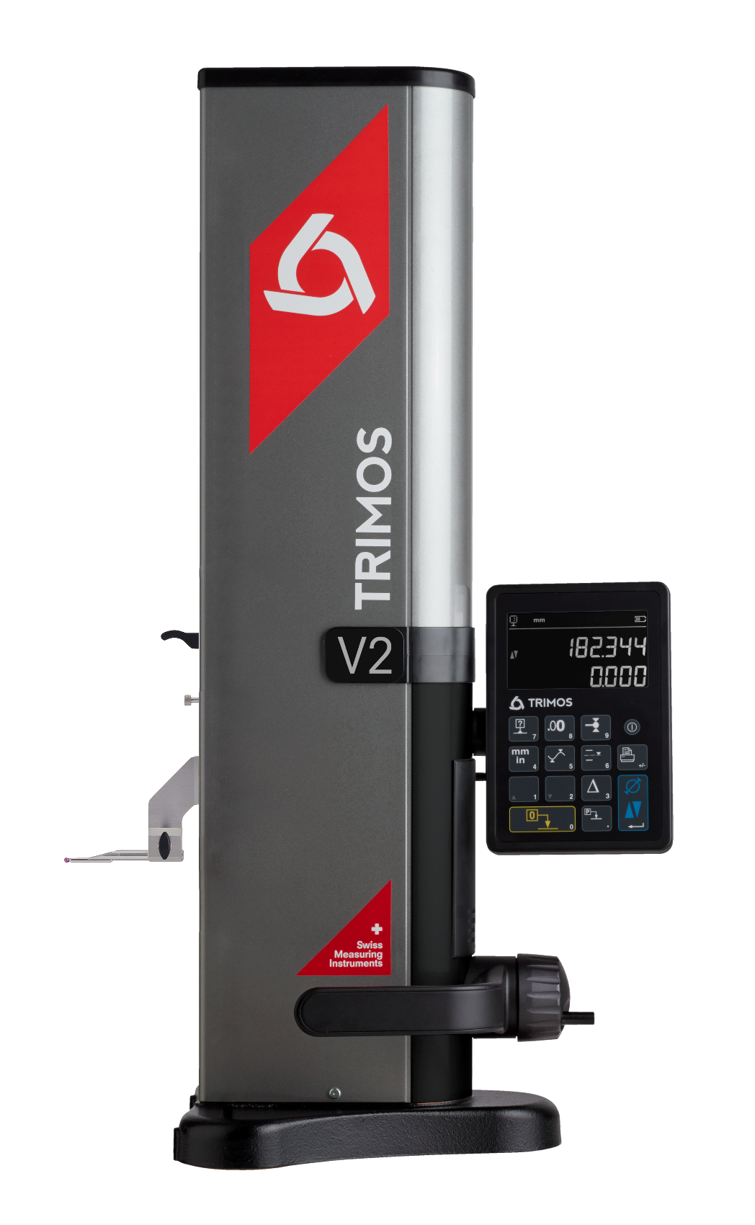
New heights in reliability and simplicity

1.
PRESENTATION

The Trimos V2 height gauge embodies Swiss precision, durability, and simplicity. Designed for professionals worldwide, it ensures accurate and easy measurements.

Effortless Simplicity
The V2’s user-friendly interface provides quick access to essential measurements, ensuring efficiency and accuracy.
Built for Durability
Engineered to Swiss standards, it withstands tough conditions, making it a reliable tool for any task.
Uncompromising Quality
As a Trimos product, the V2 merges traditional craftsmanship with modern technology, guaranteeing superior performance.
Intuitive and Smart Features
The intuitive interface streamlines navigation, while Smart Reverse simplifies diameter measurements with precision and ease.
Seamless Connectivity
USB and RS232 ports enable easy data sharing.
Warranty and Maintenance
Backed by a two-year warranty, extendable to four years, the V2 is designed for longevity with straightforward maintenance.
Versatile Measuring Ranges
Available in 400 mm and 700 mm to suit varied applications.
Reliable Support
Trimos’ dedicated team ensures you maximize the V2’s potential from the start.

More than a measurement tool, the V2 is a dependable ally that meets the highest professional standards.
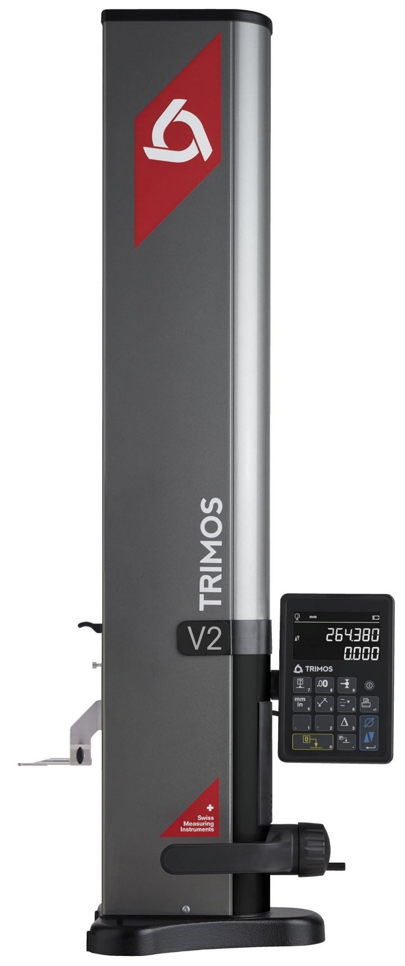

2.
KEY FEATURES

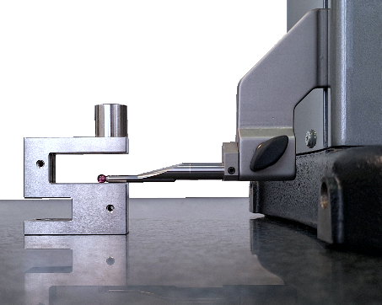 | 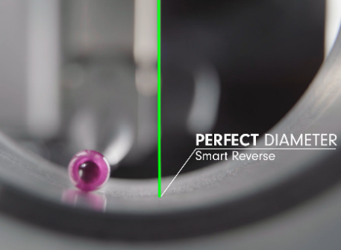 | 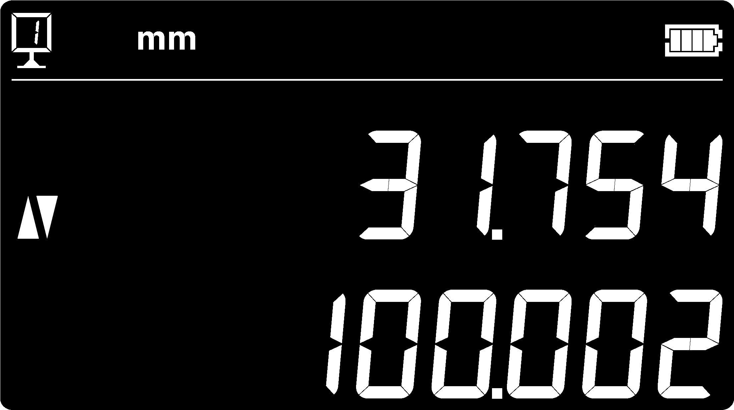
Accurate Height Measurements  Ensures reliable height and distance measurements. | SMART REVERSE  Simplifies the diameter measurements process. | Intuitive Interface  Seamless navigation and straightforward functionality
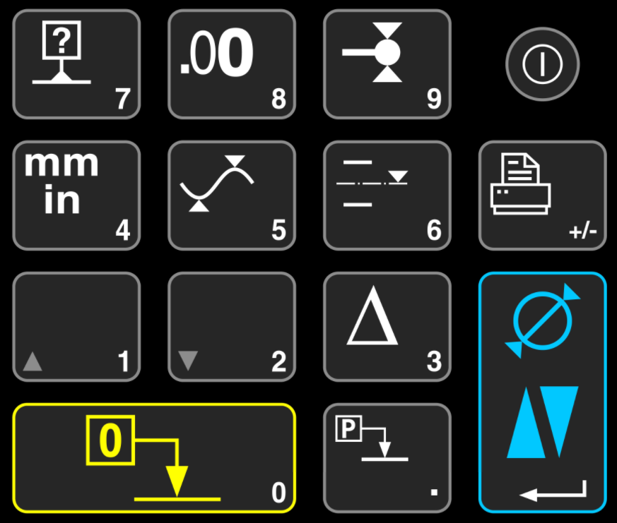 | 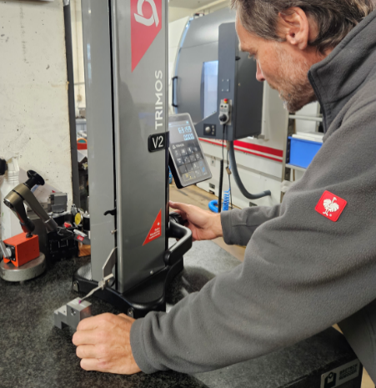 | 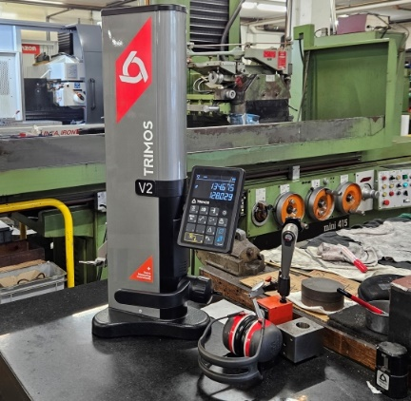
Direct Function Access  Enhances efficiency in the measurement workflow. | Ergonomic Design  Ensures comfortable and effective operation, with manual movement. | Effortless Upkeep  Designed to last in tough workshop environments.
 | 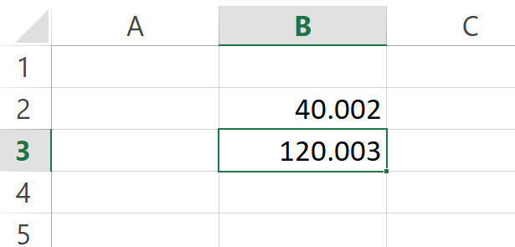  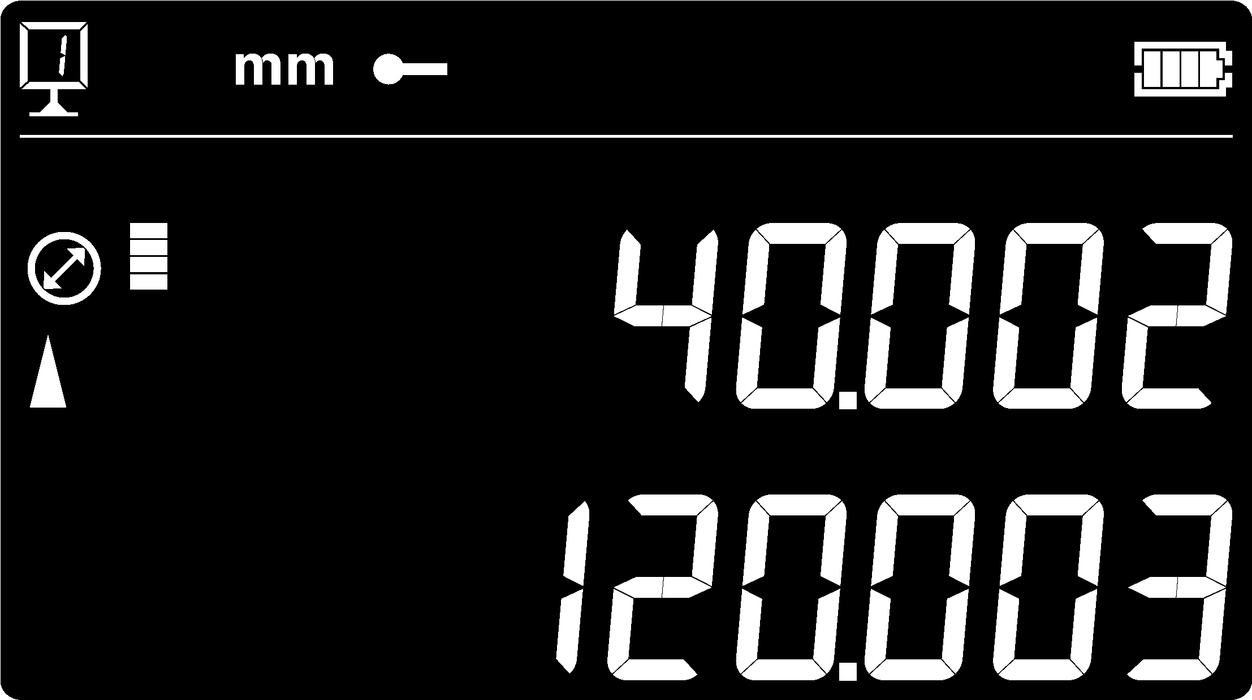 | 
Two-Year Standard Warranty  Extendable up to an additional two years = 4 years! | Advanced Connectivity  Facilitates easy data sharing with USB and RS232 ports, enhancing workflow integration. | Swiss-Made Quality  Combines cutting-edge technology with unparalleled craftsmanship.

3.
TECHNICAL DATA

V2 | 400 | 700
Measuring range mm (in) | 406 (16) | 710 (28)
Max. permissible errors, B_{MPE} µm | 8 | 8
Repeatability, R_{MPE} µm | 3 (Ø: 5)
Max. resolution mm (in) | 0.001 (0.00005)
Measuring force (adjustable electronically) N | 0.75 ÷ 1.5
Data output | USB / RS232
Protection grade of measuring system (CEI 60529) | IP67
Weight kg | 21 | 24
Max. manual displacement speed mm/s | 1000
Operational temperature °C | +10 ÷ +40
Relative humidity (operation and storage) HR | 5 ÷ 75 % (without condensation)
The above values were determined in accordance with ISO 13225 using the TA-MI-101 insert.
R_{MPE} is defined as 2 times the standard deviation (2s) over a series of 20 height measurements.
4.
MODELS & REFERENCES

V2
Measuring range 400 mm | V2-400
Measuring range 700 mm | V2-700

5.
DELIVERY

V2
Instrument according to specifications | Measuring insert with ruby ball Ø4 mm
Power supply | Setting gauge 4 mm
Calibration certificate | User’s manual


TRIMOS S.A.
Av.de Longemalle 5
CH-1020 Renens
T. +41 21 633 01 01
info@trimos.ch
www.trimos.com 750 02 0091 03 – Version 1.1/2025-04 – Changes without prior notice

