V1 / V1+

Tough gauges for the modern workshop

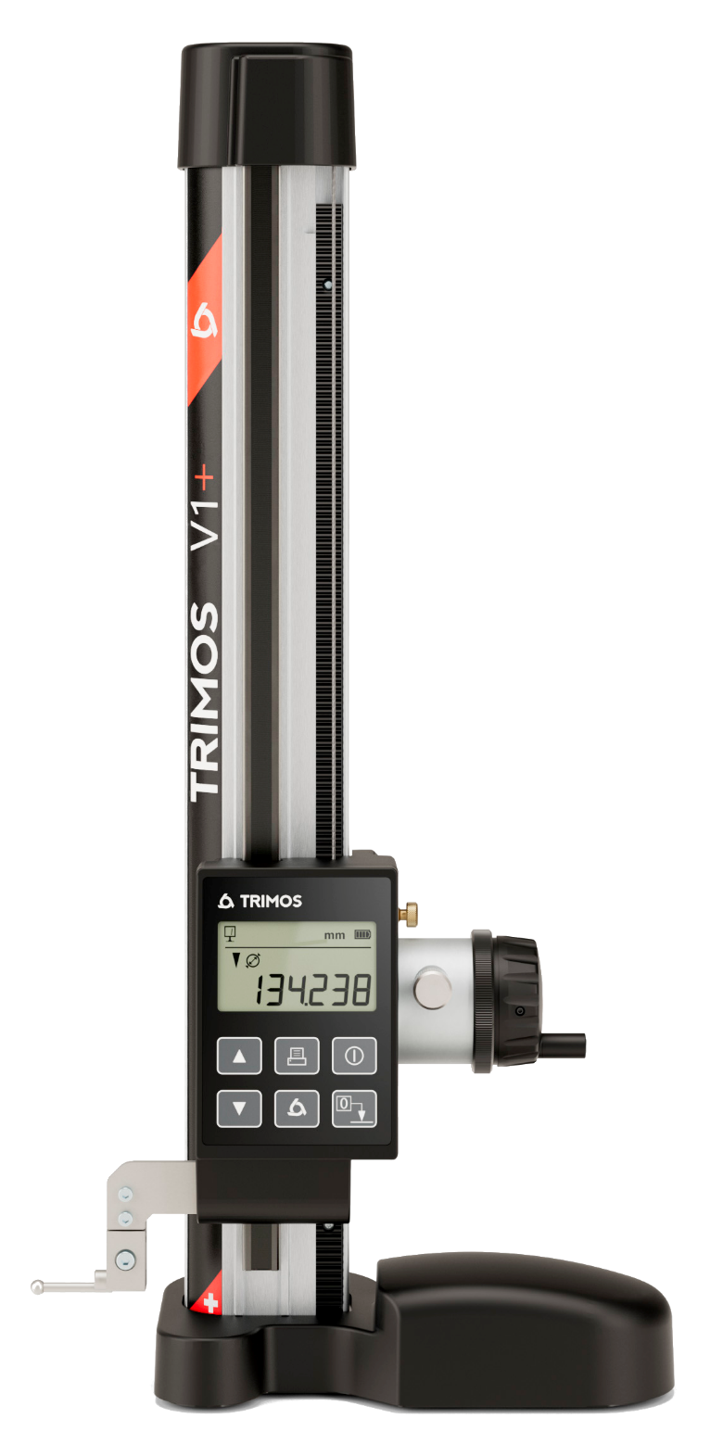

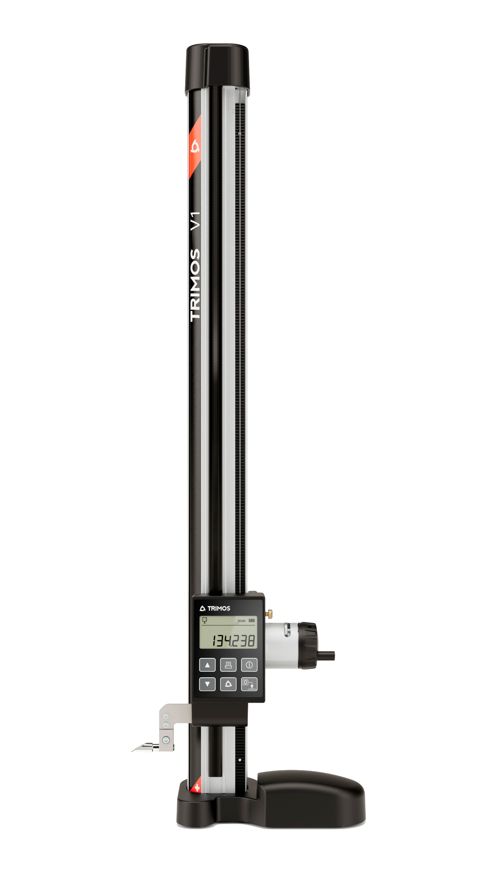
1.
PRESENTATION

In a constantly evolving sector, Trimos presents its latest innovations in dimensional metrology: the V1 and V1+ height gauges. These compact instruments are a cross between conventional tracers and more advanced height gauges. They reflect Swiss know-how in terms of precision, reliability and ease of use.

V1
Robust and designed to last, it is intended for those new to precision measurement. The V1 allows unidirectional measurements and tracing with great ease. It is an ideal transition for users of conventional tracers, while offering more comfort and precision and maintaining a simple and intuitive use.

V1+
The V1+ has all the qualities of the V1 and adds new features. It allows bidirectional measurement and diameter measurement without additional accessories. Its fine adjustment and constant measuring force guarantee precise and repeatable results, even in demanding environments.

- Robust and Easily Portable
- Clear, Simple User Interface
- Counterweight for Operational Comfort
- Quick and Smooth Carriage movement
- Designed and manufactured in Switzerland
- Bidirectional Measurement Capability (V1+)
- Measuring Force Management (V1+)
- RS232 Connectivity (Bluetooth coming soon)
- Available in 300 and 600 mm models

2.
DIFFERENCES

V1  The V1 is an entry-level height gauge with basic fine adjustment, ideal for tracing in the workshop.  Supplied with a tracer. |  | V1+  The V1+ can measure diameters. With its high-advanced fine adjustment and constant measuring force, it offers greater precision. Supplied with a Ø6 mm insert.
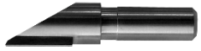 |  | 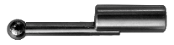

3.
APPLICATIONS AND FUNCTIONALITIES

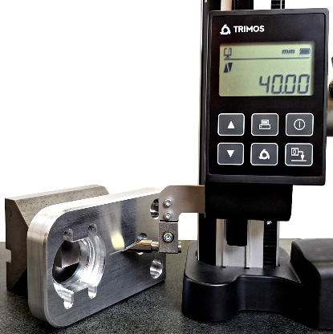 | 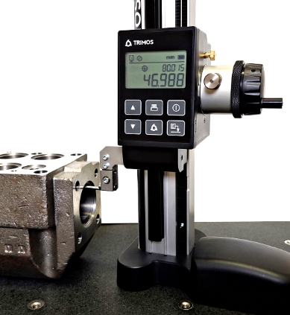 | 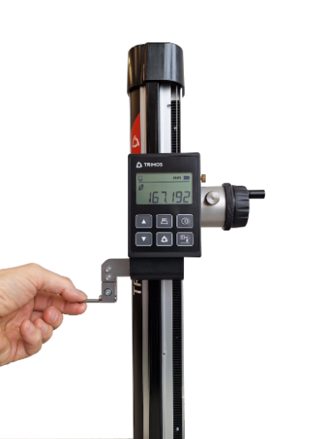
Precision Scribing  Tailored for precision scribing applications in tough environments. | Bidirectional measurements  Advanced capabilities including diameters and centerline measurements without extra tools (V1+). | Operating comfort  A counterweight system provides unparalleled operational efficiency and comfort.
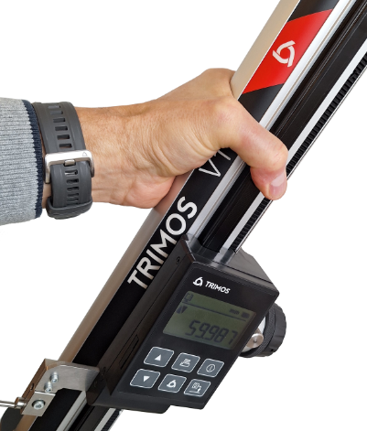 | 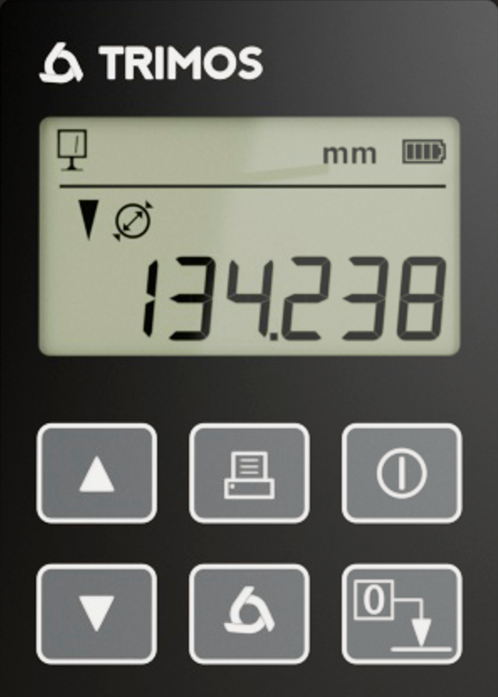 | 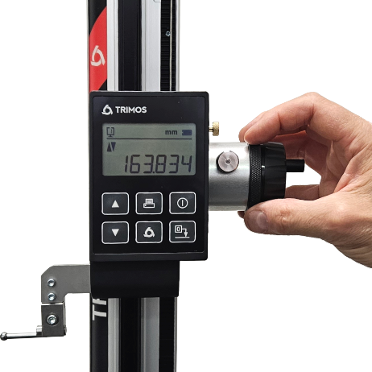
Robust Design  Engineered for durability, reliability, and easy transportability. | Immediate Use Readiness  Very simple and intuitive operation. Clear and large display. | Enhanced Accuracy  Includes measuring force management for consistent precision (V1+).
4.
TECHNICAL DATA

 | V1 |  | V1+
 | 300 | 600 | 300 | 600
Measuring range mm (in) | 306 (12) | 611 (24) | 306 (12) | 611 (24)
Max. permissible errors, B_{MPE} µm | 18 | 30 | 15 | 25
Repeatability, R_{MPE} (2s) µm | 10 |  | 5 (Ø: 0.01)
Maximum resolution mm (in) | 0.01 (0.001) |  | 0.001 (0.0001)
Measuring force N | - |  | 3
Autonomy h | 2000
Interface | RS232
Max. travel speed mm/s | 1500
Operating temperature °C | +10 ÷ +40
Weight (steel base) kg | 7 | 8 | 7 | 8
Weight (granite base) kg | - | - | 13.4 | 15

The above values were determined in accordance with ISO 13225 using the TA-MI-121 insert.
R_{MPE} is defined as 2 times the standard deviation (2s) over a series of 20 height measurements.
5.
MODELS & REFERENCES

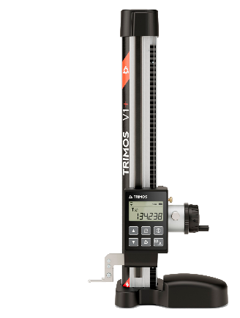 | Steel base | 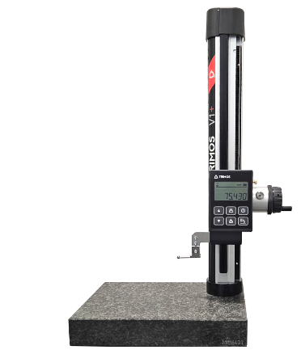 | Granite base

 | V1 |  | V1+
 | 300 | 600 | 300 | 600
Steel base | V1-300 | V1-600 | V1+300 | V1+600
Granite base | - | - | V1+300G | V1+600G

Trimos S.A.
Av.de Longemalle 5
CH-1020 Renens
info@trimos.ch
www.trimos.com 750 02 0090 03 – Version 2.1/2025-04 – Changes without prior notice

