HS3

Motorised Setting Bench

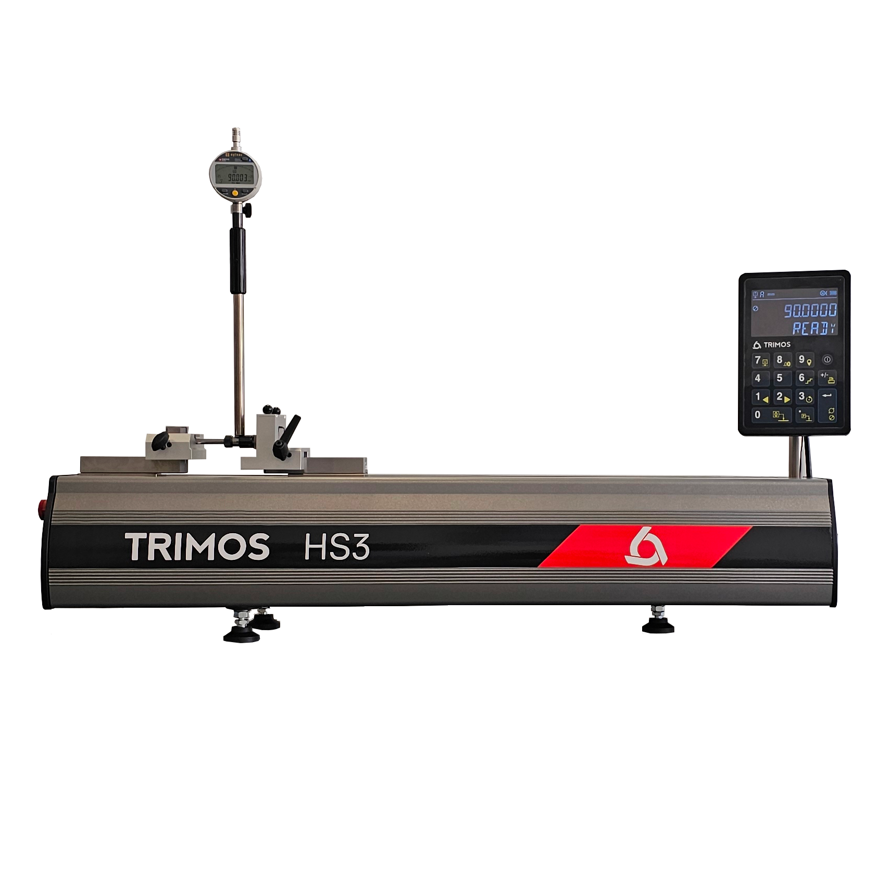

1.
PRESENTATION

HS3 - Precision and simplicity combined
The HS3 is the ideal solution for rapid setting and calibration of your variable-size measuring instruments. Thanks to its exceptional accuracy and robust construction, it is equally at home on the production floor or in the laboratory.

Based on the proven Trimos Horizon Setting range, the new HS3 combines reliability with modern design. Its heavy-duty cast-iron base ensures optimum stability. Its intuitive interface makes it quick and easy to use, for increased productivity and greater consistency in your measurements.

Its main assets
- Universal compatibility: works with 99% of 2-point bore gauges on the market.
- Immediate reading over the entire measurement range: no settings required
- Ideal for setting and zeroing gauges directly in the workshop
- Can be used as a complete ISO-compliant calibration station.
- Fast, accurate gauge adjustment thanks to a range of smart adapters

Technical specifications
- Motorised movement: quick positioning
- Instant start-up: operational in a few of seconds
- Communication via RS232 or Bluetooth: easy integration into your digital environment
- Rugged electronics: designed to last in industrial environments
- Cast iron base with the same thermal properties as steel: no temperature problems
- Calibration of internal and external instruments
- Works like a "virtual ring gauge": all diameters in one device
- In-house calibration capability: total on-site autonomy

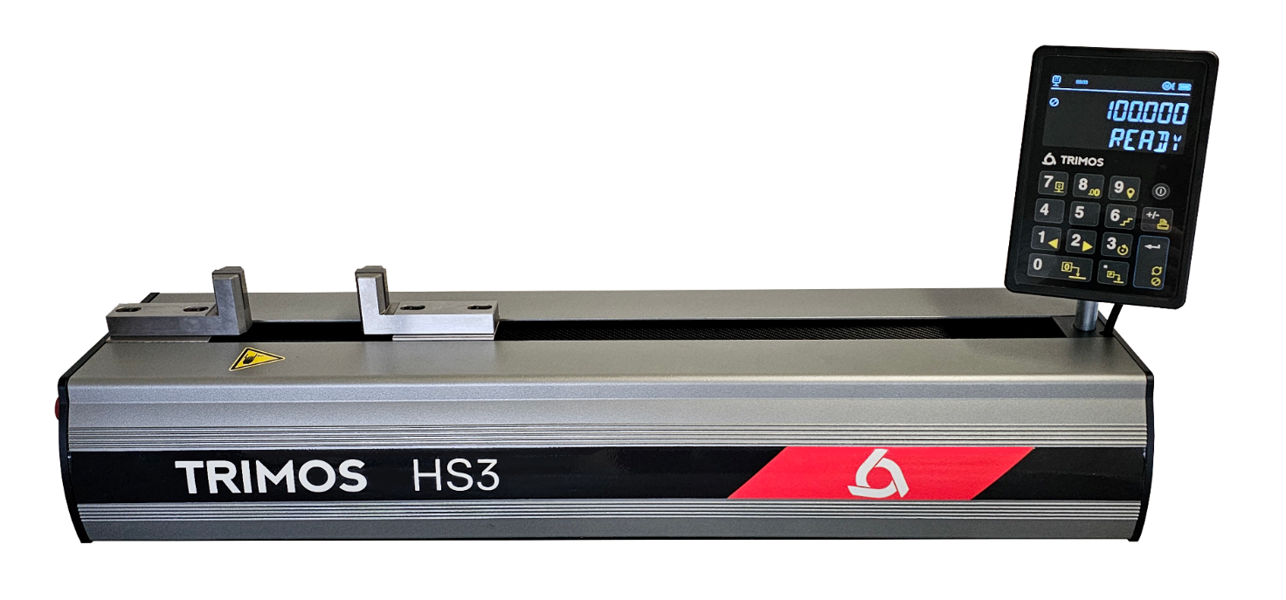
Mobile carriage
with interchangeable inserts
Instrument frame (cast iron), dimensionally stable, positioned on three points
Digital display with data output, highly resistant to the workshop environment

2.
SPECIALLY DESIGNED FOR ADJUSTMENT

- 2-point alesometers
- Internal and external comparative measurement tools
- Analogue & digital counters
- Vernier calipers
- External micrometers

3.
HIGHLIGHTS

Simplifies bore gauge adjustment - Eliminates the need for multiple rings.
Traditionally, setting a bore gauge involves using a specific ring for each diameter. This approach requires the purchase, storage and maintenance of a large number of precision rings, each requiring regular recalibration. This method is expensive, time-consuming and takes up valuable workspace.

With HS3, all that changes
The HS3 replaces all individual setting rings. A single instrument covers the entire range of bore gauge settings - no clutter, no recurring calibration of multiple gauges, any dimension available.

The result?
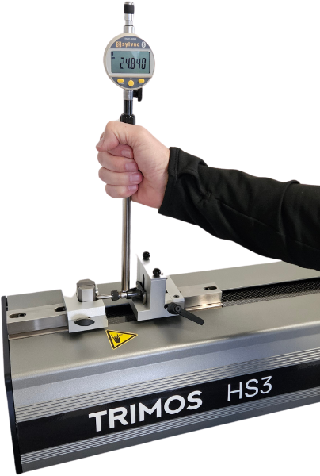
A streamlined process, no more rings to manage, and a clear improvement in efficiency and profitability.
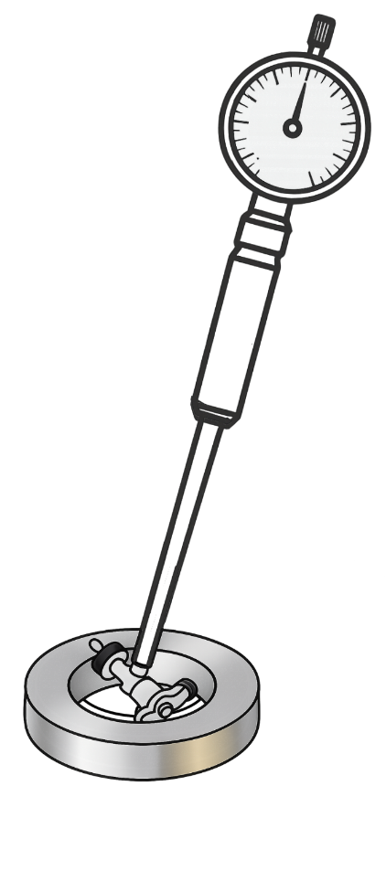

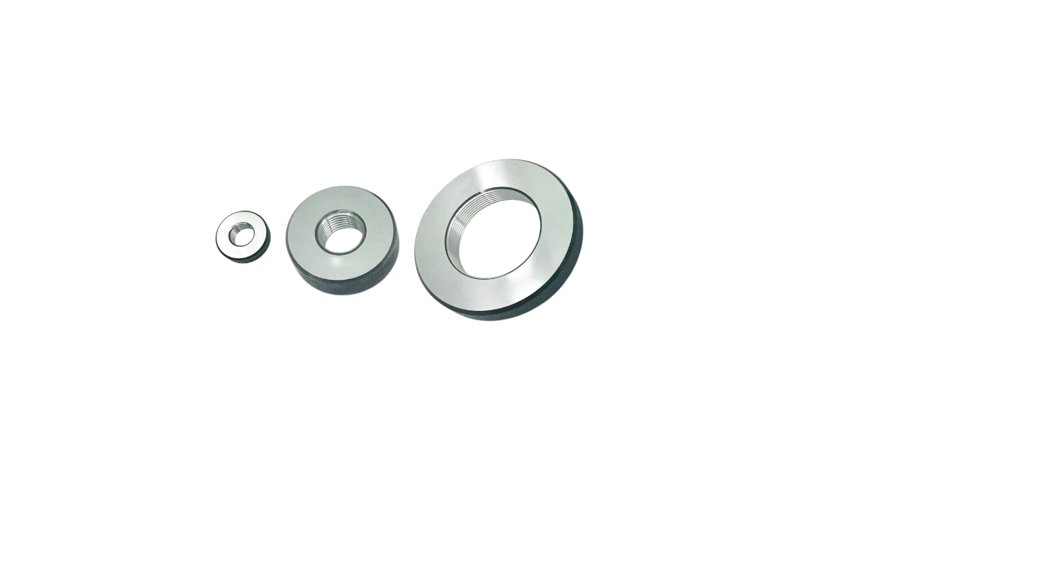
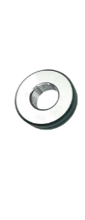

3.
APPLICATIONS
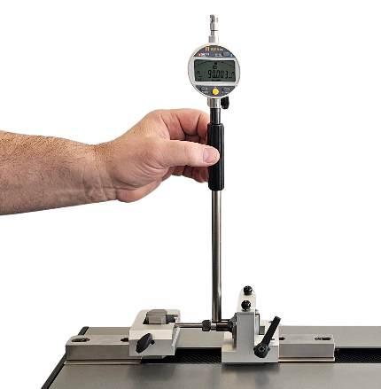 | 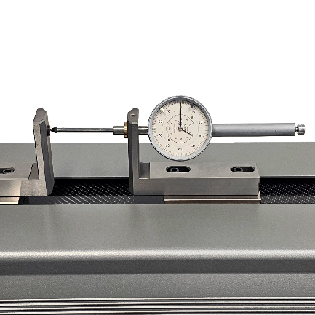 | 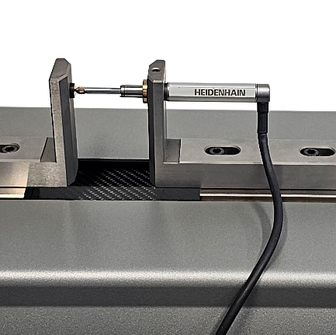
Setting 2-point bore gauges | Checking of analogue and digital dial gauges | Checking of electronic probes
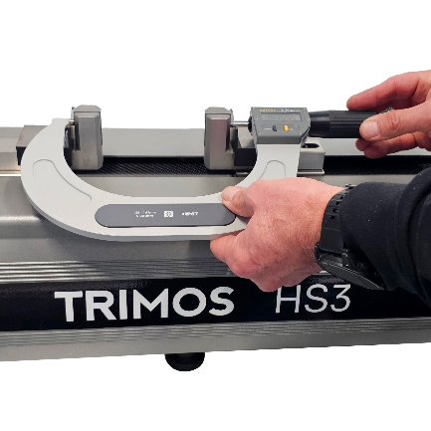 | 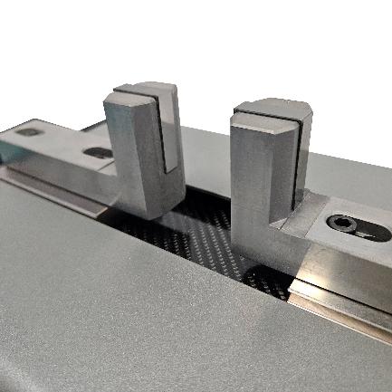 | 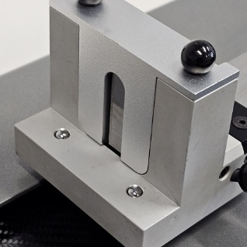
Checking of micrometers | Interchangeable hard metal inserts | Accessories for all types of measurement
4.
TECHNICAL SPECIFICATIONS

Setting the horizon | HS3-400
Measuring range (external measurements) mm (in) | 50 ÷ 460 (2 ÷ 18)
Measuring range (internal measurements) mm (in) | 1 ÷ 410 (0.1 ÷ 16)
Maximum permissible errors ¹⁾ µm | 0.7 + L(mm)/1000
Repeatability (2s) ¹⁾ µm | 0.5
Resolution mm (in) | 0.0001 (.000001)
Interfaces | RS232
Operating temperature °C | 10 ÷ 40
Storage temperature °C | -10 ÷ 40
Weight kg | 65
1) Values valid at a temperature of 20±0.2°C and a relative humidity of 50±5%.


Trimos S.A.
Av. de Longemalle 5
CH-1020 Renens
T. +41 21 633 01 01
info@trimos.ch
www.trimos.com 750 02 0093 03 - Version 1.0/2025-04 – Changes without prior notice

