V5 / V6

Height Gauges for the Workshop

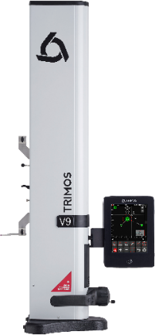
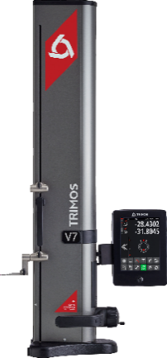
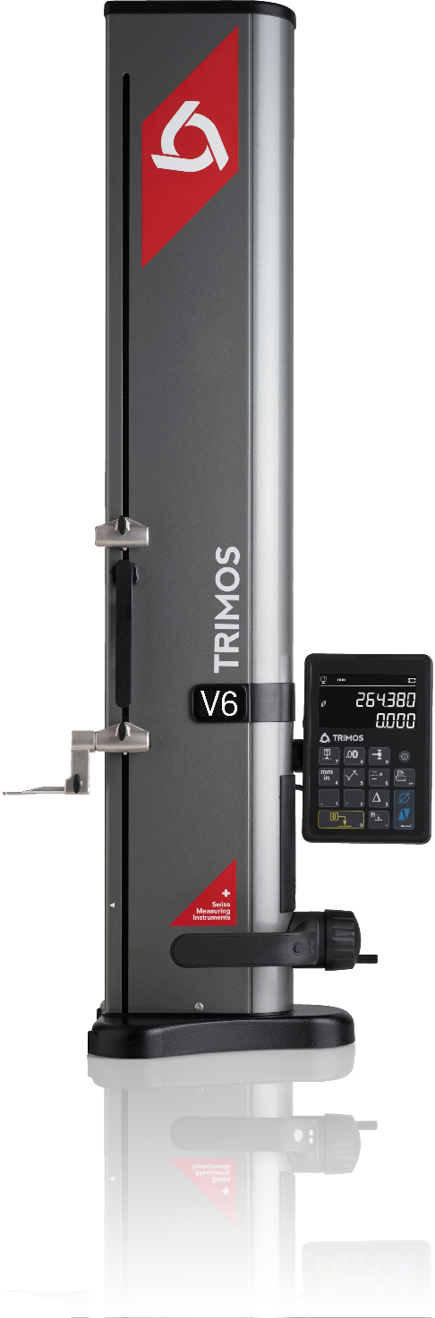
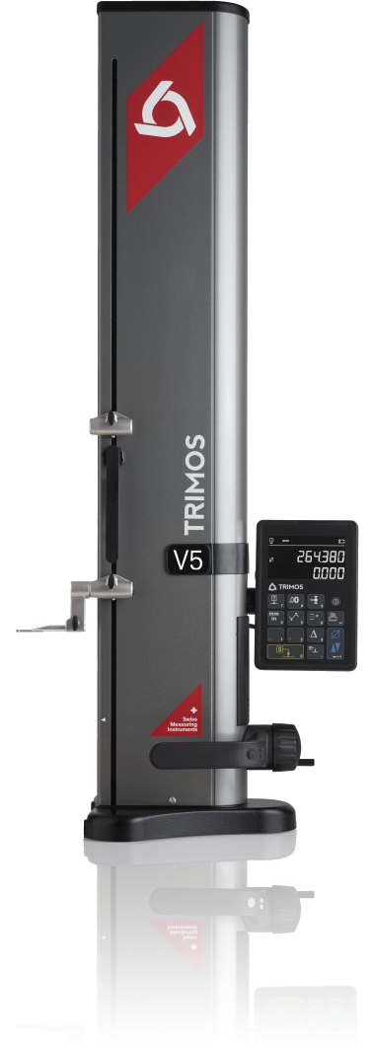
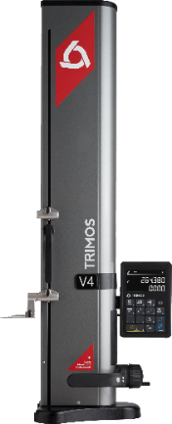
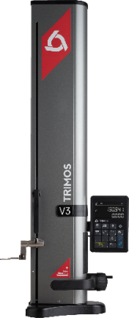
V3

V4

V7

V9

1.
INTRODUCTION
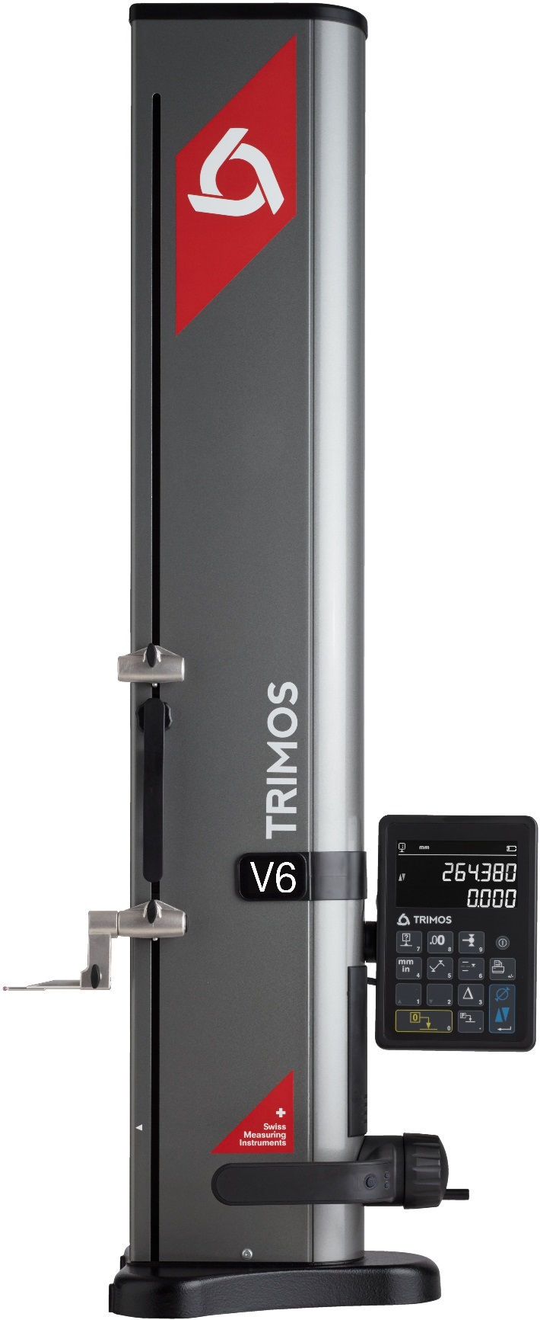
The vertical measuring instruments V5 and V6 are the descendants of the legendary V+ line, from which thousands of units have already been sold in workshops all over the world and are universally recognized for their easy use and their high quality.

Trimos was the first to offer vertical measuring instruments on the market more than 40 years ago. The V5 and V6 represent a consolidation of know-how accumulated over the years. The very legible display and the user-friendly functions offer exceptional comfort use. But that’s not it: The V5 and V6 are equipped with a revolutionary displacement handwheel which offers its user the choice of the displacement mode of the measuring carriage, either manual or motor-driven. Each one of these modes, suffers from no compromise, which means that the user who prefers a manual instrument will not notice a difference with a classic manual instrument and the same applies to the motor-driven displacement. This innovation avoids having to make a difficult choice during the purchase and can accommodate multiple potential users with the same instrument.

- Measuring ranges 400, 700 and 1100 mm
- Extremely easy to use
- Electronically adjustable measuring force
- Manual or motor-driven displacement
- Standard probes up to 400 mm
- Vast range of accessories
- All adjustments possible without tools
- RS232 and USB interfaces
- Wireless data transfer (optional)

A Cast iron base for optimal stability
B Horizontal displacement handle with buttons for functions and air cushion
C Measuring carriage displacement handwheel. Manual or motor-driven mode.
D Interchangeable insert holder and probe
E Additional probe holder
F "Black Mask" display with user-friendly functions
G Easy balance adjustment system
A
C
D
E
F
B
G
2.
DIFFERENCES

V5  The design of the V5 with its side probe holders revives an old Trimos tradition: It enables measuring with long, robust probes guaranteeing an excellent repeatability. |  | V6  The V6 is of the same calibre as the V5. It’s equipped with a more precise measuring system and enables the use of an electronic perpendicularity probe.

3.
TECHNICAL DATA

V5 | 400 | 700 | 1100
Measuring range mm (in) | 407 (16) | 711 (28) | 1110 (44)
Measuring range with extension mm (in) | 719 (28) | 1023 (40) | 1422 (56)
Max. permissible errors, B_{MPE} µm | 2.5 + L(mm)/300
Repeatability, R_{MPE} (2s) µm | 2
Frontal squareness deviation, S_{MPE} µm | 5 | 8 | 11
Maximal Resolution mm (in) | 0.0005 (0.00005)
Measuring force N | 0.75 ÷ 1.5
Autonomy h | 12
Interfaces | USB / RS232 / Wireless
Air cushion | Yes
Weight kg | 21 | 24 | 33

V6 | 400 | 700 | 1100
Measuring range mm (in) | 407 (16) | 711 (28) | 1110 (44)
Measuring range with extension mm (in) | 719 (28) | 1023 (40) | 1422 (56)
Max. permissible errors, B_{MPE} µm | 2 + L(mm)/400
Repeatability, R_{MPE} (2s) µm | 1 (Ø: 2)
Frontal squareness deviation, S_{MPE} µm | 5 | 8 | 11
Maximal Resolution mm (in) | 0.0001 (0.000005)
Measuring force N | 0.75 ÷ 1.5
Autonomy h | 12
Interfaces | USB / RS232 / Wireless
Air cushion | Yes
Weight kg | 21 | 24 | 33

The above values have been determined according to ISO 13225, with the standard measuring insert (TA-MI-101).

4.
APPLICATIONS AND FUNCTIONALITIES

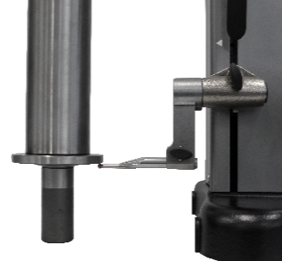 | 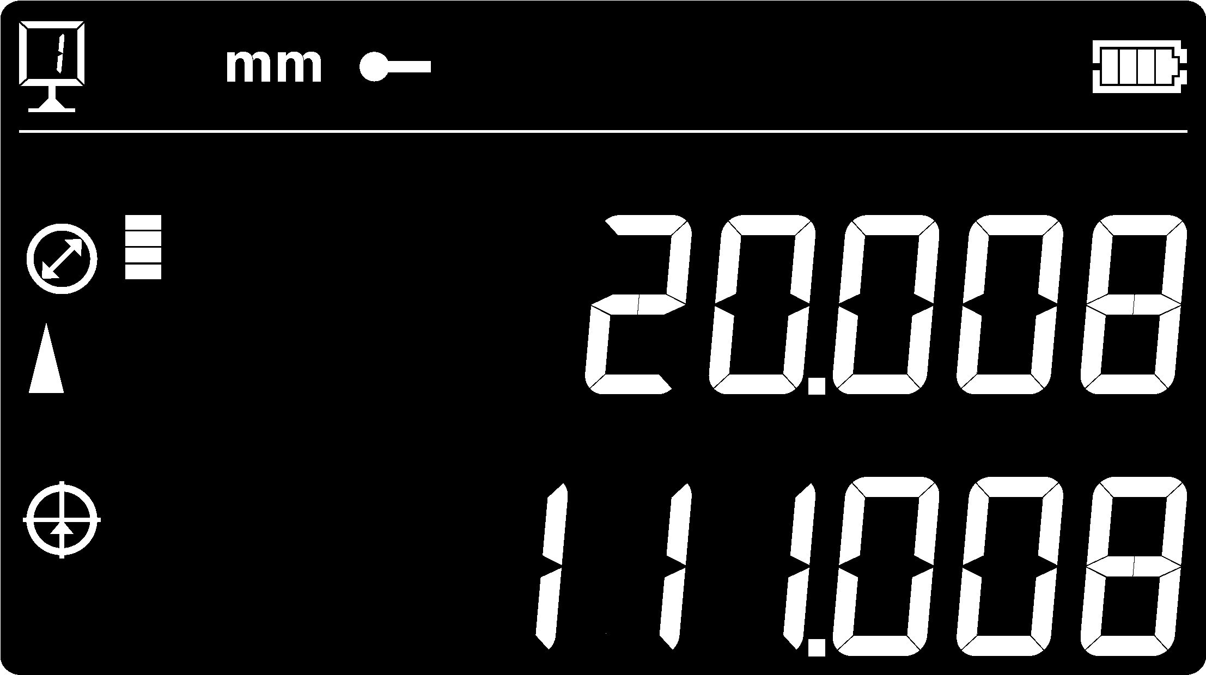  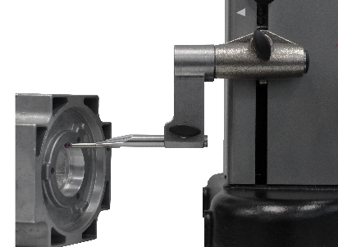 | 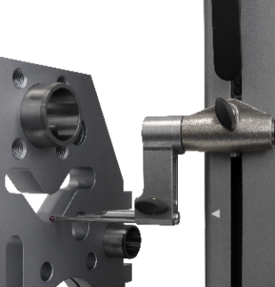
Height Measurements  Measurements of height, thickness and chain of dimensions | Diameter Measurements  Simultaneous display of diameter and centerline | Min/Max/Delta  The motorization guarantees a perfectly constant measuring force | Perpendicularity  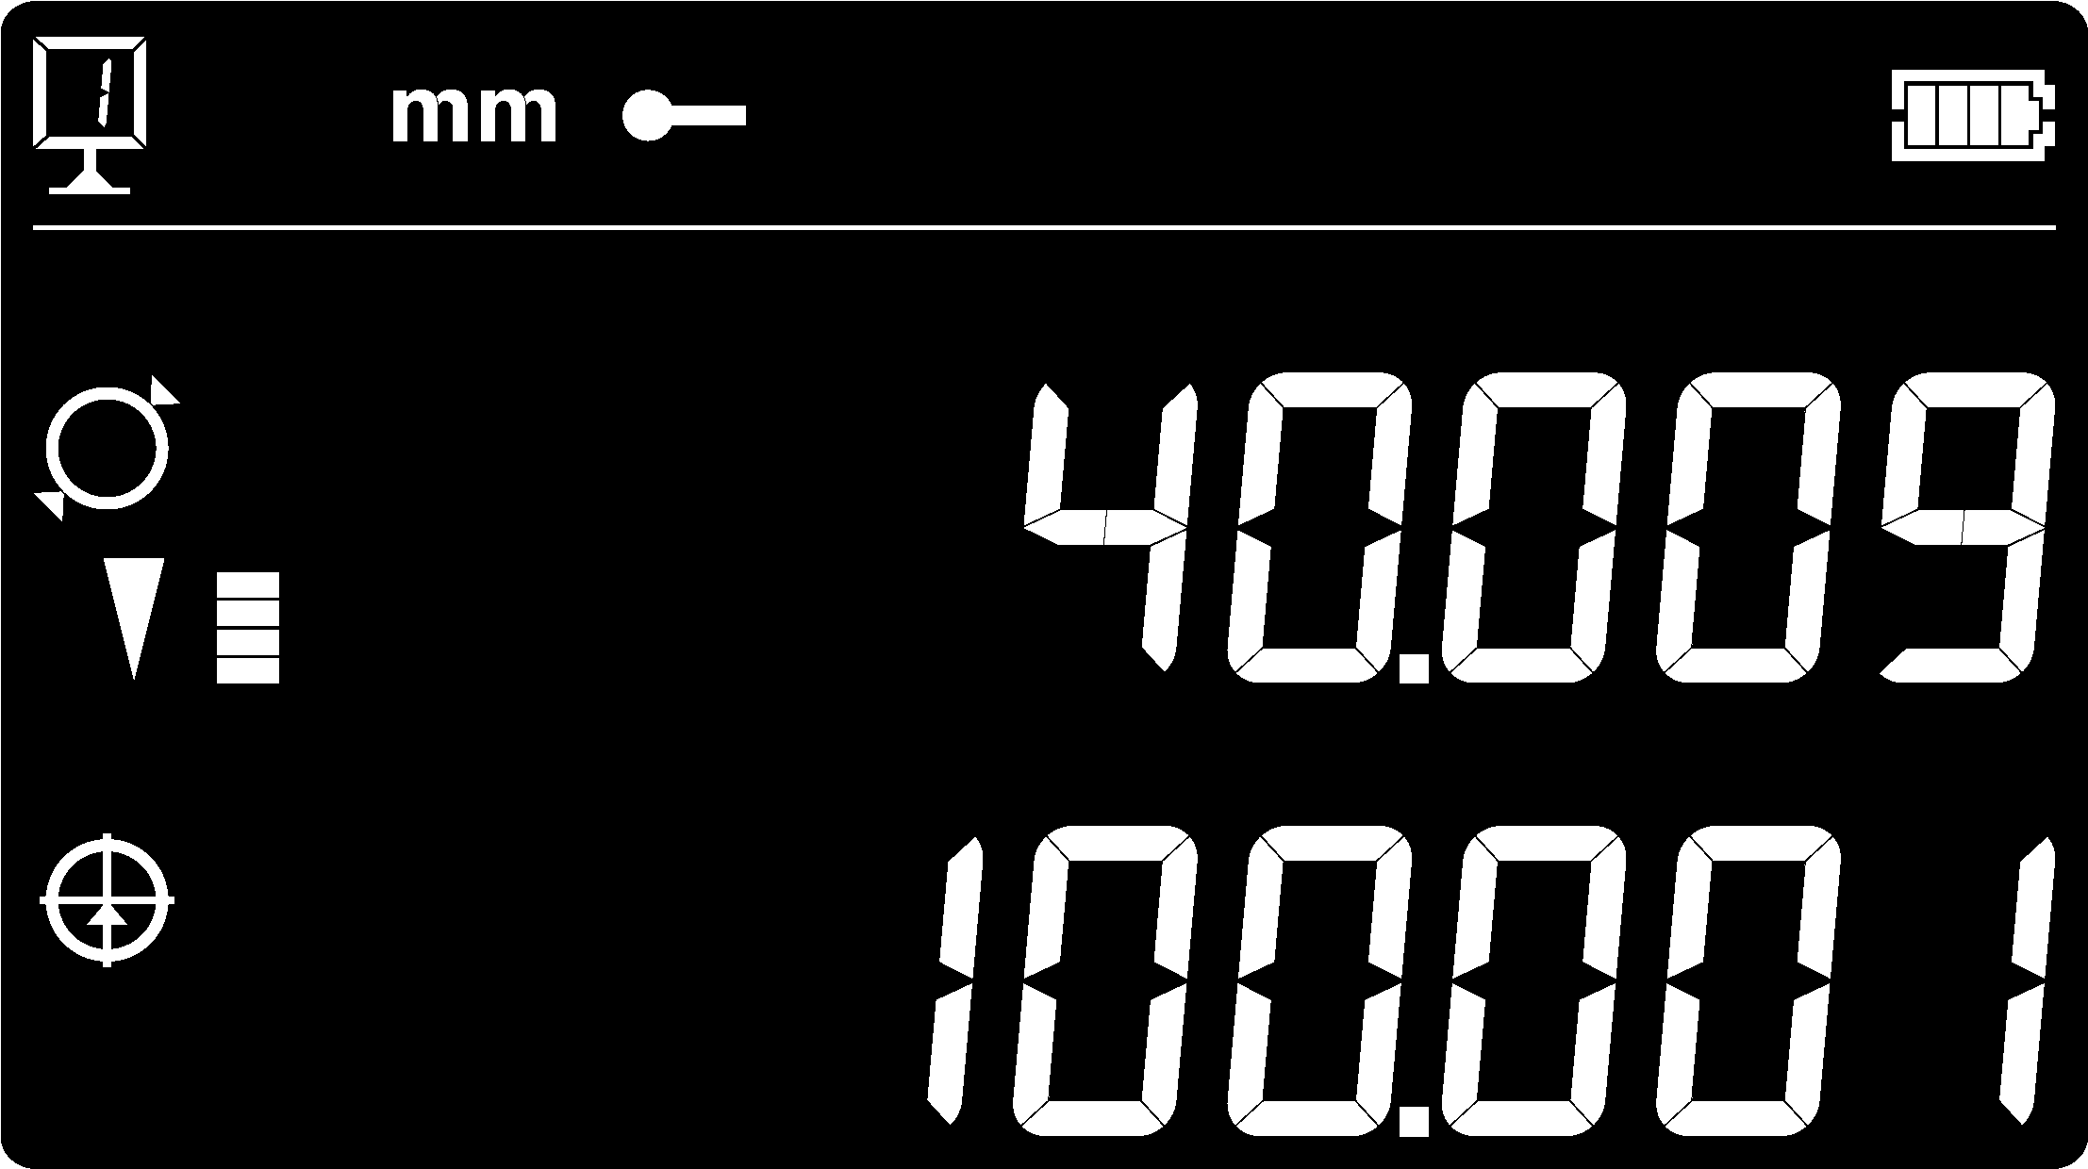  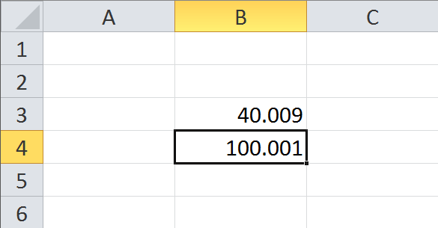  Squareness measurements with electronic probe (V6)
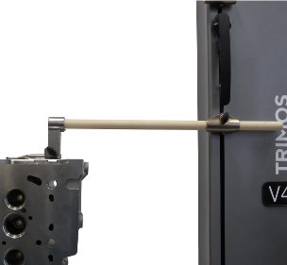 | 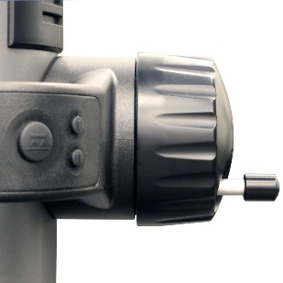  Manual  Motorised | 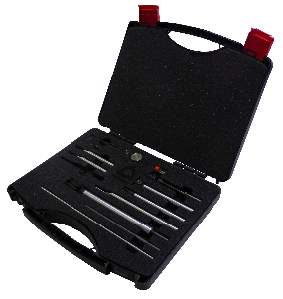
Long Probes  Standard measuring inserts up to 400 mm, with excellent repeatability | Handwheel  Instant switch from the manual to the motor-driven mode | Accessories  Very large range of accessories for any type of application | Interface  The data transfer via the USB, RS232 port or Wireless is very easy

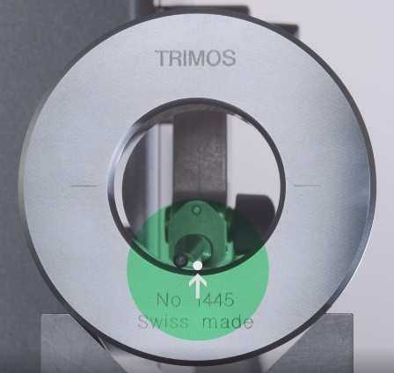 | SMART REVERSE:  Diameter measurement faster, more accurate and simpler  SmartReverse technology is the result of an intense collaboration between Trimos users and our R & D team in order to optimize diameter measurements.  SmartReverse makes the measurement of diameters very efficient by clearly indicating the reversal points with audible and visual signals. The user is guided precisely during the measurement of diameters, which generates a significant gain in speed and reliability of the measurement.

Trimos S.A.
Av.de Longemalle 5
CH-1020 Renens
T. +41 21 633 01 01
info@trimos.ch
www.trimos.com 750 02 0030 03 – Version 1.5/2019-03 – Changes without prior notice

