V3 / V4

Height Gauges for the Workshop

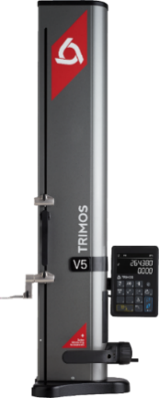
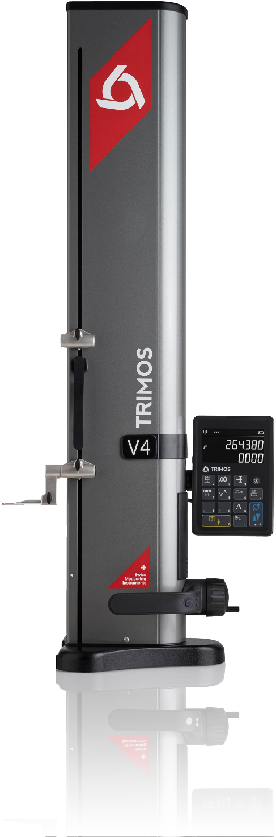
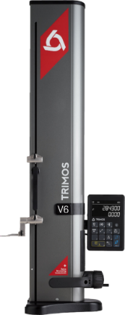
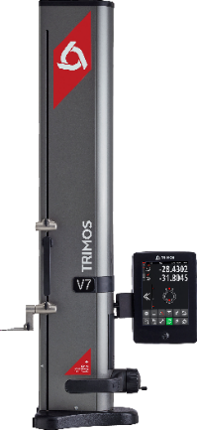
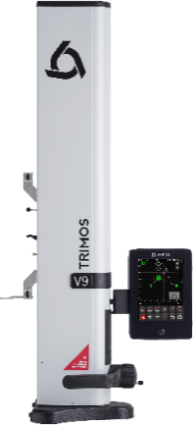
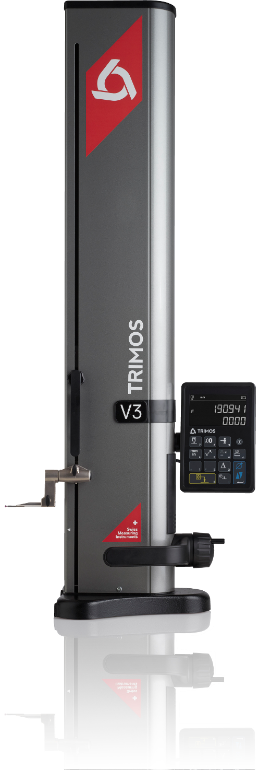

V9

V7

V6

V5

1.
INTRODUCTION
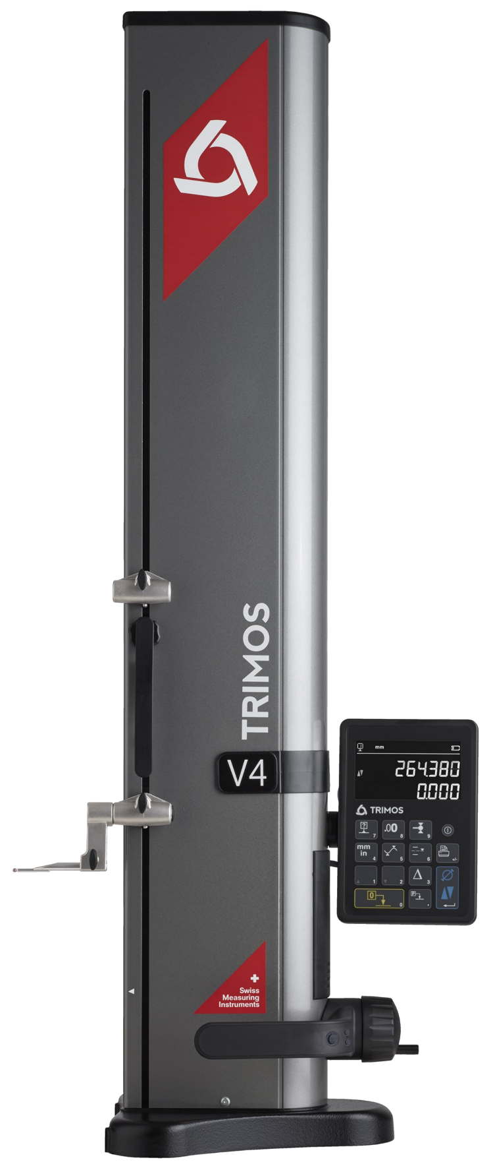
The V3 and V4 vertical measuring instruments have been developed for the most difficult workshop environments. Manufactured in their entirety in Switzerland, they will guarantee a robust, precise and reliable product on the long run.

For more than 40 years Trimos philosophy has been to offer easy-to-use instruments that are very efficient in production environment.
The display unit provides functions that are directly accessible and depicted with symbols easy to understand.
This allows for easy and quick handling even by unqualified personnel. The large 2-line « Black Mask » display offers an exceptional contrast in all lighting conditions, a unique characteristic on the market.

- Measuring ranges 400 and 700 mm
- Extremely easy to use
- Electronically adjustable measuring force
- Standard probes up to 400 mm
- Vast range of accessories
- All adjustments possible without tools
- RS232 et USB interfaces
- Wireless data transfer (optional for V4)

A Cast iron base for optimal stability
B Horizontal displacement handle with buttons for functions and air cushion (V4)
C Measuring carriage displacement handwheel
D Interchangeable insert holder and probe
E Additional probe holder (V4)
F "Black Mask" display with user-friendly functions
G Easy balance adjustment system

E
G
D
F

A
C
B

2.
DIFFERENCES

V3  The V3 height gauge represents the entry-level of Trimos universal measuring columns. It fully benefits from the developments realized on superior models. A robust and easy-to-use instrument including all functions essential for a use in the workshop. |  | V4  The V4 height gauge offers the same functions as the V3. In addition it is equipped with a second probe holder as well as with an air cushion for easy displacement on the measuring table. The programmable functions buttons of the handle allow a quick access to the functions most used.

3.
TECHNICAL DATA

V3 | 400 |  | 700
Measuring range mm (in) | 407 (16) |  |  | 711 (28)
Measuring range with extension mm (in) | 508 (20) |  |  | 812 (32)
Max. permissible errors, B_{MPE} µm | 7 |  |  | 8
Repeatability, R_{MPE} (2s) µm | 2 (Ø: 4)
Frontal squareness deviation, S_{MPE} µm | 10 |  |  | 15
Maximal Resolution mm (in) | 0.001 (0.00005)
Measuring force N | 0.75 ÷ 1.5
Autonomy h | 40
Interfaces | USB / RS232
Air cushion | No
Weight kg |  | 21 |  |  | 24

V4 | 400 |  | 700
Measuring range mm (in) | 407 (16) |  |  | 711 (28)
Measuring range with extension mm (in) | 719 (28) |  |  | 1023 (40)
Max. permissible errors, B_{MPE} µm | 4.5 |  |  | 6
Repeatability, R_{MPE} (2s) µm | 2 (Ø: 4)
Frontal squareness deviation, S_{MPE} µm | 10 |  |  | 15
Maximal Resolution mm (in) | 0.001 (0.00005)
Measuring force N | 0.75 ÷ 1.5
Autonomy h | 20
Interfaces | USB / RS232 / Wireless
Air cushion | Yes
Weight kg |  | 21 |  |  | 24

The above values have been determined according to ISO 13225 with the standard measuring insert (TA-MI-101).

4.
APPLICATIONS AND FUNCTIONALITIES

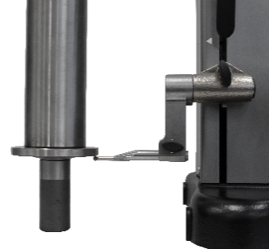 | 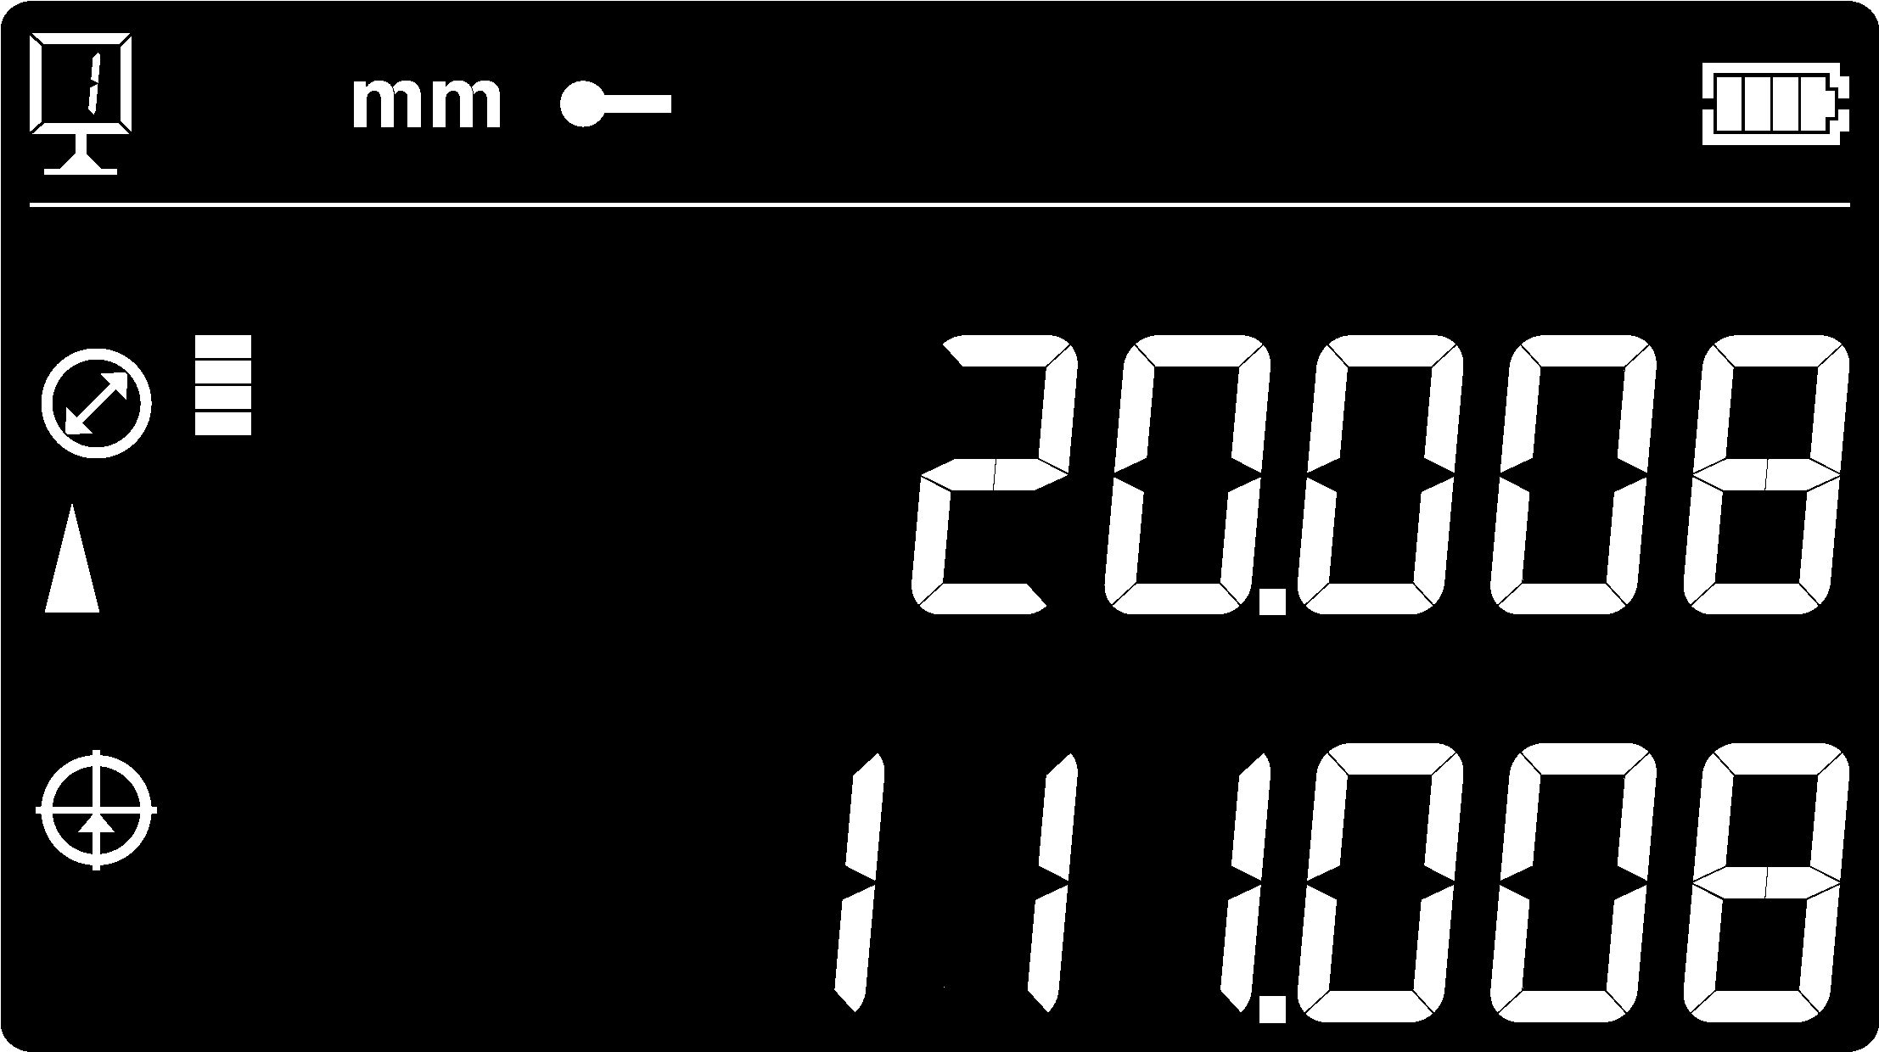  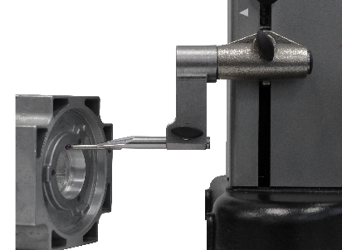 | 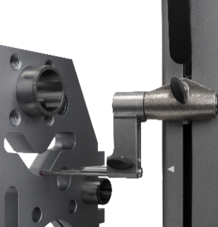 | 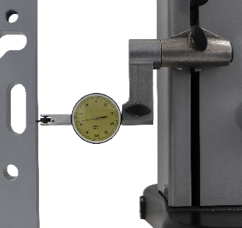
Height Measurements  Measurement of height, thickness and chain of dimensions | Diameter Measurements  Simultaneous display of diameter and centerline | Min/Max/Delta  Easy detection of min, max points or flatness of a surface | Perpendicularity  All instruments are mechanically corrected
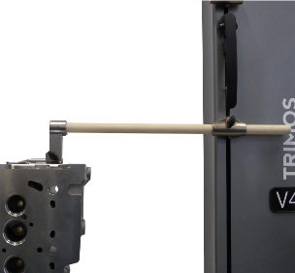 | 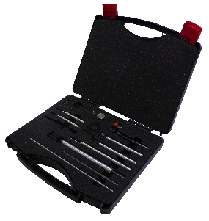 | 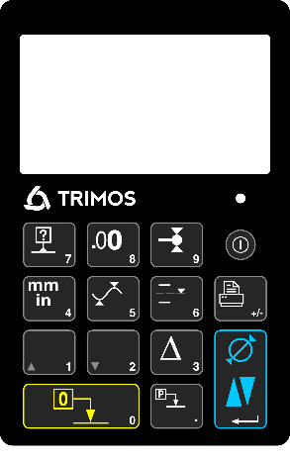 | 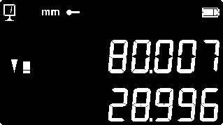
Long Probes  Standard measuring inserts up to 400 mm, with excellent repeatability | Accessories  Very large range of accessories for any type of application | User-Friendly Functions  Straighforward symbols and directly accessible functions | Maximum Contrast  Easy reading at any time thanks to the "Black Mask" display

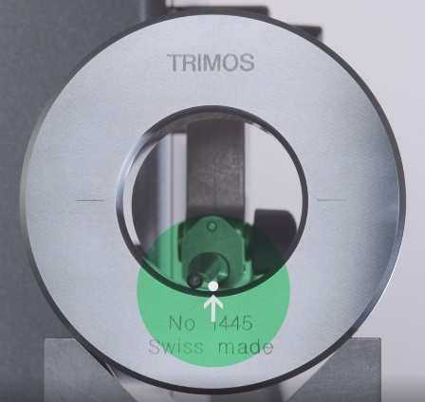 | SMART REVERSE:  Diameter measurement faster, more accurate and simpler  SmartReverse technology is the result of an intense collaboration between Trimos users and our R & D team in order to optimize diameter measurements.  SmartReverse makes the measurement of diameters very efficient by clearly indicating the reversal points with audible and visual signals. The user is guided precisely during the measurement of diameters, which generates a significant gain in speed and reliability of the measurement.

Trimos S.A.
Av.de Longemalle 5
CH-1020 Renens
T. +41 21 633 01 01
info@trimos.ch
www.trimos.com 750 02 0027 03 – Version 1.7/2019-03 – Changes without prior notice

