Horizon Setting HS4

Setting of Measuring Equipment with Variable Dimensions

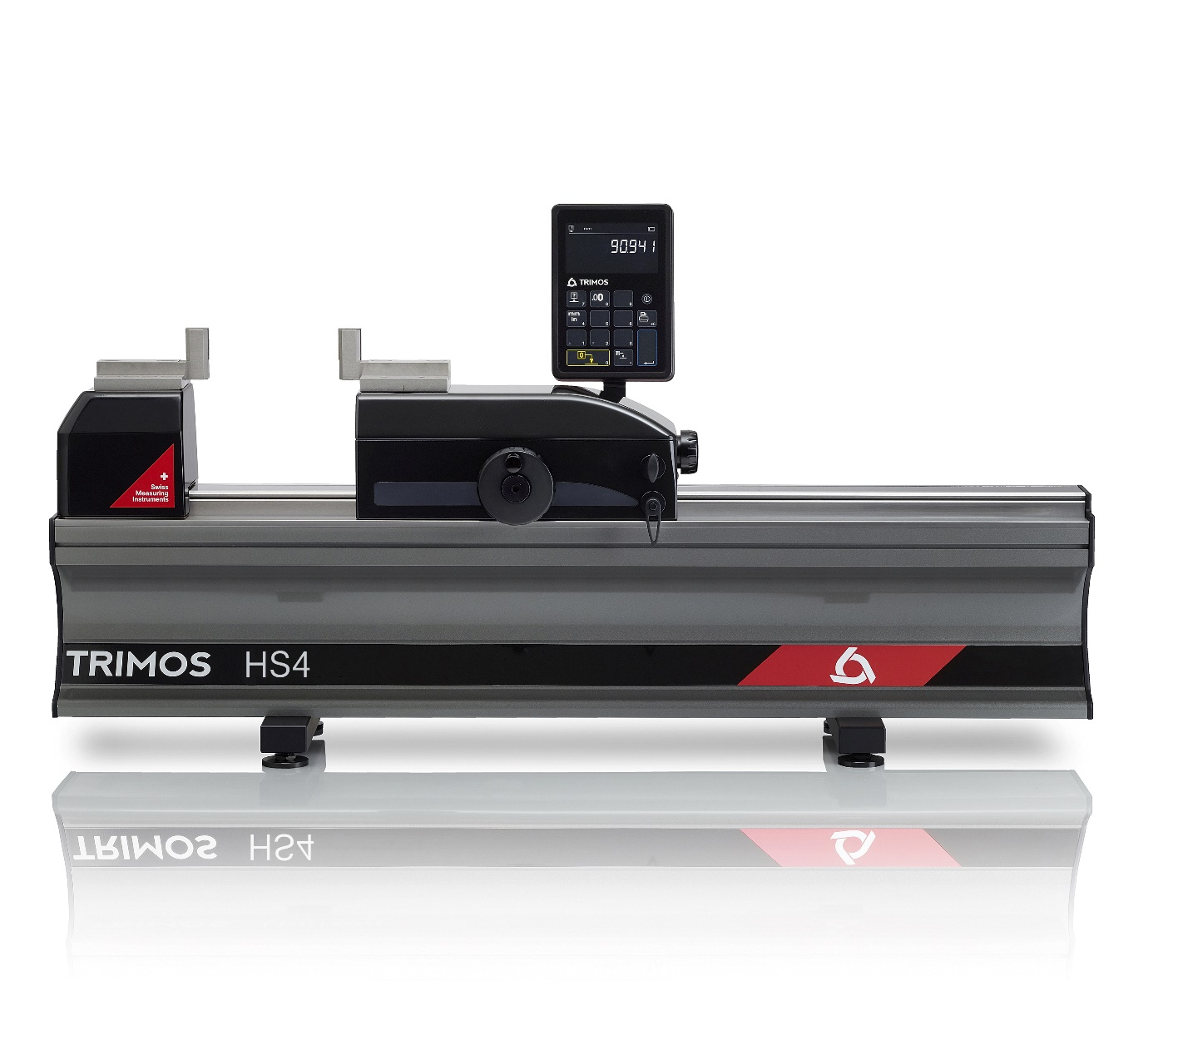
1.
PRESENTATION

Horizon Setting is the ideal instrument for the control and calibration of measuring means with fixed and variable dimensions. Its high precision and finishing level position it as a top of the range model for workshop or laboratory use. It is the perfect answer to current needs in the manufacturing field.

This new model is based on the already well known Trimos Horizon Premium, but a new electronics and innovative display are incorporated. A modern and ergonomic design, as well as a great ease of use guarantee optimal and high productivity measuring results.

Trimos proposes a complete range of instruments from 500 mm to 3000 mm. All measuring ranges are direct, which means that the whole measuring range is available without adjustment or intermediary re-calibration. A large selection of easily interchangeable accessories completes the possible applications and guarantees a correct positioning of the instruments to be calibrated.

- Delivered with two parallel 25 mm TEL5 gauge blocks
- Robust design, ideal for use in workshop
- Very simple use
- Fast and precise checking
Dimensionally stable instrument base, positioned on three level points

Handwheel for displacement of measuring carriage and force management

Digital display with data output
Fine adjustment carriage
Interchangeable accessories
Locking device for fine measuring carriage

Locking
device for main carriage

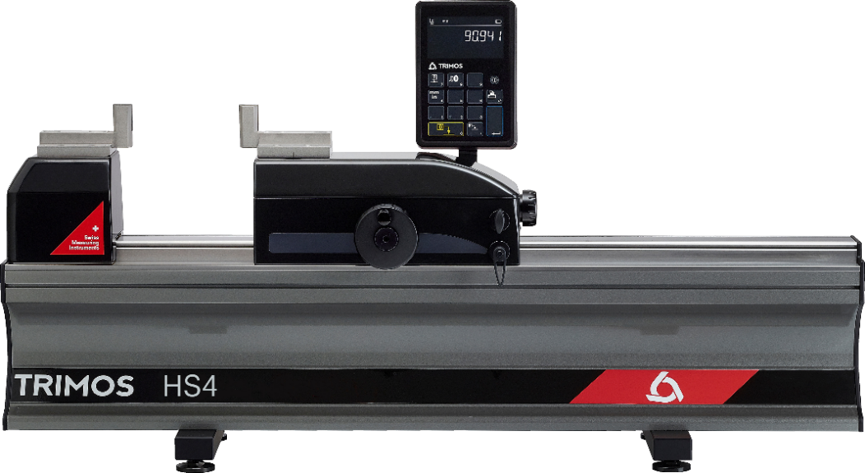
- Works on battery or power supply

2.
SPECIALLY DESIGNED FOR SETTING

- 2 points bore gauges
- 2 points internal and external comparative measuring equipment
- Dial indicators
- Calipers

3.
FEATURES
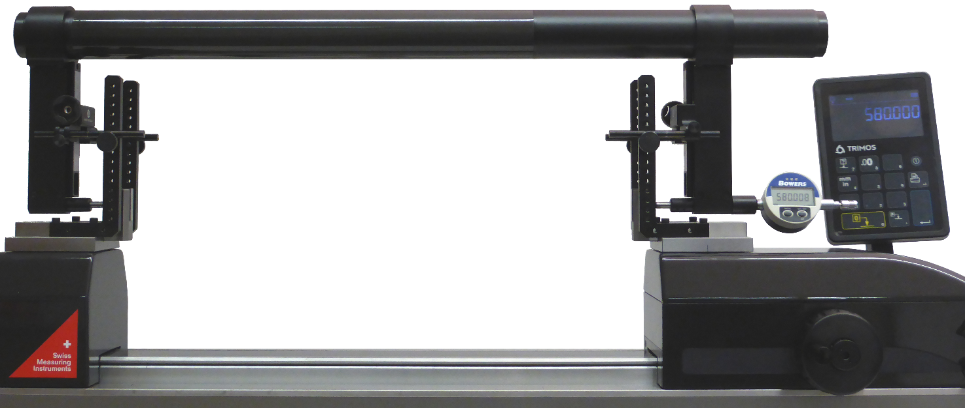

Setting of a large gauge

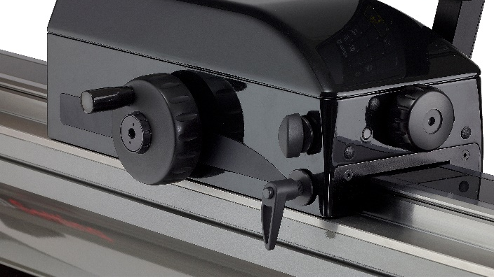  Two locking devices to hold the carriage |  | 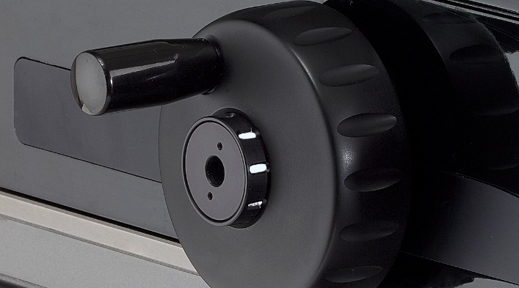  Setting force management with indicator

4.
TECHNICAL SPECIFICATIONS
Horizon Setting HS4 | HS4-500 | HS4-1000 | HS4-1500 | HS4-2000 | HS4-3000
Measuring range mm (in) | 550 (20) | 1050 (40) | 1550 (60) | 2050 (80) | 3050 (120)
Max. permission errors, E_{MPE} µm | 0.7+L/1000
Repeatability, R_{MPE} (2s) µm | 0.5
Maximal Resolution mm (in) | 0.0001 (0.00001)
Measuring force (0 setting) N | 15
Interfaces | USB / RS232
Weight kg | 94 | 123 | 152 | 181 | 239
Max displacement speed mm/s | 1500
Operational Temperature °C | +10 ÷ +40

5.
APPLICATIONS

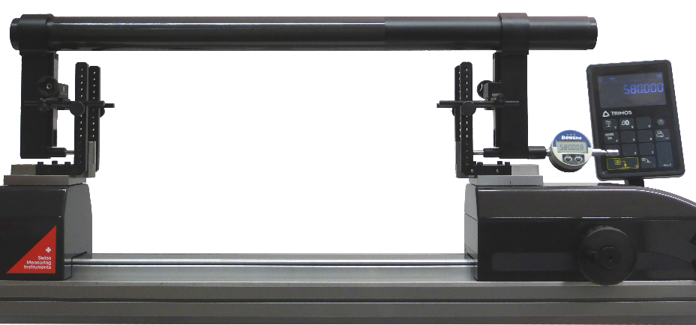 |  | 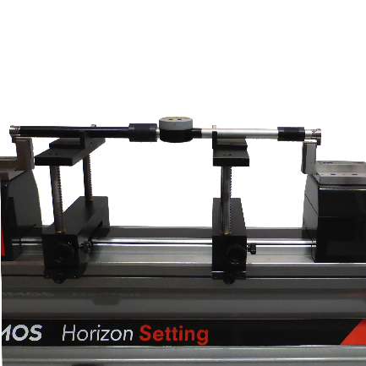
Setting of a large gauge |  | Setting of two points internal and external comparative measuring equipment (TEL5, TELMA7, TELMN7.2)
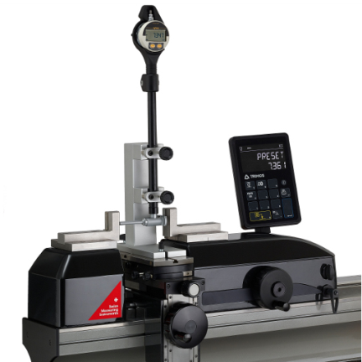 | 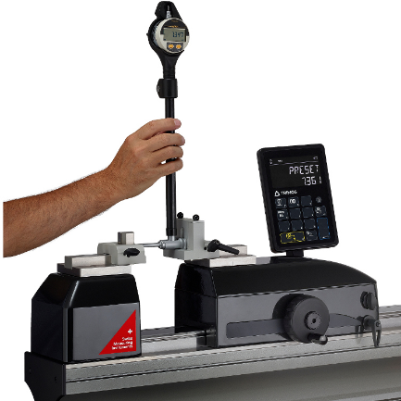 | 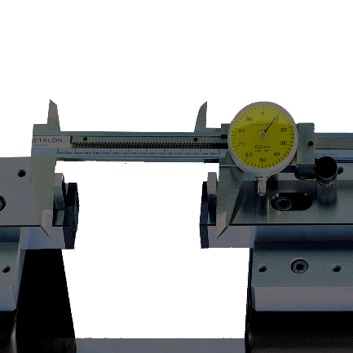
Setting of 2-point bore gauges with holder (TA-SU-313, TA-SU-318, TEL5) | Setting of 2-point bore gauges by hand (TA-SU-301, TEL5) | Checking of calipers (TEL 5.10)
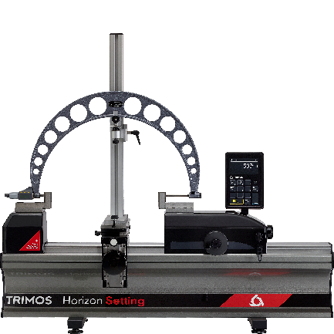 | 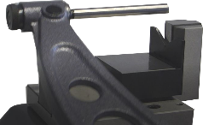  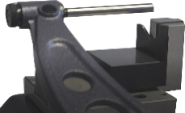  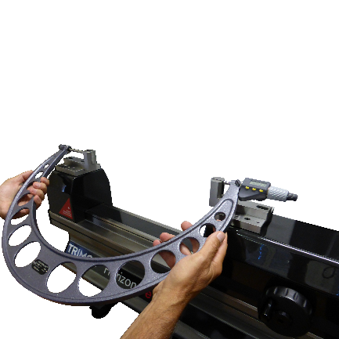 | 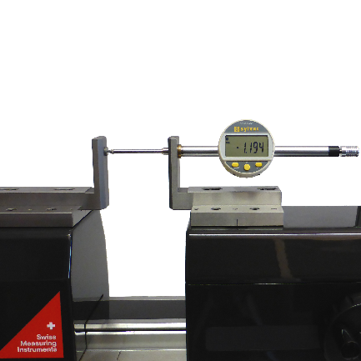
Checking of external micrometer held on a support (TA-SU-313, LABC20.1/SP02, TEL5) | Manually checking of external micrometer (TEL5) (TEL11) | Checking of dial indicator  (TEL5CN)
Trimos S.A.
Av.de Longemalle 5
CH-1020 Renens
T. +41 21 633 01 01
info@trimos.ch
www.trimos.com 750 02 0061 03 – Version 2.0/2022-01 – Changes without prior notice

